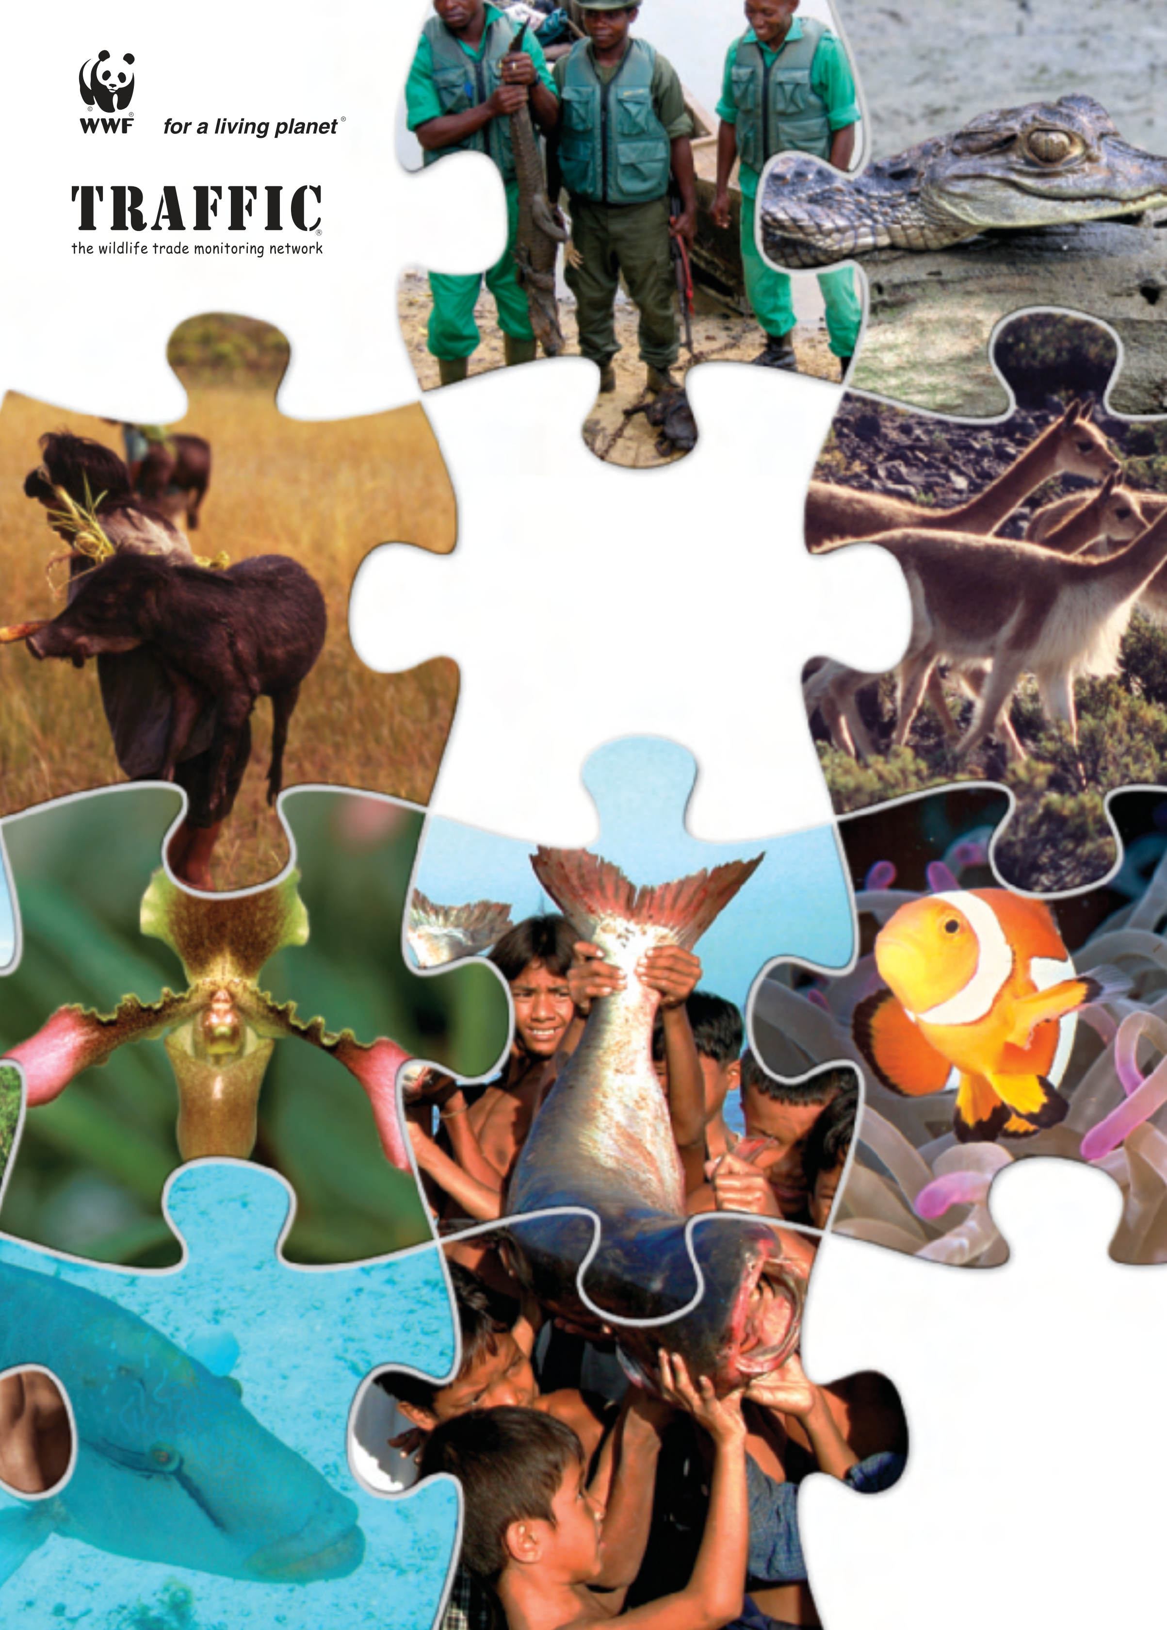
TRADING NATURE
A report, with
case studies, on
the contribution
of wildlife trade
management
to sustainable
livelihoods and
the Millennium
Development Goals
by Dilys Roe



Published by TRAFFIC International, Cambridge, UK
and WWF International, Gland, Switzerland.
© 2008 TRAFFIC International and WWF International.
All rights reserved.
All material appearing in this publication is copyrighted
and may be reproduced with perrmission. Any
reproduction in full or in part of this publication must
credit TRAFFIC International and WWF International as
the copyright owners.
The views of the author expressed in this publication do
not necessarily reflect those of the TRAFFIC network,
WWF or IUCN.
The designations of geographical entities in this
publication, and the presentation of the material, do not
imply the expression of any opinion whatsoever on the
part of TRAFFIC or its supporting organizations
concerning the legal status of any country, territory, or
area, or of its authorities, or concerning the delimitation of
its frontiers or boundaries.
The TRAFFIC symbol copyright and Registered
Trademark ownership is held by WWF. TRAFFIC is a
joint programme of WWF and IUCN.
Suggested citation: Roe, D. (2008). Trading Nature.
A report, with case studies, on the contribution of wildlife
trade management to sustainable livelihoods and the
Millennium Development Goals. TRAFFIC International
and WWF International.
Case study authors: Andrew Hurst (wild meat case study);
Helen J. Scales (coastal fisheries case study); and Sue
Wells (coastal fisheries and skins case studies).
ISBN 978 1 85850 237 3
Front cover photograph credits: WWF-Canon: André
Bärtschi, Olivier van Bogaert, Alain Compost, James
Frankham, Diego M. Garces, Michel Gunther, Zeb Hogan,
Cat Holloway, R. Isotti-A. Cambone, Hartmut Jungius,
Elizabeth Kemf, Roger LeGuen, Frédéric Monnot,
Juan Pratginestos.
Printed on FSC-certified paper and according to FSC-
certified processes.
TRAFFIC is a UK registered charity.

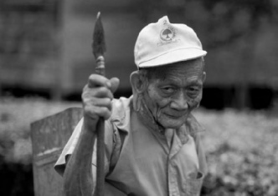
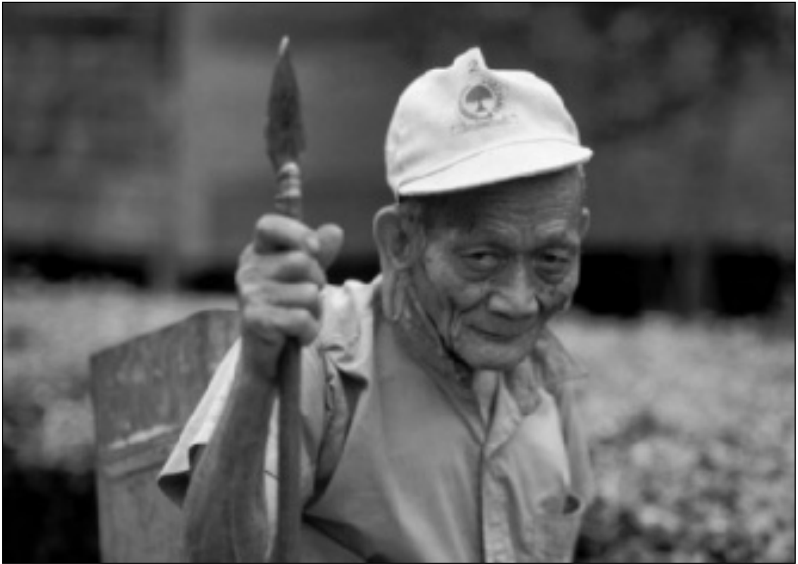
TRADING NATURE
A REPORT, WITH CASE STUDIES, ON THE CONTRIBUTION OF WILDLIFE TRADE MANAGEMENT TO SUSTAINABLE LIVELIHOODS AND THE MILLENNIUM DEVELOPMENT GOALS
by Dilys Roe
Credit: Tantyo Bangun/WWF-Canaon
A rattan harvester departs for work, East Kalimantan, Indonesia

FOREWORD
Dear readers,
It is with pleasure that WWF and TRAFFIC introduce this report, showing linkages between well-managed, sustainable wildlife trade and the Millennium Development Goals. This report is the second in a series demonstrating how species conservation contributes to sustainable development.
The worldwide value of wildlife trade has been estimated at USD300 billion. This excludes the consid-erable amount of domestic trade that takes place—especially in biodiversity-rich countries—as well as the value of wildlife that is harvested for direct consumption.
Trade on this scale presents us with opportunities but also with considerable challenges and risks. On the one hand, wildlife provides much of the food (especially protein) and medicinal products that are available to poor communities that live in areas of high biodiversity. The trade in wildlife and wildlife products, both domestic and international, also generates cash income and employment in biodiversity-rich countries and can represent an important contribution to their GDP. When this trade is legal, sustainable and effectively managed it can provide benefits for local communities—and when it is poorly managed and largely illegal, the benefits to local communities are lost.
By contributing to food security, by providing accessible health remedies and by creating valuable trade partnerships with importing countries, sustainable wildlife trade can be central to achievement of many of the Millennium Development Goals.
On the other hand, the fact remains that, while some communities and countries have been extremely successful in managing and regulating the use of their wildlife resources, a huge proportion of wildlife trade is manifestly unsustainable and often illegal. Wholesale “plundering” of natural resources will both deplete wildlife populations and deprive poor communities of essential natural resources in the long term, as well as lead to environmental degradation. Therefore, while sustainable wildlife trade can be positive for the delivery of the Millennium Development Goals, when it is at unsustainable levels or largely illegal, it represents a significant threat to their achievement.
The report addresses how societies can reconcile these contradictions and minimize the risks posed by wildlife trade. Critical factors include the establishment of appropriate ownership and tenure regimes for wildlife, the development of means to enhance wild production and the use of certification processes to identify wildlife goods that are derived sustainably.
WWF’s mission is to stop the degradation of the planet’s natural environment and to build a future in which humans live in harmony with nature by: conserving the world’s biological diversity; ensuring that the use of renewable natural resources is sustainable; and reducing pollution and wasteful consumption. An approach to the global wildlife trade that is integrated with human needs is fundamental to the fulfilment of this mission.
ii TRADING NATURE:Wildlife trade and the Millennium Development Goals

The challenge for governments, scientists, industry, nongovernmental organizations and communities is to embrace both the challenges and the opportunities of species conservation and to deliver integrated conservation and development outcomes. We hope this report will help decision-makers, conserva-tionists, development experts, politicians, funders and interested individuals embrace this challenge from the perspective of wildlife trade.
Dr Susan Lieberman
Director, WWF International, Species Programme
TRADING NATURE:Wildlife trade and the Millennium Development Goals iii

ACKNOWLEDGEMENTS
Special thanks are due to WWF International, and particularly to Amanda Nickson, Transition Deputy Director, WWF Global Species Programme, for the valuable support for the preparation of this report, and to the Swedish International Development Cooperation Agency (Sida) for providing the funding support that made this work possible. The Rufford Maurice Laing Foundation is gratefully acknowledged for its support of the final stages of production of this report.
The following are thanked for their preparation of the case studies contained within this report: Andrew Hurst (case study on wild meat trade in Africa), Helen J. Scales (case study on trade in coastal fisheries products from Asia) and Sue Wells (case studies on the trade in coastal fisheries products from Asia and skins from South America).
For reviewing a draft of this report, or sections of it, and for their helpful comments thanks are due to: Tim Christophersen, Environmental Affairs Officer for Forest Biodiversity, CBD Secretariat; Amanda Nickson, Transition Deputy Director, WWF Global Species Programme; Thomasina Oldfield, Acting Co-ordinator, Species Trade and Use Unit, IUCN Species Programme; Alvaro Velasco, Regional Chairman, Latin America and the Caribbean, Crocodile Specialist Group of IUCN; Heather Koldewey, Zoological Institute of London, Associate Director of Project Seahorse; Gayatri Lilley, Marine Aquarium Council, Indonesia; Genee Mislang, Marine Aquarium Council, Indonesia; Gregor Hodgson, ReefCheck; Richard Ambrose, University of California; Yvonne Sadovy, Division of Ecology and Biodiversity, School of Biological Science, University of Hong Kong; Steven Broad, Executive Director, TRAFFIC; Simon Milledge, Deputy Director, TRAFFIC East/Southern Africa; Sabri Zain, Advocacy and Campaigns Director, TRAFFIC and James Compton, Asia-Pacific Programme Co-ordinator, TRAFFIC.
Finally, thanks to Julie Gray, Reports Editor, TRAFFIC, for her editorial support and preparation of the final report for publication and to Teresa Mulliken, Co-ordinator, Programme Development and Evaluation, TRAFFIC, for her support during the writing of this report.
iv TRADING NATURE:Wildlife trade and the Millennium Development Goals

CONTENTS
Executive summary vii
Introduction 1
Methodology 2
Background 3
Analysis: contributions of wildlife trade to the MDGs 16
Discussion: challenges to wildlife trade as a development tool 27
Conclusions 33
CASE STUDIES—WILDLIFE TRADE MANAGEMENT IN PRACTICE
Case study 1: The trade in wild meat in East and Southern Africa 36 The nature and scale of the wild meat trade 36 Management of the wild meat trade 41 Impacts of trade management 45 Conclusions and recommendations—enhancing the contribution of the wild meat trade to 46 achieving the MDGs
Case study 2: The Latin American trade in wildlife skins and wool 50 The nature and scale of the Latin American skin trade 50 Management of the skin trade 51
Peccaries 51
Caimans 54
Vicuña 55 Impacts of trade management 57 Conclusions—the contribution of the skin trade to achieving the MDGs 59
Case study 3: Trade in Asian coastal fisheries products 61 Introduction 61 Ornamental fish and invertebrates for the marine aquarium trade 62
Nature and scale of the trade 62
Management of the trade 64
Impacts of trade management 66
TRADING NATURE:Wildlife trade and the Millennium Development Goals v

Seahorses 67 Nature and scale of the trade 67 Management of the trade 69 Impacts of trade management 69 Humphead Wrasse 70 Nature and scale of the trade 70 Management of the trade 71 Impacts of trade management 73 Conclusions—can the Asian coastal fisheries trade contribute to achieving the MDGs? 73
References 75
vi TRADING NATURE:Wildlife trade and the Millennium Development Goals

EXECUTIVE SUMMARY
Introduction
There is growing awareness of the social significance of wild resources, the Millennium Ecosystem Assessment (MA) making a clear link between biodiversity, ecosystem services and human well-being. There remains, however, much ignorance concerning the role that trade in wild products plays in supporting the livelihoods of poor people and the potential of this trade to contribute to the achievement of the Millennium Development Goals (MDGs). Despite growing acceptance of the importance of biodiversity goods and services to human well-being, there is still little recognition of the direct contri-bution of products derived from wild sources to human livelihoods—particularly the livelihoods of the rural poor.
This report looks at the importance of effective management of trade in wild species in order to maximize its potential to deliver on the MDGs. It also presents the findings of three case studies: the wild meat trade in East and Southern Africa; the skin and wool trade in Latin America; and, the high-value fisheries trade in South Asia. A review of the wider literature on trade in wild resources further contributed to exploration of the current and potential contribution of sustainable wildlife trade to achieving the MDGs.
The nature and scale of wildlife trade
Wildlife trade, in simple terms, is any sale or exchange by people of wild animal and plant resources. Wild species are traded in many forms in order to produce a wide variety of products including medicines, food, ornaments, furniture, pets, building supplies and so on. Quantifying the value of the wildlife trade is not easy—the use and trade of wild species is multi-faceted and encompasses many dimensions and scales. Nevertheless, it is clear that wildlife trade is a major economic activity. TRAFFIC has estimated the value of legal, international wildlife trade alone to be worth nearly USD300 billion in 2005, based on declared import values. A discernible trend also seems to be a steady increase in value. Reported trade in wildlife commodities (not including timber and commercial fisheries) has increased from “at least” five billion US dollars per annum in the 1980s, to over USD15 billion in the early 1990s, to over USD21 billion by 2005. These figures also do not reflect the huge amount of domestic trade that takes place, much of this trade providing valuable benefits and services to local communities and national economies in the form of livelihoods, employment, health care and food security.
The importance of managing wildlife trade
A consideration of the potential of the wildlife trade is relevant to discussions concerning the delivery of the MDGs for two main reasons:
• Wildlife trade is big business and a significant portion of this value is captured by poor countries and by poor people.
TRADING NATURE:Wildlife trade and the Millennium Development Goals vii

• Much harvesting and trade of wild products is poorly managed and, as such, unsustainable wildlife trade can be one source of the extensive biodiversity loss and ecosystem degradation that has been highlighted by the MA and noted as an obstacle to the achievement of the MDGs.
It is thus essential that wildlife trade is well managed and sustainable in order to maximize its contri-bution to the MDGs—where this potential exists—and, at very least, so as not to undermine the subsistence base on which the livelihoods of so many of the poor depend. Wildlife trade is managed through a variety of measures—regulatory and voluntary, formal and informal, direct and indirect—and at a variety of levels from global to local.
Contributions of wildlife trade to the MDGs
The most obvious contribution of wildlife trade to the MDGs is to the poverty reduction target of Goal 1. Sustainable wildlife trade can make a significant—if under-recognized—contribution to the economies of cash-poor but biodiversity-rich countries. For example, Uganda’s lake fisheries produce fish worth over USD200 million a year; employ 135 000 fishers and 700 000 small-scale operators in processing, trade and associated industries; generate USD87.5 million in export earnings; and contribute 2.2% to Gross Domestic Product (GDP).
Within poor countries, huge numbers of people have some involvement in wildlife trade—estimates of the number of people dependent on wild resources for at least part of their income range from 200 million worldwide to one billion just in Asia and the Pacific (van Rijsoort, 2000). There is growing recognition that sustainable, long-term poverty reduction is dependent upon a secure natural resource base. Despite its lack of recognition in national-level accounting, for some individuals, households or communities, wild resources can be a significant source of cash income, particularly in marginal agricultural areas or where there are few other livelihood opportunities:
• Analysis of the wild meat trade reveals estimates of contributions of up to 34% of household income in East and Southern Africa.
• In Palawan and the central Philippines, seahorse fishers and traders reported that seahorses contributed approximately 30–40% to their annual income.
• While the caiman skin trade generates a low income for ranchers compared to cattle, it can be significant for the poor and landless with few other income-generating opportunities.
The amount and relative significance of income from wildlife to rural households varies hugely and in part depends on the degree to which households are incorporated into a cash economy. For primarily subsistence households the total amount of income generated by selling wild resources is generally very low—but it may be the main, or only, source of cash. Overall, the World Bank estimates that forest products provide roughly 20% of poor rural families’ “income”—of which half is cash and half is in the form of subsistence goods.
viii TRADING NATURE:Wildlife trade and the Millennium Development Goals

Beyond cash income, case studies of the wild meat trade in Southern Africa, skin and wool trade in Latin America and high-value fisheries trade South Asia—as well as the wider literature—highlight contributions across a wide range of the MDGs but particularly:
• Hunger (MDG 1): Sustainable wildlife trade can help enhance food security both directly— providing consumers with a valuable, affordable source of protein—and indirectly—by increasing the amount of cash in the household that is available to spend on food. The importance of fisheries for food security highlights the importance of a well-managed trade, however. Unsustainable harvests can come at a substantial cost to the natural reef resources on which local communities rely for food and coastal protection. Conversely, if well managed, the trade in flagship species such as seahorses, Humphead Wrasse Cheilinus undulatus and certain ornamental fish, not only promotes their own conservation but can also have beneficial knock-on effects on the conservation status of a broader range of species that are important as local food sources.
• Health (MDGs 4, 5, 6): Sustainable wildlife trade can make a major contribution to primary healthcare. An enhanced protein supply (e.g from access to fisheries or wild meat products) is in itself, hugely beneficial for human health, but beyond that the trade in wildlife-based medicines (of plant and animal origin) is a major component of the wildlife trade and benefits millions of poor people. The World Health Organization (WHO) estimates, for example, that up to 80% of the African population uses traditional medicine for primary health care (WHO, 2003). Unregulated wildlife trade can, however, have unexpected negative implications for human health. The meat trade, for example, can not only result in exposure to HIV-related viruses but, where it threatens primates with extinction, can also affect research into treatments.
• Global partnership for development (MDG 8): As a global industry, wildlife trade is well placed to contribute to the development of “an open, rule-based, predictable, non-discriminatory trading and financial system” (Target 12). In fact some would argue that the Convention on International Trade in Endangered Species of Wild Fauna and Flora (CITES) is just that. Certainly with its increasing focus on livelihoods as well as conservation concerns, CITES is moving in this direction.
The commitment to good governance that is central to Goal 8—and indeed critical to achieving all the MDGs—is also central to sustainable management of the wildlife trade.
Unregulated wildlife trade, however, threatens to undermine the achievement of Goal 7—to “ensure environmental sustainability”—and hence hinder progress towards the other goals, as well as undermining the whole system under which developing countries attempt to find the balance between meeting both conservation and development goals. To date, much trade in wildlife has not been well managed and as a result, ecological degradation has occurred. Unless well managed, wildlife trade can cause direct harm through over-exploitation of targeted species, to the point where the survival of a species hangs in the balance. The MA highlights that overall, up to 30% of mammal, bird and amphibian species are threatened with extinction. Additional detail provided by IUCN, shows that one in four mammals, one in eight birds, and one third of all amphibians are threatened, as are over 8000 species of plants, fungi and algae. Over-exploitation is identified as one of the main threats to wild species on the Red List, affecting approximately one third of threatened mammal and bird species and also having a heavy impact on marine species (IUCN, 2007a).
TRADING NATURE:Wildlife trade and the Millennium Development Goals ix

Unsustainable wildlife trade can also cause problems beyond the target species, as over-exploitation of one species disrupts ecosystem structure and functions and, potentially, the delivery of essential ecosystem services. Over-fishing, for example, not only affects individual species but can also have serious repercussions for the wider marine ecosystem, e.g. through disruption of predator-prey relationships.
Key challenges to wildlife trade as a development tool
Even when well managed, wildlife trade is not a panacea for sustainable livelihoods and poverty reduction. In recent years, a considerable amount of research has documented the limited scope for increased commercialization of many wild resources. Nevertheless, it is possible to identify a number of key challenges that could, if overcome, really make a difference to realizing the potential of sustainable wildlife trade to contribute to the MDGs.
Of central importance is security of tenure over land and resource rights. For many, most wildlife is largely an “open access” resource, with few if any controls in place or, if they are, enforced, with regard to harvest. This has its advantages in that the potential benefits of trade are accessible to the poor. The disadvantage of open access resources, however, is the inability to exclude outsiders from harvest. There is little doubt that many “outsiders” are also poor people in desperate search of a living. The reality, however, is that without secure ownership, or exclusive access rights, there is little incentive for local people to invest in the long term sustainability of the wildlife resource—far better to exploit it while it is there and before others do the same. This not only has implications for trade-related incomes in the areas where stocks are depleted, but also for meeting the ongoing needs of subsistence users.
Captive, or semi-intensive, production has been highlighted as one possible mechanism for reducing the pressure on wild resources, while maintaining a regular source of supply for the trade. While this may help secure more regular income, its potential for broad-based poverty reduction efforts is constrained by the relatively limited number of beneficiaries. While low barriers to entry are noted as a major advantage to harvesting of wild resources, involvement in captive production can be constrained by the requirement for capital investment—often beyond the reach of many poor people. Difficulties with establishing successful production in non-wild habitats and the potential for such ex situ production facilities to be used as a cover for illegal trade in wild specimens have also been noted as constraints to this approach.
Introducing some kind of standard, certification and accompanying labelling scheme is attracting increasing attention as a mechanism that helps to promote sustainable management while at the same time generating better returns for poor producers. What is not clear from these various schemes is whether certification does indeed generate higher prices—the fisheries case study notes that there is currently little evidence of real increases in prices of aquarium fish as a result of Marine Aquarium Council certification for example. For many, the costs of certification itself may be prohibitive—the peccary pelt certification scheme discussed in the case study on the South America skin trade highlights
x TRADING NATURE:Wildlife trade and the Millennium Development Goals

the need for significant donor investment—at least in the initial stages. Recognizing these limitations, however, efforts are being made to enhance the pro-poor potential of certification. Even if certification has little impact on the prices captured by primary producers, it is hoped that it may help to promote a more sustainable, better-managed trade with associated ecological benefits.
Conclusions
Wildlife trade is a globally significant industry that, if well managed and sustainable, can generate significant benefits for poor people and can contribute to many of the MDGs—directly and indirectly. In many cases, however, wildlife trade is unregulated, unmanaged or poorly managed—often resulting in a lose-lose situation for both biodiversity conservation and for poor people’s livelihoods. Unsustainable wildlife trade has caused major population declines for a number of species—in turn limiting the ability of local people to exploit these species for subsistence use or to derive income from them over the long term. At the same time, inappropriate management interventions can result in significant opportunity costs for poor people with little or no conservation benefit.
On the other hand, well-managed trade can reverse the declines in previously threatened species—as well as preventing currently unthreatened species becoming over-exploited. This can open up new opportunities for income generation as well as securing subsistence resources for food, health and other needs. Under the appropriate conditions, sustainable and well-managed wildlife trade can thus contribute significantly to securing sustainable livelihoods at the local level and to delivering on the MDGs at the national level.
Management interventions are not a quick-fix solution, however. Even the well-managed trade can be limited in the benefits it can provide—largely because of the nature of wildlife products and the relatively limited scope for their commercialization, but also because of weak governance regimes and insecure land and resource tenure. The commitment to good governance that is critical to achieving all the MDGs is also central to sustainable management of the wildlife trade. Enhancing the contribution of wildlife trade management to sustainable livelihoods and therefore to achieving the MDGs therefore implies:
• Far greater attention to biodiversity governance so that local people have security of tenure over their land and resources giving them an incentive for sustainable management and an authority to exclude outsiders.
• Further exploration of semi-intensive production mechanisms that do not present barriers to entry for poor people—this might mean coupling new production technologies with access to credit and training.
• Further analysis of sustainable off-take levels for species in trade—before populations reach critical levels—and experimentation with management regimes that can support those, without undermining local people’s livelihoods.
• Development of “pro-poor” approaches to standards and certification that encourage sustainable management while at the same time generating decent returns for poor producers.
TRADING NATURE:Wildlife trade and the Millennium Development Goals xi

• Recognition of the links between different components of the wildlife trade and the need for a co- ordinated approach to its management.
• Further development of innovative approaches being put in place to address the unsustainable harvest of the most commercially valuable commodities (timber, fish) to other parts of the wildlife trade whose value may be unrecognized.
Recognition of the link between consumer demand and unsustainable production and associated•
attention to awareness-raising in consumer countries.
• Greater integration of commercial and subsistence requirements of wildlife resources so that the one use does not undermine the other.
A recent report by WWF notes that the principles of sustainable use and benefit-sharing that are part of both the MDGs and the Convention on Biological Diversity (CBD) are supportive, but present implementation challenges. Sustainable wildlife trade offers one mechanism for achieving this synergy—but only if management is appropriate to local people’s needs.
xii TRADING NATURE:Wildlife trade and the Millennium Development Goals

INTRODUCTION
The Millennium Development Goals (MDGs, see Table 4) are a set of eight goals and 18 targets, agreed by national governments and development agencies in 2000 as a “road map” for development assistance and poverty reduction efforts. The sustainable management of natural resources is specif-ically addressed in Goal 7, but also underpins delivery of the other goals since human well-being is inextricably linked to a healthy environment (Millennium Ecosystem Assessment, 2005a). The Millennium Ecosystem Assessment (MA) warns that the degradation of ecosystem services poses a significant barrier to the achievement of the MDGs (Millennium Ecosystem Assessment, 2005a).
Despite growing acceptance of the importance of biodiversity goods and services to human well-being, there is still little recognition of the direct contribution of plant and animal products derived from wild sources to human livelihoods—particularly the livelihoods of the rural poor. Numerous studies (e.g. Prescott-Allen and Prescott-Allen, 1982; Scoones et al., 1992; Neumann and Hirsch, 2000; Angelsen and Wunder, 2003; Millennium Ecosystem Assessment, 2005a; World Resources Institute, 2005) have found that it is often the poorest people and households that are most dependent on wild resources—for food, fuel, fodder, medicines and so on. Overall, the UK Department for International Development (DFID) estimates that of the 1.2 billion people in absolute poverty (with an income of less than USD1/day), up to 150 million (13%) rely on wildlife as a key element of their livelihood asset base (DFID, 2002). This is partly to do with their proximity to wildlife resources but also related to their limited access to substitutes or alternatives (Millennium Ecosystem Assessment, 2005a). Other factors (Belcher et al., 2007) include:
• Wild resources are generally available as common property or open access resources and hence accessible to remote communities with little financial or physical capital;
• Wild resources can be harvested and used with little processing and with low-cost technologies; • Wild resources are available for direct consumption or sale when crops fail or when other shocks hit the household.
In addition to local use, wildlife resources are also frequently harvested and sold by people and/or companies based far from the resource, supplying markets hundreds or even thousands of miles away.
Much harvesting and trade of wild products is, however, poorly managed and, as such, unsustainable wildlife trade can be one source of the ecosystem degradation highlighted by the MA, resulting in over-exploitation of target species and knock-on effects on other species and wider habitat conservation. This in turn will have longer-term implications for the success or failure of efforts to tackle poverty reduction.
The importance of wildlife resource use is currently not well-reflected in much of the policy debates concerning trade and the environment. Not surprisingly therefore, there is also little understanding of the importance of providing a policy and regulatory environment that promotes good governance, supports the sustainable management of these critical resources and provides the basis for long-term, sustainable poverty reduction.
TRADING NATURE:Wildlife trade and the Millennium Development Goals 1

This report explores the significance of wildlife trade to poor people and poor countries. Drawing on case studies documenting the trade in wild meat, coastal fisheries products and skins and wool—as well as the wider literature on trade in non-timber forest products (NTFPs)—the report assesses the ways in which sustainable wildlife trade contributes to securing more sustainable livelihoods and delivering on the MDGs. Significant contributions can be shown across the majority of the MDGs, but it is an unfortunate reality that much of wildlife trade is currently unsustainable and poorly managed. This runs the risk of undermining the very resource base on which many poor people are so dependent—and in turn, undermining the achievement of the other MDGs. This report therefore also looks at the importance of effective management of the trade in wild species in order to maximize its potential to deliver on the MDGs.
The report begins with a general introduction to wildlife trade and its links to delivery of the MDGs, followed by a summary of different mechanisms used to manage the trade. The importance of the trade to the MDGs is then considered in more detail through drawing on the case studies and an exploration of the wider literature. The challenges of maximizing the development potential of the trade are highlighted and conclusions stemming from the discussion provided. The three case studies give examples of wildlife trade management in practice in Africa (wild meat), South America (skins and wool) and South-east Asia (coastal fisheries products).
METHODOLOGY
The research for this report was conducted as a desk-based study including a literature review (covering both “grey” and published literature), consultations with relevant experts and, where relevant, review of web-based project documents and other information. The case studies were selected to illustrate the major commodity types (not including commercial timber and fisheries) within wildlife trade—wild meat, skins and wool, ornamental and food fish; different regional contexts—Africa, Asia and Latin America; and very different governance contexts and management regimes.
A note on definitions
Many of the examples used in this report are from the literature on NTFPs which have been defined as“all biological materials other than timber which are extracted from forests for human use” (de Beer and McDermott, 1996). There is, however, no universal agreement as to what is and what is not an NTFP (Belcher, 2003) although van Andel et al. (2003) note that wildlife (by which they mean products of animal origin) are often excluded from NTFP inventories.
To further complicate matters, the Food and Agriculture Organization of the United Nations (FAO), a source of much of the analysis on the nature and scale of trade in wild resources, uses the term non-wood forest product (NWFP), which they define as “products of biological origin other than wood derived from forests, wooded lands and trees outside forests” (FAO, 2001), rather than NTFP.
2 TRADING NATURE:Wildlife trade and the Millennium Development Goals



Furthermore, the term “forest” itself has no single definition, and NTFP/NWFP are increasingly applied to wild species (primarily terrestrial) from a variety of habitats.
Much of the literature on the trade in NTFP/NWFPs would thus appear to be applicable to the trade in the majority of wildlife species and has thus been included in our analysis whether or not labelled as wildlife. In the context of this report the term “wildlife” is used to describe wild animal, plant and fungal species, terrestrial and aquatic, that continue to occur in the wild regardless of whether or not domestic varieties have been developed—this encompasses those products described as NTFPs or NWFPs. Similarly the term “wildlife trade” is used to describe the sale or exchange by people of such wildlife resources—including live specimens and their derivatives.
BACKGROUND
What is wildlife trade?
Wildlife trade, in simple terms, is any sale or exchange by people of wild animal and plant resources. Wild species are traded in many forms in order to produce a wide variety of products. Major uses (Roe et al., 2002) include:
Medicines: Many medicines, both traditional
and “western” are based on wild plants or
compounds extracted from them. Based on a
review of published medicinal floras, | Myrtle Myrta communis,Tunisia | Credit: WWF-Canon/Michel Gunther
Schippmann et al. (2006) estimate that | Myrtle Myrta communis,Tunisia | Credit: WWF-Canon/Michel Gunther
50 000–70 000 plant species are used in | Myrtle Myrta communis,Tunisia | Credit: WWF-Canon/Michel Gunther
traditional and modern medical systems | Myrtle Myrta communis,Tunisia | Credit: WWF-Canon/Michel Gunther
throughout the world. The same authors | Myrtle Myrta communis,Tunisia | Credit: WWF-Canon/Michel Gunther
propose that approximately 3000 medicinal | Myrtle Myrta communis,Tunisia | Credit: WWF-Canon/Michel Gunther
and aromatic plant (MAP) species are | Myrtle Myrta communis,Tunisia | Credit: WWF-Canon/Michel Gunther
involved in international trade, based on the | Myrtle Myrta communis,Tunisia | Credit: WWF-Canon/Michel Gunther
number of documented species imported to | Myrtle Myrta communis,Tunisia | Credit: WWF-Canon/Michel Gunther
and exported from major centres of MAP
trade.
Food: Although most wildlife hunted or collected for use as food is consumed directly, there is a substantial international trade in a variety of NTFPs (Table 1). The trade in fisheries products dominates the food trade in animal species.
Ornaments and furnishings: A wide variety of wildlife products are used for decoration and ornamental purposes including: wood, ivory, coral, turtle and mollusc shells, reptile and other skins, and feathers. Tourist items are often crafted from local wildlife, including jewellery and ornaments
TRADING NATURE:Wildlife trade and the Millennium Development Goals 3

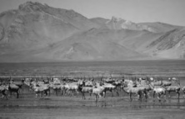
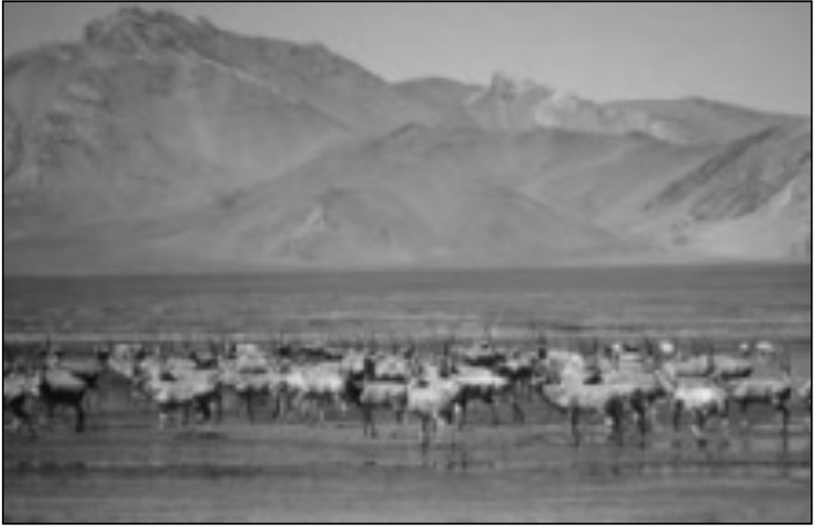
crafted from corals and shells, curios such as insects or other small animals encased in plastic and stuffed animals.
Clothing: Skins, furs, feathers and wool from
many mammal, reptile, bird and fish species
Credit: Ronald Petocz/WWF-Canon | A herd of endangered Tibetan Antelope | are traded internationally to make clothing,
Credit: Ronald Petocz/WWF-Canon | A herd of endangered Tibetan Antelope | boots and shoes, bags and other items. These
Credit: Ronald Petocz/WWF-Canon | A herd of endangered Tibetan Antelope | include expensive and high fashion items, e.g.
Credit: Ronald Petocz/WWF-Canon | A herd of endangered Tibetan Antelope | shahtoosh shawls made from the endangered
Credit: Ronald Petocz/WWF-Canon | A herd of endangered Tibetan Antelope | Tibetan Antelope Pantholops hodgsonii, as
Credit: Ronald Petocz/WWF-Canon | A herd of endangered Tibetan Antelope | well as more widely available and legally
Credit: Ronald Petocz/WWF-Canon | A herd of endangered Tibetan Antelope | traded products such as snake skin accessories
Credit: Ronald Petocz/WWF-Canon | A herd of endangered Tibetan Antelope | (e.g. belts, wallets).
Pantholops hodgsonii on the Aqik Lake plain,

Arjin Mountains, Xinjiang, China

Pets/hobbies: The increased availability of air transport around the world has greatly

expanded the variety and numbers of wild species traded for use as pets or as hobbies. The interna-tional trade is dominated by reptiles, birds and ornamental fish, but includes invertebrate species such as scorpions and spiders.
Credit: Michel Gunther/WWF-Canon | 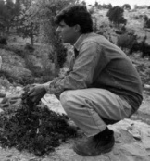 | Ornamental plants: A significant percentage of what are
Credit: Michel Gunther/WWF-Canon |  | now considered common garden and indoor plants
Credit: Michel Gunther/WWF-Canon |  | (including snowdrops Gallanthus spp., crocuses Crocus
Credit: Michel Gunther/WWF-Canon |  | spp., cyclamens Cyclamen spp., palms and so on) are the
Credit: Michel Gunther/WWF-Canon |  | product of international trade that has been taking place for
Credit: Michel Gunther/WWF-Canon |  | centuries. Although much of the trade now involves artifi-
Credit: Michel Gunther/WWF-Canon |  | cially propagated plants, there are still millions of wild
Credit: Michel Gunther/WWF-Canon |  | plants traded internationally each year, including a specialist
Credit: Michel Gunther/WWF-Canon |  | trade in rare species.
Credit: Michel Gunther/WWF-Canon |  | Manufacturing and construction: | Forest products
Credit: Michel Gunther/WWF-Canon |  | including timber, rattan and bamboo for furniture making,
Credit: Michel Gunther/WWF-Canon | Wild snowdrop harvest,Turkey
Credit: Michel Gunther/WWF-Canon | Wild snowdrop harvest,Turkey | plant oils and gums, dyes, resins, latex, etc. are all traded
internationally in large volumes.
Relatively few of the products listed in Table 1 are commonly thought of as being components of“wildlife trade”, with the exception of wild animals and animal products, ornamental and medicinal plants and incense woods (Broad et al., 2003). The scale of the international trade in more “typical”(if actually less common) wildlife products is illustrated by recent data for species covered by the Convention on International Trade in Endangered Species of Wild Fauna and Flora (CITES) (Table 2).
4 TRADING NATURE:Wildlife trade and the Millennium Development Goals


Table 1
Commercially significant wild resources in international trade
Category Product
FOOD PRODUCTS Nuts: brazil nuts, pine nuts, pignolia nuts, malva nuts, walnuts and chestnuts Fruits: jujube, sapodilla, ginkgo
Fungi: morels, truffles, pine mushrooms
Vegetables: bamboo shoots, osmunds, reindeer moss, palm hearts
Starches: sago
Bird nests
Oils: shea nuts, babassu oil, illipe oil
Maple sugar
HERBS AND SPICES Nutmeg, mace, cinnamon, cassia, cardamom,
Galanga, allspice, caraway, bay leaves, oregano etc.
INDUSTRIAL PLANT OILS AND WAXES Tung oil, neem oil, jojoba oil, kemiri (candle, lumbang) oil, akar wangi, babassu, oticica and kapok oils
Carnauba wax
PLANT GUMS For food uses: gum arabic, tragacanth, karaya, carob
Technological grade gums: talha, combretum
NATURAL PIGMENTS
Annatto seeds, logwood, indigo OLEORESINS Pine oleoresin, copal, damar, gamboge, benzoin gum, dragon's blood (Benjamin), copaiba oil, amber
FIBRES AND FLOSSES Fibres: bamboo, rattan, xateattap, aren, osier, raffia, toquilla straw products, cork, esparto, Erica and other broom grasses
Flosses: kapok or silk cotton
VEGETABLE TANNING MATERIALS Quebracho, mimosa, chestnut and catha/cutch
LATEX Natural rubber, gutta percha, jelutong, sorva and chicle
INSECT PRODUCTS Honey, beeswax, lac and lac-dye, silk, cochineal,
aleppo galls, kermes
INCENSE WOODS
Sandalwood, gharu or aloewood [agarwood] ESSENTIAL OILS Various
Pyrethrum, derris, medang and peuak bong PLANT INSECTICIDES
MEDICINAL PLANTS Various
WILD PLANTS
Various ANIMALS AND ANIMAL PRODUCTS Ivory, trophies, skins, feathers, eggs, butterflies, live animals and birds
bidi leaves, soap nut, Quillaia bark, betel and cola nuts, chewing sticks, lacquer, dom nuts MISCELLANEOUS
or ivory nuts
Source: Iqbal 1993, as cited in Iqbal 1995.
TRADING NATURE:Wildlife trade and the Millennium Development Goals 5


Table 2
The scale of reported international trade in CITES-listed species (2000–2005)
Commodity | Type | Numbers of specimens
Live birds | Birds of prey (Falconiformes) | 30 000
Live reptiles and amphibians | Parrots (Psittacidae) | 2.5 million
Live reptiles and amphibians | Song birds (Passerines) | 3.9 million
Live reptiles and amphibians | Others | 300 000
Live reptiles and amphibians | Tortoises | 600 000
Reptile skins | Lizards | 5.6 million
Reptile skins | Snakes | 1.7 million
Reptile skins | Amphibians | 236 000
Reptile skins | Crocodiles | 11.1 million
Invertebrates | Lizards | 10.7 million
Invertebrates | Snakes | 8.2 million
Invertebrates | Corals | 6.5 million
Invertebrates | Others (e.g.live or dead insects, | 3 million
spiders, butterflies, beetles)
Plants | Galanthus plants or bulbs | 244 million
Tropical Timber | Orchids | 370 million
Tropical Timber | Cacti | 88 million
Tropical Timber | Cyclamen plants or bulbs | 18 million
Tropical Timber | Mahogany | 745 000 m3
Tropical Timber | Pericopsis spp. | 71 000 m3
Tropical Timber | Ramin | 322 000 m3
Source: Adapted from Engler and Parry-Jones (2007) based on CITES annual report data compiled by UNEP-WCMC.
What is wildlife trade worth?
Quantifying the value of wildlife trade is not easy—the use and trade of wild species is multi-faceted and encompasses many dimensions and scales:
•  •  6 | The majority of wild resources have low cash value and are used for direct consumption rather than sale (Wollenberg and Belcher, 2001; Belcher et al., 2007). The dividing line between subsistence use of wildlife and wildlife trade is often blurred (Burgess, 1992; Freese, 1998): wildlife and wildlife products are often consumed
  "We do not go out to hunt wildlife, we just collect it when we see it; all households do this".
  Villager | from | Chham Thom,
  Cambodia, cited in Singh et al., 2006b.
•  •  6 | TRADING NATURE:Wildlife trade and the Millennium Development Goals

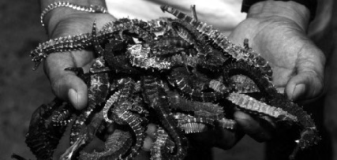
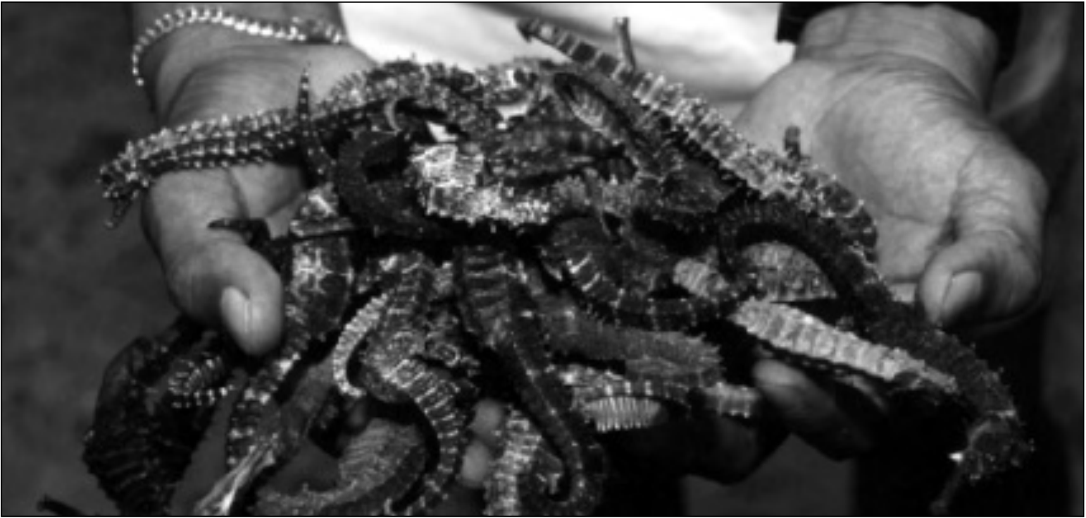
directly and sold in to the cash economy by the same people and in the same locations (Broad et al., 2003).
• Wildlife may be sold and used locally, transported for sale in urban centres, sent across national borders to markets in neighbouring countries or shipped half way around the world.
• The number and characteristics of actors involved in the trade vary with the species and product involved and trade chains between harvester and end-consumer are often highly complex.
• Most wildlife trade occurs within national borders; for example, in Brazil it was estimated that 70% of wild animals were sold within the country (van Andel, 2003). The nature of such trade is that it is often carried out through informal networks and not documented or captured in government statistics (Broad et al., 2003).
• Not all wildlife trade is legal, and therefore is not open to scrutiny, and some legal trade is not subject to any official reporting requirements.
• Comprehensive trade data only exist for species covered by CITES—and even here problems with the accuracy of CITES trade reporting mean that trade data are indicative rather than actual.
Customs data provide information on levels of processing and overall trade volumes, but rarely on the species or number of specimens involved.
Nevertheless, it is clear that wildlife trade is a major industry. The value of legal, international wildlife trade is estimated to be worth nearly USD300 billion in 2005, based on declared import values (Table 3). This figure contrasts with a declared import value of EUR14 billion (USD17 billion) for the global trade in coffee, tea and spices in 2005 (Engler and Parry-Jones, 2007).
A discernible trend also seems to be a steady increase in value. Even without timber and fisheries included, reported international trade in wildlife commodities has increased from “at least” USD5 billion per annum in the 1980s (Fitzgerald, 1989), to over USD15 billion in the early 1990s (Broad et al., 2003), to over USD21 billion by 2005 (Table 3). Figure 1 illustrates this trend for a number of key commodities.
Credit: WWF-Canon/Jürgen Freund
Dried seahorses collected for medicine, Philippines
TRADING NATURE:Wildlife trade and the Millennium Development Goals 7


Table 3
Estimate of the value of the international wildlife trade in 2005
Commodity Estimated value in 2005 (USD)
Live animals
Primates 94 million
Cage birds 47 million
Birds of prey 6 million
Reptiles and amphibians 38 million
Ornamental fish 319 million
Animal products for clothing/ornaments etc.
Mammal furs and fur products 5 billion
Reptile skins 338 million
Ornamental corals and shells 112 million
Natural pearls 80 million
Animal products for food (excluding fish)
Game meat 773 million
Frogs legs 50 million
Edible snails 75 million
Plants
Medicinal plants 1.3 billion
Ornamental plants 13 billion
TOTAL (not including fisheries and timber) 21.2 billion
Wild fisheries* 81.5 billion
Timber 190 billion
TOTAL 292.7 billion
Source: Engler (in prep.), based on UN Statistics Division Commodity Trade Statistics Database except * from
FAO Fisheries Statistics
8 TRADING NATURE:Wildlife trade and the Millennium Development Goals

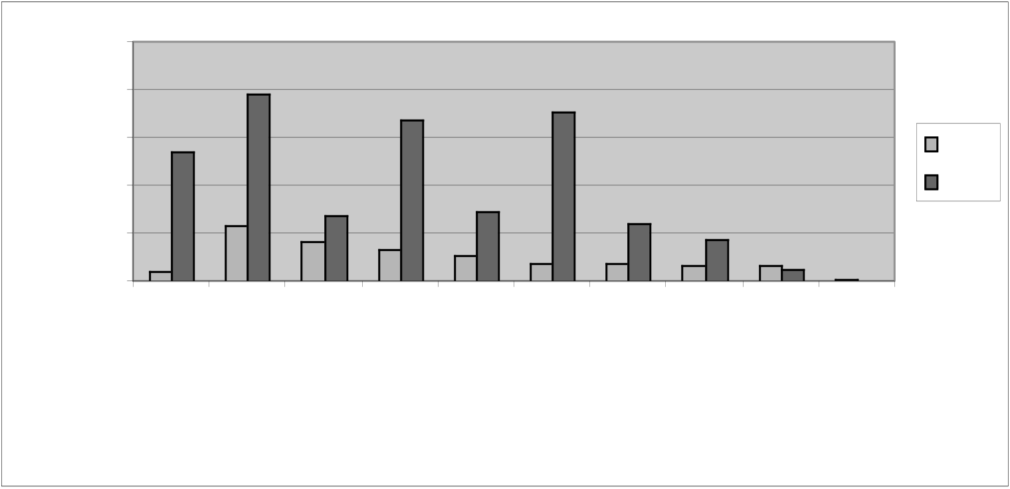
Figure 1
Changes in the value of the reported international trade in major wild resources—
1995–2005
2500
US$ millions USD | 2000 | Plants used  in pharmacy Plants used in  pharmacy, | Nuts Nuts | Essential Essential oils  oils | Cork Cork | Natural  Natural honey Gums and  Gums and resins honey  resins  Product | Live animals | Spices Spices | Bamboo and Bamboo and rattan  rattan | Ivory Ivory | 1995
US$ millions USD | 1500
US$ millions USD | 1000 |  |  |  |  |  |  |  |  |  | 2005
US$ millions USD | 500
US$ millions USD | 0
Source: 2005 data from Engler (in prep.), based on UN Statistics Division Commodity Trade Statistics Database; 1995 data from Iqbal (1995).
What relevance does wildlife trade have to the MDGs?
The MDGs provide the overarching policy framework for international poverty reduction and development assistance efforts. They focus on key development concerns including income poverty, hunger, child and maternal health, universal primary education, and access to safe water and sanitation (Table 4).
Even at the time of their formulation, the MDGs were not new ambitions—they are largely a consoli-dation of commitments made at various UN conferences since the pivotal UN Conference on the Human Environment held in Stockholm in 1972 (Satterthwaite, 2003). What is unusual about them, however, is the unprecedented level of commitment from national and international agencies and from the public, private and civil society sectors. As a result, any efforts to address poverty reduction and human development must be set within the context of the MDGs in order to ensure their relevance to this global effort.
A consideration of the potential of wildlife trade is relevant to discussions concerning the delivery of the MDGs for a number of reasons:
1. As noted above, wildlife trade is big business and a significant portion of this value is captured by poor countries and by poor people;
2. Conversely, unsustainable, poorly-managed wildlife trade can contribute to biodiversity loss and undermine the subsistence base of many poor people’s livelihoods.
TRADING NATURE:Wildlife trade and the Millennium Development Goals 9


Table 4
A summary of the Millennium Development Goals and Targets
Goal Targets

1. Eradicate extreme poverty and hunger

1. Reduce by half the proportion of people living on less than a dollar a day; (achieve full and productive employment and decent work for all, including women and young people) 2. Reduce by half the proportion of people who suffer from hunger

2. Achieve universal primary education 3. Ensure that all boys and girls complete a full course of primary schooling
3. Promote gender equality and empower women 4. Eliminate gender disparity in primary and secondary education
4. Reduce child mortality 5. Reduce by two thirds the mortality rate among children under five
5. Improve maternal health 6. Reduce by three quarters the maternal mortality ratio; (achieve, by 2015, universal
access to reproductive health)

6. Combat HIV/AIDs, malaria and other diseases

7. Halt and begin to reverse the spread of HIV/AIDS; (achieve, by 2010, universal access to treatment for HIV/AIDS for all those who need it)
8. Halt and begin to reverse the incidence of malaria and other major diseases

7. Ensure environmental sustainability 9. Integrate the principles of sustainable development into country policies and programmes; reverse loss of environmental resources; (Reduce biodiversity loss, achieving, by 2010, a significant reduction in the rate of loss)
10. Reduce by half the proportion of people without sustainable access to safe drinking water 11. Achieve significant improvement in lives of at least 100 million slum dwellers, by 2020

8. Develop a global partnership for development

12. Develop further an open, rule-based, predictable, non-discriminatory trading and financial system. Includes a commitment to good governance, development, and poverty reduction
13. Address the special needs of the least developed countries
14. Address the special needs of landlocked countries and small island developing States 15. Deal comprehensively with the debt problems of developing countries
16. In co-operation with developing countries, develop and implement strategies for decent and productive work for youth
17. In co-operation with pharmaceutical companies, provide access to affordable essential drugs in developing countries
18. In co-operation with the private sector, make available the benefits of new
technologies, especially information and communications

Note: italicized text refers to additional targets signed at the UN General Assembly in June 2006.
10 TRADING NATURE:Wildlife trade and the Millennium Development Goals


The case studies and the wider literature reviewed for this report also indicate that a well-managed, sustainable wildlife trade can contribute to:
• | food security (either directly through increased | "The contributions of fisheries to the
• | access to protein from wild meat or fish, or | MDGs are of two kinds: direct contribution
• | indirectly by increasing household incomes and | MDGs are of two kinds: direct contribution
• | indirectly by increasing household incomes and | to specific goals and indirect support to all
• | hence ability to purchase high value food); | to specific goals and indirect support to all
• | hence ability to purchase high value food); | the goals through enhanced livelihoods. It
• | health, through access to traditional medicines, | is a strength of fisheries, and in particular
• | plant-based pharmaceuticals and more secure | of small-scale fisheries, that it enables
• | protein supplies; | of small-scale fisheries, that it enables
• | protein supplies; | millions of poor fishers, processors and
• | gender equity, recognizing that women are often | traders to diversify their livelihood
• | involved in NTFP harvests, through specific | strategies on the basis of income and
• | opportunities for women within the trade; | strategies on the basis of income and
• | opportunities for women within the trade; | commercial skills while at the same time
• | education targets by enabling poor households | supplying vast numbers of poor consumers
• | to cover school fees (Roe et al., 2002). | with essential nutrition".
• | a global partnership for development through | WorldFish Center, 2005.
• | more equitable trading and benefit-sharing | WorldFish Center, 2005.
arrangements and through improved governance
of natural resources.
Credit: Jason Rubens/WWF-Canon | 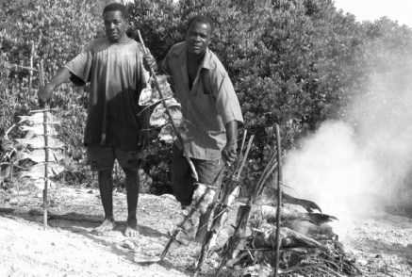
Fish smoking, Mafia Island,Tanzania
TRADING NATURE:Wildlife trade and the Millennium Development Goals 11

Some of these contributions can be direct (cash, jobs, more food, more equitable trading arrangements, etc) and well-managed wildlife trade can help enhance livelihood security over the longer term, thus reducing the vulnerability of poor people to external shocks and indirectly supporting all the goals.
How management of wildlife trade can enhance its contri-bution to the MDGs
Before moving on to consider wildlife trade contributions in detail, recognizing the difference that management of wildlife trade can make to its ecological and socio-economic impacts, this section concludes with a brief overview of the ways in which wildlife trade is managed at different levels, from global to local. These different approaches are considered in more detail within the individual case studies.
Wildlife trade is managed through a variety of measures—regulatory and voluntary, formal and informal, direct and indirect—and at a variety of levels from global to local. For some species or taxa, regional or bilateral agreements exist or species/taxa-specific action plans. Wildlife trade regulation has been reviewed in detail elsewhere (see Roe et al., 2002; Oldfield, 2003; Burgener, 2007) and such review is not repeated here. However, the main international and national regulatory measures are briefly reviewed below along with mention of local approaches based on customary law and traditional institutions and an introduction to the voluntary approaches that are becoming a significant complement to regulation.
International trade controls
The best known instrument for managing international trade in wildlife is CITES which came into effect in 1975 and which has over 170 member countries (Parties). By acceding to CITES, Parties agree to controls (both export and import) on international trade in species that are listed in one of the Convention’s three Appendices:
Appendix I includes species that are considered by the Parties to be threatened with extinction. International trade is generally prohibited although exceptions can be made (e.g. for sport-hunted trophies) as long as the export is deemed not detrimental to the wild population and the import is not for commercial purposes.
Appendix II includes species that are not necessarily threatened with extinction but that might become so unless trade is closely controlled. It also includes species that are not of conservation concern, but which resemble other CITES-listed species so closely that their trade needs to be regulated in order to assist trade control measures for the more threatened species.
Appendix III includes species for which a Party considers the co-operation of other countries to be necessary to prevent unsustainable or illegal trade in native species.
12 TRADING NATURE:Wildlife trade and the Millennium Development Goals


CITES Appendix I currently lists over 800 animal and plant species while Appendix II contains over 4000 animal species and around 25 000 plant species.
Parties to CITES meet approximately every three years to consider amendments to the CITES Appendices and discuss implementation of the Convention. Areas of concern are often addressed through adoption of “Resolutions” and “Decisions”, which highlight key issues and make recommen-dations directed to the Parties, CITES Committees, non-governmental organizations and others. These resolutions are “soft law”—unlike the text of the Convention, they are not binding on the Parties—but their implementation is strongly encouraged. In cases where there is significant concern regarding CITES implementation, the Standing Committee can recommend, and has recommended, that Parties suspend imports from and/or exports of CITES-listed species to a given Party or Parties.
Although CITES decisions are made on the basis of conservation concerns, increasing attention has been paid recently to the impacts some CITES decisions may have on local people’s livelihoods and a commitment has been made to identify whether these conservation-motivated decisions will have unintended negative implications for poor people (Box 1).
In addition, the new CITES Strategic Vision 2008–2013, adopted at the 14th meeting of the Conference of the Parties to CITES (CoP14), outlines the Convention’s direction into the millennium and was drafted to take account of issues, such as contributing to the MDGs, that are relevant to CITES. Objective 3.4 of the Strategic Goals of the Vision calls for the contribution of CITES to the relevant MDGs and sustainable development goals set at the World Summit on Sustainable Development to be strengthened by ensuring that international trade in wild fauna and flora is conducted at sustainable levels.
Box 1
CITES and livelihoods
CITES has governance implications for wildlife producing, processing and consuming countries. Proposals
to list species in the CITES Appendices or to move species between Appendices can be submitted by any
Party, whether or not that Party is a range State for the species concerned. The acceptance of CITES
listing proposals can have significant financial implications for range States (Martin,2000). Listing decisions
can also have significant implications for the livelihoods of local people who may have been dependent on
harvesting or trading certain species for all, or part, of their income. Prompted by an amendment to CITES Resolution Conf 8.3 Recognition of the Benefits of Trade in Wildlife at the 13th meeting of the
Conference of Parties (CoP 13) in 2006, a Decision was adopted at CITES CoP 14 in 2007 that calls for
the development and use of a toolkit to assess the positive and negative impacts of implementing CITES
listing decisions on the livelihoods of the poor and the drafting of voluntary guidelines to address negative
impacts (CITES Decision 14.3).
TRADING NATURE:Wildlife trade and the Millennium Development Goals 13

National wildlife trade regulations
Even prior to the coming into force of CITES in the mid-1970s, a number of countries had already developed measures to regulate trade in wildlife—particularly exports. National (and in the case of the European Union (EU), regional) level trade controls for native and exotic species have continued to evolve in parallel with CITES for a variety of reasons. These include: conservation (e.g. of threatened species under the US Endangered Species Act), animal welfare (e.g. within the EU there are import bans on the skins of young Harp Seals Phoca groenlandica and Hooded Seals Cystophora cristata and on species trapped in ways that do not meet “international humane trapping standards”; human health concerns (e.g. the recent EU ban on wild bird imports was motivated by concerns over the spread of avian influenza); and concerns regarding the introduction of invasive species. In consideration of the relationship between conservation and income, in 2001, the Government of Namibia announced a ban on the export of native live animals. In implementing the ban, they cited the importance of wildlife to the country in terms of tourism, hunting and other forms of use and the need to make sure Namibia remained “competitive in this regard” by ensuring that it was a unique destination for seeing certain species (Anon., 2001).
In some cases wildlife trade is regulated indirectly through resource access or harvest controls (although sometimes these are implemented in combination with direct trade controls). The goals of such controls are often two-fold: first, to ensure that harvests are conducted in a manner consistent with government resource management and/or conservation objectives; and second to achieve financial objectives, e.g. revenue generation through fees or taxes. Such controls can take a number of forms—e.g. full harvest bans, permits determining quotas, timing, size of specimens etc.—and are likely to be in place for all but the commonest of species.
Local norms and institutions
Local norms and institutions have long regulated the use of wildlife at the individual, household and community level. Numerous examples exist of customary practices that influence the timing and rate of harvesting, or that prohibit the use of certain species or harvesting in certain areas (see, for example, Jaireth and Smyth, 2003). Many of these are aimed at resource management in general but a few are specifically intended to regulate the use of wildlife in trade (Box 2). In Madagascar, for example, crayfish harvesting is widespread in the Ranomafana area for subsistence use and small-scale trade. In some villages, however, strong traditional fady (taboos) prevent commercial harvesting but still allow subsistence use (Jones et al., 2006).
14 TRADING NATURE:Wildlife trade and the Millennium Development Goals


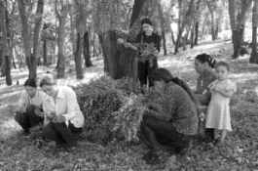
Box 2
Local action to regulate commercial fishing in the Brazilian Amazon
During the 1960s the Brazilian Government instituted a number of development projects to integrate the Amazon region into the modern Brazilian economy. One of these was the establishment of the Manaus Free Trade Zone—a commercial centre in the heart of the Amazon basin. The resulting population growth placed increasing pressure on local fisheries with commercial vessels venturing further and further from Manaus in pursuit of new fishing grounds. Silves, on the banks of Canaçari lake, was one such location, where commercial fishermen from Manaus were locally regarded as poachers.
After witnessing dramatic declines in their own fishing yields,in the early 1980s residents of Silves blocked the entrance to the lake. The commercial fishermen called in the military police but this hostile response only further stimulated the collective efforts to protect the fisheries. As a result of community pressure, the Municipality of Silves institutionalized community regulations, establishing a management system comprising protected areas; commercial areas, where sustainable harvesting is practised; and subsistence areas for local use only. “By prioritising local meaning and perceived needs, the cabolco fishermen of Silves had developed a system of sustainable resource use in which those who created the regulations were the ones who would be subjected to them. The impetus for participation and commitment was based in the high stakes involved. For most the issue was that of livelihood.”
Source: Chernela (2003).
Voluntary measures
In addition to the regulatory measures |  | Credit: Michel Gunther/WWF-Canon
described above, a growing number of |  | Credit: Michel Gunther/WWF-Canon
standards, certification schemes and |  | Credit: Michel Gunther/WWF-Canon
associated labels are being developed |  | Credit: Michel Gunther/WWF-Canon
for various wildlife products— |  | Credit: Michel Gunther/WWF-Canon
including timber, fish, medicinal |  | Credit: Michel Gunther/WWF-Canon
plants (see Box 3) and skins—to |  | Credit: Michel Gunther/WWF-Canon
promote the sustainable management |  | Credit: Michel Gunther/WWF-Canon
of wildlife resources (including their |  | Credit: Michel Gunther/WWF-Canon
trade). Examples of these initiatives |  | Credit: Michel Gunther/WWF-Canon
are provided throughout this report |  | Credit: Michel Gunther/WWF-Canon
and their potential for generating |  | Credit: Michel Gunther/WWF-Canon
and their potential for generating | Local women sorting leaves for myrtle distillation in | Credit: Michel Gunther/WWF-Canon
conservation and livelihood benefits is | Local women sorting leaves for myrtle distillation in | Credit: Michel Gunther/WWF-Canon
conservation and livelihood benefits is | Tunisia. Certification of the myrtle products is designed | Credit: Michel Gunther/WWF-Canon
discussed in the next section. | to help build self-sustaining small community enterprises | Credit: Michel Gunther/WWF-Canon
based on forest products.
TRADING NATURE:Wildlife trade and the Millennium Development Goals 15


Box 3
International Standard for Sustainable Wild Collection of Medicinal Plants
More than 400 000 t of medicinal and aromatic plants are traded annually, with around 80% of the species
harvested from the wild. Almost 70 000 species are involved, many of them are in danger of over-
exploitation and even extinction through over-collection and habitat loss. For example, in India, almost
300 medicinal plants are considered threatened by IUCN.
The International Standard for Sustainable Wild Collection of Medicinal and Aromatic Plants (ISSC-MAP)
was drawn up following extensive consultation with plant experts and the herbal products industry
worldwide. It promotes appropriate management of wild plant populations to ensure plants used in
medicine and cosmetics are not over-exploited. The Standard is based on six principles: maintaining wild
MAP resources,preventing negative environmental impacts,legal compliance,respecting customary rights,
applying responsible management practices, and applying responsible business practices.
Organizations and experts involved in the ISSC-MAP consultation included: the German Federal Agency
for Nature Conservation (BfN), the IUCN/SSC Medicinal Plant Specialist Group (MPSG),WWF Germany,
and TRAFFIC, as well as industry associations, companies, certifiers and community-based NGOs.
ANALYSIS—CONTRIBUTIONS OF WILDLIFE TRADE TO THE MDGS
This section draws on the findings of the case studies presented at the end of this report and on a wider review of the available literature on traded wildlife products.
Wildlife trade and poverty reduction (MDG 1)
The most obvious contribution of wildlife trade to the MDGs is to the poverty reduction target of Goal 1: wildlife trade can generate significant returns both to poor countries and to poor people. An analysis of wildlife trade routes shows a general direction of flow from developing to developed countries (Roe et al., 2002). Unfortunately, wildlife exports (other than the commercially valuable timber and marine fisheries industries) are rarely factored into estimates of Gross Domestic Product (GDP) contributions to the national economy (Nasi and Cunningham, 2001). Nevertheless, sustainable wildlife trade can make a significant, if under-recognized, contribution to the economies of cash-poor but biodiverse countries, as shown by the following examples:
• Uganda’s lake fisheries produce fish worth over USD200 million a year, employ 135 000 fishers and 700 000 small-scale operators in processing, trade and associated industries, generate USD87.5 million in export earnings and contribute 2.2% to GDP (The Republic of Uganda, 2004, cited in WorldFish Center, 2005).
16 TRADING NATURE:Wildlife trade and the Millennium Development Goals


• In Brazil’s Amazonas municipality, collection of the Cardinal Tetra Paracheirodon axelrodi for the aquarium fish trade is responsible for 80% of the income to the municipality (van Andel et al., 2003).
• In Guyana, wild animals are by far the most important commercial NTFP, with exports worth up USD2 million per year in the late 1990s (van Andel et al., 2003).
Table 5 identifies the major importers and exporters for key wildlife commodities.
Table 5
Major trade flows for key wildlife commodities
Commodity | Major importers | Major exporters
Primates | USA, France, Japan, Canada, UK | Mauritius, China, France, USA, Viet Nam
Cage birds | France, UK, Belgium, Japan, USA | Belgium, Netherlands, France, Singapore, China
Birds of prey | Malaysia, Japan, UK, Korea, Qatar | Germany, Mongolia, UK, Denmark, Canada
Reptiles | USA, Hong Kong, Japan, Singapore, Germany | USA, Thailand, China, Singapore, Slovenia
Ornamental fish | USA, UK, Japan, Germany, France | Singapore, Malaysia, Spain, Japan, Czech Rep.
Mammal furs/fur products | Hong Kong, USA, China, Italy, Japan | China, Hong Kong, Denmark, Finland, Italy
Reptile skins | Italy, France, Singapore, Japan, Germany | Singapore, USA, France, Italy, Colombia
Ornamental corals & shells | USA, France, China, Hong Kong, Japan | Belgium, USA, Japan, UK, Viet Nam
Natural pearls | USA, Australia, UK, Italy, Switzerland | USA, Switzerland, UK, Australia, India
Game meat | Germany, France, Belgium, Switzerland, Netherlands | New Zealand, France, Belgium, Poland, Germany
Frogs legs | France, USA, Belgium, Italy, Canada | Belgium, Viet Nam, Turkey, Italy
Edible snails | China, France, Spain, Italy, Hong Kong | China, Morocco, Tunisia, Romania, Poland
Ornamental plants | Germany, USA, UK, France, Netherlands | Netherlands, Colombia, Italy, Belgium, Denmark
Source: Analysis by TRAFFIC based on UN Statistics Division COMTRADE database.
Recognizing the potential of trade in wildlife products for developing countries, the United Nations Conference on Trade and Development (UNCTAD) established a “BioTrade Initiative” in 1996 to further stimulate trade and investment in the sustainable use of biological resources (Box 4). The BioTrade Initiative currently has national programmes in Bolivia, Brazil, Colombia, Costa Rica, Ecuador, Peru, Uganda, Venezuela and Viet Nam as well as regional programmes in the Amazon and Andes. The objective of the initiative is to enhance the capability of developing countries to produce value-added products and services derived from biodiversity, for both domestic and international markets.
Within poor countries, huge numbers of people have some involvement in wildlife trade. The fisheries case study, for example, points out that in Asia alone, millions of people are involved in a wide range
TRADING NATURE:Wildlife trade and the Millennium Development Goals 17


of fishery-related activities. Estimates of the number of people dependent on wild resources for at least part of their income range from 200 million worldwide to one billion just in Asia and the Pacific (van Rijsoort, 2000).
Box 4
The UNCTAD BioTrade Initiative
The BioTrade Initiative assists developing countries in the formulation and implementation of National BioTrade Programmes. It focuses on countries which are rich in biodiversity and whose governments have a clear interest in developing a national capacity to promote biotrade—currently participating countries are Bolivia, Brazil, Colombia, Costa Rica, Ecuador, Peru, Uganda,Venezuela and Viet Nam.
BioTrade activities are generally oriented towards the production, transformation and commercialization of products derived from the sustainable use of biological resources, or the provision of services derived from such resources. BioTrade products may include those coming from wild collection or from cultivation practices. The latter refers to products derived from cultivation of native species (domesticated and wild varieties) through activities such as agriculture or aquaculture. In this case, cultivation is considered as a strategy to assure the conservation of endangered species and their ecosystems. Products derived from wild collection include products such as fauna (e.g. ornamental fish), fauna derivates (e.g. crocodile leather or meat) and flora (e.g. medicinal plants).
Since 2003 the BioTrade Initiative has also hosted the BioTrade Facilitation Programme (BTFP) which focuses on enhancing sustainable bio-resources management, product development, value adding processing and marketing. The Biotrade Initiative is also aiming to develop ecolabelling for wildlife products in the form of a BioTrade standard. This programme is aimed at promoting trade in wildlife products that will help to alleviate poverty,contribute to sustainable development and help countries fulfil their obligations under the CBD.
• In north-east Brazil, approximately 25 000 mainly local and indigenous people were involved in commercial collection of the leaves of Pilocarpus spp. in the late 1990s for the production of a single medicinal compound, pilocarpine (Pinheiro, 1997, cited in ten Kate and Laird, 1999).
• In Nepal, 470 000 Nepalese households were engaged in commercial collection of medicinal plants in the late 1990s (Olsen, 1999).
• In Cameroon, it was estimated in 1990 that one third of the people from the Oku Mountain region supplement their income by collecting bark from African Cherry Prunus africana for export to the pharmaceutical industry (Falconer, 1990).
• In peri-urban areas of Sub-Saharan Africa, tens of thousands of poor farmers and small traders supplement their incomes by selling fuelwood. Sometimes this activity even becomes their main
18 TRADING NATURE:Wildlife trade and the Millennium Development Goals


source of cash. Notably, this includes also the poorest of the poor; for instance, many rural landless people are among those specializing in fuelwood production (Vedeld et al., 2004).

The case studies reinforce this finding that, despite their lack of recognition in national-level accounting, for some individuals, households or communities, wild resources can be a significant source of cash income, particularly in marginal agricultural areas or where there are few other livelihood opportunities:

"Wildlife can bring two types of economic benefit to developing peoples or countries. First, wildlife may be used directly as food, fodder, fuel or fibre. Second, that same wildlife may be sold,providing communities or countries with much-needed income. In some cases this income is a prominent item

• | The wild meat case study reveals estimates of | in national budgets; even where it is
• | The wild meat case study reveals estimates of | negligible in GNP terms it is generally
• | contributions of up to 34% of household income | negligible in GNP terms it is generally
• | contributions of up to 34% of household income | important and sometimes vital for the
• | in East and Southern Africa (Barnett, 2000). A | important and sometimes vital for the
• | in East and Southern Africa (Barnett, 2000). A | communities most closely concerned with
• | recent study found that an average hunter in | communities most closely concerned with
• | recent study found that an average hunter in | the trade."
• | Gile game reserve in Mozambique could earn | the trade."
• | Gile game reserve in Mozambique could earn | Prescott-Allen and Prescott-Allen (1982).
• | around USD29 over four months from sales of | Prescott-Allen and Prescott-Allen (1982).
wild meat compared to an average annual
income from crop sales of USD49 (Fusari and Carpaneto, 2006). Similar findings have been noted from Central Africa (de Merode et al., 2004).
• The marine ornamental trade provides income for poor people in coastal communities where few other livelihood options exist and where there is dwindling production from capture fisheries.
• In the Philippines, most people who target seahorses are subsistence fishers who derive their main cash income from these species, allowing them to buy rice and other food (Vincent, 1997). In Palawan and the central Philippines, seahorse fishers and traders reported that seahorses contributed approximately 30–40% to their annual income—although sometimes reaching 80%—and up to 90- 100% in the main seahorse fishing season.
• While the caiman skin trade generates a low income for ranchers compared to cattle, income earned through, for example, the collection of eggs or neonates, can be significant for the poor and landless with few other income-generating opportunities (Thorbjarnarson, 1999).
The amount and relative significance of income from wildlife to rural households varies hugely and in part depends on the degree to which households are incorporated into a cash economy (Belcher et al., 2007). For primarily subsistence households the total amount of income generated by selling wild resources is generally very low—but it may be the main, or only, source of cash. In Colombia, for example, nearly 200 pescadores fish for ornamental species along the Iniridia, Orinoco and Atabapo rivers. The fishery is especially important since there exist few alternative sources of income (van Andel et al., 2003). In less remote areas, wildlife harvesting or cultivation may help diversify
TRADING NATURE:Wildlife trade and the Millennium Development Goals 19


livelihoods that are predominantly based on agriculture and may provide important supplementary income, especially at difficult times of the year. Some households, with good links to potential markets and with access to potentially high value products, may derive the major part of their household income from wildlife trade (Box 5). The World Bank estimates that overall forest products provide roughly 20% of poor rural families’ “income”—of which half is cash and half is in the form of subsistence goods (Vedeld et al., 2004).
Box 5
The scale and significance of income from wildlife products
Cambodia Resin collection, primarily for export to Viet Nam for use in the boat building industry, can earn families KHR150 000–200 000 (USD38–50) per month (Global Witness, 2001).
Cameroon Harvesters of edible palm weevil larvae average a monthly income of USD71, compared to USD28 for cocoa producers (Burgener, 2007).
China One kilogramme of matsutake mushrooms can earn a harvester more money than the average annual wage in Yunnan Province (FAO, 1999).
In the Arabuko-Sokoke Forest, hunters can earn USD275 per year by selling meat compared to Kenya
an average per capita income in this area of USD38 (Bennett and Robinson, 2000).
Kenya Woodcarvers can earn at least USD1125 per month selling through a co-operative (Choge,2004). Peru The capture of a single mouth-brooding male Silver Arowana Fish Osteoglossum bicirrhosum in Isla Verde or San Juan represents cash earnings of USD12–230 compared to an average daily wage of USD2–3 (Moreau and Coomes, 2006).
South Africa Medicinal plant sellers earn a mean annual income of USD2680 (Botha et al., 2004 in World Resources Institute, 2005).
Southern At least 9000 rural people in Botswana, Namibia and to a lesser extent South Africa rely on Africa harvesting Devil’s Claw Harpagophytum spp., often as their only source of income (Wynberg, 2004).
Furthermore, the case studies demonstrate that many of the beneficiaries of wildlife trade are amongst the poorest of the poor—the targets of MDG 1:
• Coastal, and in particular reef, fisheries are of great importance to poor communities as they can be exploited by people of all ages and abilities with little or no capital investment required (Gonzales et al., 2006; Whittingham et al., 2003).
• In Bolivia, it is estimated that over 60% of the income from the trade in Yacare Caiman Caiman yacare leather benefited indigenous populations compared to just under 40% for private ranch owners (Aparicio and Rios, 2006).
• In the district of San Cristobal, Peru, community members involved in the trade in Vicuña Vicugna vicugna wool can collectively earn about USD50 000 a year (Roe et al., 2002). This kind of money
20 TRADING NATURE:Wildlife trade and the Millennium Development Goals


is highly significant when it is considered that the range of the Vicuña coincides with the home of some of the poorest people in South America, who inhabit a region with harsh climatic conditions that reduce options for agriculture and limit economic activities.
The case studies also demonstrate contributions of sustainable wildlife trade to the additional target in MDG 1 in terms of providing employment for different sectors of society, e.g. women. The marine ornamental industry, for example, involves a range of different groups including the collectors who use boats or swim, women who glean on shallow reefs, packers, cleaners and others who work in the processing and exporting companies, many of whom get most of their yearly income from the business. Similarly the wild meat case study notes that a wide spread of opportunities with men as hunters and middlemen and women as traders/sellers. Furthermore, Brown and Williams (2003) note that in “West and Central Africa, hunting is traditionally undertaken by young men at an early stage of the family cycle, to accumulate capital which is later invested in setting up enterprises with a longer time horizon, such as export crop production and petty trade. It thus provides a stepping stone to greater prosperity for a social category that might otherwise be problematic for society.”
Wildlife trade and food security (MDG 1)
Sustainable wildlife trade can help enhance food security both directly—providing consumers with a valuable, affordable source of protein—and indirectly—by increasing the amount of cash in the household that is available to spend on food. The wild meat case study highlights the role that the trade plays in the livelihoods of many people in Eastern and Southern Africa. Beyond its importance in the day-to-day economies of rural people, wild meat also acts as a safety net during times of famine, civil strife or other forms of disruption to which the rural poor are particularly vulnerable. Wild meat is also important where domestic meat is prohibitively expensive or largely unavailable.

The fisheries products described in the case study for this report are all high-value products and generally not components of poor people’s diets. Nevertheless, their trade can have an impact on food security. In the Philippines, for example, most people who target seahorses are subsistence fishers who derive their main cash income from these species, allowing them to buy rice and other food (Vincent, 1997).
The importance of fisheries for food security highlights the importance of a well-managed trade, however. The components of the fish trade considered in this report—ornamentals, live food, and seahorses—are all in decline, driving local fishermen to employ unsustainable practices such as using cyanide or harvesting juveniles or pregnant adults (and hence depleting breeding stocks) or taking a risk of investing in

"Our paddy was flooded last year so we came to fish, collect mushrooms and wildlife to sell to buy rice."
Villager from Xe Pain, Lao PDR, quoted in Singh et al., 2006a.
"Usually if we need money then we fish and sell the fish to buy
food, | clothes |  | and | things."
Villager |  | from | Koh | Seng,
Cambodia, quoted in Singh et al., 2006b.

TRADING NATURE:Wildlife trade and the Millennium Development Goals 21



expensive equipment (motorized boats, diving equipment, etc.) in order to maintain their catch sizes and hence their incomes. This income commonly comes at a substantial cost to the natural reef resources on which local communities rely for food, coastal protection and other ecological services. Conversely, if well managed, the trade in high value species such as seahorses, Humphead Wrasse Cheilinus undulatus and certain ornamental fish, can not only promote their own conservation but can also result in a reduction of unsustainable or destructive practices more generally, and therefore have beneficial knock-on effects on the conservation status of a broader range of species that are important as local food sources.

"The fish that I catch everyday to feed my children is a product of long hours of hard work to make both ends meet. My youngest child is sickly and very small. I know he should have good food, but it is a struggle when circumstances are not favourable to make a living. The reefs are blasted and the fish I catch is lesser and are smaller. Every year, I see more and more fishers. I even have to travel longer and further to be able to bring home food." Lucio, father of four children, fisherman, Palawan, Philippines, cited in Castro et al., undated.

Wildlife trade and access to education (MDG 2)
Clearly wildlife trade cannot make a direct contribution to MDG 2 “Achieve universal primary education”. Nevertheless, income from wildlife trade can provide a critical source of additional income which can make the difference between sending children to school or not (Roe et al., 2002; Marshall et al., 2006).
Wildlife trade and gender equality (MDG 3)
The MDG target on gender equality relates directly to equality within education. Wildlife trade is clearly not relevant here. However as the discussion above on employment opportunities highlights, wildlife trade provides significant opportunities for the involvement and empowerment of women. Women involved in the NTFP trade in Bolivia and Mexico experienced an elevated status within their households and communities as a result of having an independent source of income (Marshall et al., 2006). Overall, FAO (2001) notes: “Traded products contribute to the fulfilment of daily needs and provide employment as well as income, particularly for rural people and especially for women”.
Wildlife trade and health (MDGs 4, 5 and 6)
Although not directly addressed by the case studies in this report, sustainable wildlife trade can make a major contribution to primary healthcare. An enhanced protein supply—as documented above and noted in the wild meat case study—is in itself, hugely beneficial for human health, but beyond that the trade in wildlife-based medicines (of plant and animal origin) is a major component of wildlife trade and benefits millions of poor people. The World Health Organization (WHO) (2003) estimates, for example, that up to 80% of the African population uses traditional medicine for primary health care.
22 TRADING NATURE:Wildlife trade and the Millennium Development Goals


Those that are not able to collect or harvest medicinal plants and animal products themselves are reliant on the trade for access to these products. This is particularly important in areas where more “modern”packaged medicines are relatively costly, there is difficult access modern healthcare facilities or there are high ratios of traditional medicine practitioners to patients. The trade in medicinal plants also underpins healthcare systems in much of Asia. The fisheries case study highlights the importance of seahorses in traditional Chinese medicines.
Unregulated wildlife trade can, however, have unexpected negative implications for human health. Chivian (2003) notes that Chimpanzees Pan troglodytes are believed to be the original source of the HIV-1 epidemic, caused by the transmission of Chimpanzee simian immunodeficiency virus (SIVcpz) to humans through the consumption of Chimpanzee meat. The continued trade in wild meat may not only result in exposure to other strains of SIV but, where it threatens primates with extinction, “may also prevent full understanding of the dynamics of HIV/AIDS infections, and success in discovering an effective treatment” (Chivian, 2003).
Wildlife trade and environmental sustainability (MDG 7)

There is growing recognition that sustainable, long-term, poverty reduction is dependent on a secure natural resource base. The MA highlights the linkages between that natural resource base and human well-being: biodiversity underpins the delivery of a range of ecosystem services upon which all of humanity depends. Well-managed wildlife trade based on sustainable off-take levels can provide incentives for conser-vation and hence secure the natural resource base on which many poor people’s livelihoods depend. Allowing a controlled, sustainable trade in skins and wool from some previously threatened species in Latin America—including caimans and Vicuña—is considered important in securing the conservation status of these species.
The case studies highlight that, to date, however, much trade in wildlife has not been well managed and as a result, ecological

"Given the impact of trade on consumption patterns it is not surprising that while trades in natural resources is incredibly important for local livelihoods,
unregulated | trade | is | also
regarded by villagers as an issue of concern. For instance, villagers often attribute declines in fish catches to increased
trading | in | fish, | sometimes
specifically identifying large-scale trade to foreign countries as the key concern." Singh et al., 2006a.

degradation has occurred. Trade in wild meat in East and Southern Africa is largely illegal. As a result, although the trade continues in a clandestine way, there is little incentive for the rural poor to engage in sustainable management of wildlife resources and significant population depletions have occurred. Similarly, the fisheries case study highlights how unsustainable practices, such as the use of cyanide to stun fish and facilitate their capture, are considered to be a major threat to reefs across the Indo-Pacific and especially in South-east Asia.
TRADING NATURE:Wildlife trade and the Millennium Development Goals 23



The MA warns, however, that such degradation of ecosystem services poses a significant barrier to the achievement of the MDGs (Millennium Ecosystem Assessment, 2005a). The MA identified five direct drivers of biodiversity loss—habitat change, over-exploitation, invasive species, pollution and climate change—reflecting external pressures such as demographic change, socio-political, cultural or economic factors and so on. Unsustainable wildlife trade can both contribute to the direct drivers (particularly habitat loss and over-exploitation), and be affected by the indirect drivers (in particular cultural factors, demographics and economic changes).

"Wildlife trade has resulted in the introduction of many invasive species; examples include the introduction into Europe of American Mink
Mustela | vison, | Red-eared
Terrapins Trachemys scripta and numerous plant species." TRAFFIC, 2008.

Unless it is sustainable and well managed, wildlife trade can cause direct harm through over-exploitation of targeted species, to the point where the survival of a species hangs in the balance—the hunting of Tigers Panthera tigris and rhinoceroses for traditional medicines and artefacts are well-known examples. Currently, nearly 30% of Globally Threatened Birds (GTBs) are threatened by over-exploitation, mainly through hunting for food | 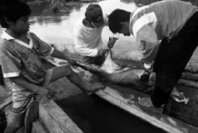  Credit: André Bärtschi/WWF-Canon

and trapping for the cage-bird trade. For some species that are especially highly sought after, over-exploitation is causing huge declines in

Skinning a Collared Peccary Pecari tajacu in the Alto Purus Reserved Zone, Ucayali, Peru.

both numbers and range, and is known to be the most significant threat to them (BirdLife International, 2004). The MA highlights that, overall, up to 30% of mammal, bird and amphibian species are threatened with extinction (Millennium Ecosystem Assessment, 2005a). Additional detail provided by IUCN shows that one in four mammals, one in eight birds, and one third of all amphibians are threatened, as are over 8000 species of plants, fungi and algae. Over-exploitation is identified as one of the main threats to wild species on the Red List, affecting approximately one third of threatened mammal and bird species and also having a heavy impact marine species (IUCN, 2007a).

Unsustainable wildlife trade can also cause problems elsewhere, as over-exploitation of one species disrupts ecosystem structure and functions and, potentially, the delivery of essential ecosystem services. Over-fishing, for example, not only affects individual species but causes repercussions in the whole marine system. Invasive species—another key driver identified by the MA—can also be associated with wildlife trade. It is therefore essential that wildlife trade is sustainable

"Direct effects of hunting on one species will likely have indirect effects on other species within that ecosystem and
ultimately | change | the
ecosystem itself." Brown et al., 2006.

24 TRADING NATURE:Wildlife trade and the Millennium Development Goals


and well managed. Unsustainable wildlife trade threatens to undermine the achievement of Goal 7, and, hence, hinder progress towards other goals, as well as undermining the whole system by which developing countries attempt to find the delicate balance between meeting both conservation and development goals.
Wildlife trade and global partnerships for development (MDG 8)
As they relate to a global industry, management systems for wildlife trade are well placed to contribute to the development of “an open, rule-based, predictable, non-discriminatory trading and financial system” (Target 12). In fact some would argue that CITES is already playing this role. Certainly with its increasing focus on livelihoods as well as conservation concerns, CITES is moving in the direction of addressing development as well as conservation concerns. The commitment to good governance that is central to Goal 8—and indeed critical to achieving all the MDGs—is also central to sustainable management of wildlife trade. The problems—and opportunities foregone—that are associated with poor governance are well recognized in the most valuable segments of wildlife trade—marine fisheries and timber. Illegal logging, for example, and the related trade
in illegally harvested timber, is estimated to cost developing | In | economic | terms, | rural
countries USD12.3–18.4 billion annually (ICTSD, 2004) while | communities, |  | traders | and

the average annual value of “illegal, unreported and unregulated” (IUU) fishing could be nearly USD1 billion in sub-Saharan Africa alone (MRAG, 2005). Of particular signif-icance to Goal 8 is the potential significance of wildlife trade to the Least Developed Countries (Table 6). Although the absolute values are not that great, they can represent a significant share of overall exports.
Table 6

government have lost massive potential revenues to wasteful harvesting and processing, non-collection of royalties and
under-valuation | of | forest
products. Milledge et al., 2007.

The significance of wildlife trade to the Least Developed Countries (LDCs)
LDC | Wildlife product | Value (USD millions) | Year reported

Afghanistan | Hides, skins and fur skins | 21 | 1977
Eritrea | Coral, seashell etc. | 0.7 | 2003
Ethiopia | Hides and skins | 0.1 | 2003
Haiti | Essential oils | 3.2 | 1995
Maldives | Live fish | 1.3 | 2005
Mali | Live reptiles | 0.3 | 2004
Niger | Live mammals | 0.7 | 2005
Somalia | Live animals | 5 | 1982
Sudan | Gum arabic | 102 | 2005
Tanzania | Ornamental fish | 0.2 | 2005
Vanuatu | Live animals | 0.1 | 2000
Yemen | Live fish | 0.1 | 2004

Source: Analysis by TRAFFIC based on UN Statistics Division COMTRADE database
TRADING NATURE:Wildlife trade and the Millennium Development Goals 25


Losses are not just felt at the national level, however, but also at the village, household and individual level. A recent study of the timber trade in Tanzania, for example, noted that contemporary timber trade dynamics were: 1) undermining the National Strategy for Growth and Reduction of Poverty; 2) represented an opportunity cost of up to a four-fold budget increase at District Council level; and 3) meant that local harvesters were receiving barely one per cent of the export price (Milledge et al., 2007). National governments and international development assistance agencies have developed a number of programmes to address these issues, but to date these initiatives have not been extended to the trade in other resources.
Summary of the key contributions of wildlife trade to the MDGs
Table 7 summarizes the key contributions of wildlife trade to each of the MDGs.
Table 7
Contributions of wildlife trade to the MDGs

Millennium Development Goals
Goal 1: Eradicate extreme poverty and hunger
Goal 2: Achieve universal primary education
Goal 3: Promote gender equality and empower women
Goal 4: Reduce child mortality
Goal 5: Improve maternal health
Goal 6: Combat HIV/AIDS, malaria and other diseases
Goal 7: Ensure environmental sustainability
Goal 8: Develop a global partnership for development

Contributions from wildlife trade
Income from wildlife trade can be significant for some. For others, even though the actual amounts may be small it may represent the only source of cash. Income can be earned directly—as harvesters or traders—or indirectly through employment throughout the trade chain. Sustainable wildlife trade can also contribute to food security—either directly by providing access to wild food products or indirectly by increasing the amount of income available to spend on food.
Indirect contribution, but income from wildlife trade can help contribute to school fees.
Some components of the wildlife trade, e.g. NTFP collection, have a partic-ularly high level of involvement from women.
Sustainable wildlife trade can contribute to health improvements through improved nutrition, improved access to traditional medicines, supplying raw materials for manufacture of pharmaceutical products, as a source of fuelwood for heat and cooking, and increased incomes for healthcare.
Well-managed wildlife trade can enhance the sustainability of the natural resource base, both the species in trade and their surrounding ecosystems—but much wildlife trade is currently unsustainable and undermines the natural resource base on which many poor people’s livelihoods depends.
Wildlife trade can encourage partnerships between trading nations, such as through CITES, and between responsible businesses and local communities. However, poor governance regimes are limiting the potential of the trade and greater assistance is required from the international community in addressing this.

26 TRADING NATURE:Wildlife trade and the Millennium Development Goals

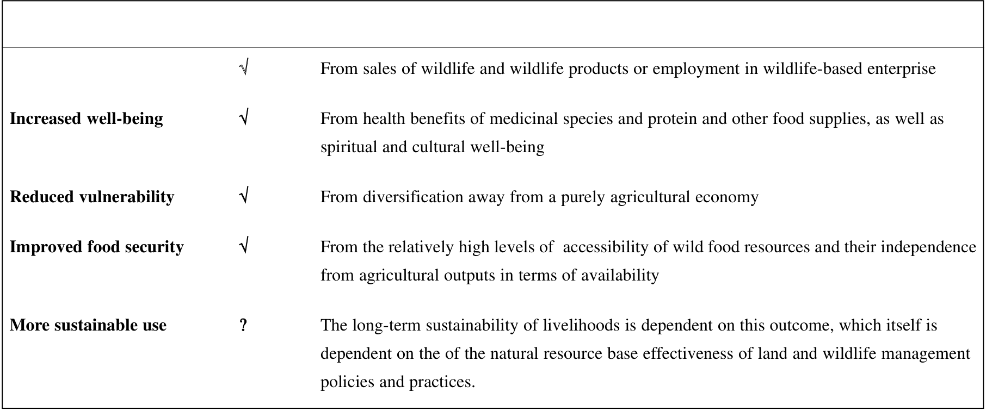
DISCUSSION: CHALLENGES TO WILDLIFE TRADE AS A DEVELOPMENT TOOL
The preceding analysis highlights the role that sustainable wildlife trade can play in supporting local people’s livelihoods and contributing to the achievement of many of the MDGs (Figure 2). Nevertheless, unsustainable resource harvest and trade is undermining the environmental sustainability that is called for in MDG 7 and that underpins the delivery of the other MDGs.
Figure 2
Wild resources contributing to sustainable livelihood outcomes
Livelihood outcomes*
More income | √ | From sales of wildlife and wildlife products or employment in wildlife-based enterprise
Increased well-being | √ | From health benefits of medicinal species and protein and other food supplies, as well as
spiritual and cultural well-being
Reduced vulnerability | √ | From diversification away from a purely agricultural economy
Improved food security | √ | From the relatively high levels of accessibility of wild food resources and their independence
from agricultural outputs in terms of availability
More sustainable use | ? | The long-term sustainability of livelihoods is dependent on this outcome, which itself is
dependent on the of the natural resource base effectiveness of land and wildlife management policies and practices.
Note: * From the DFID Sustainable Livelihoods Framework (DFID, 1999).
This points to the need for improved natural resource governance and, in particular, better management of wildlife trade—although management alone is insufficient to enhance the contribution of wildlife trade to the MDGs. In the case of wild meat, for example, the trade is largely illegal, clandestine and hence unmanaged and yet continues to be an important source of income and a significant contributor to food security. In other cases, the trade may be managed but the benefits may by-pass those who are the most dependent on the traded resource. When products become more valuable, for example, more powerful individuals or groups (including wholesalers and urban traders) can move in and often bypass local gatherers or usurp traditional rights of use and access (Arnold, 1995). The MA notes, for example: “The increase in international trade in biological products has improved the well-being for
many social groups and individuals, especially in countries with well-developed markets and trade
rules and among people in developing countries who have access to biological products. However
many groups have not benefited from trade. Some people who live near and are dependent on
biodiversity-rich areas have experienced a drop in their well being rather than an increase. Examples
include many indigenous groups and local communities who have relied on these products and the
ecosystems services they support for many of the constituents of well being. Weak and inefficient
TRADING NATURE:Wildlife trade and the Millennium Development Goals 27

institutional structures that oversee the equitable distribution of benefits are key reasons for the
inequitable distribution of benefits at the national and local levels”. Millennium Ecosystem
Assessment (2005a:40)
Even when well managed, wildlife trade does not ensure sustainable livelihoods and poverty reduction. In recent years, a considerable amount of research has documented the criteria affecting the success or failure of NTFP commercialization (e.g. Vedeld et al., 2004; Marshall et al., 2006; Belcher and Schrekenberg, 2007) and many of the same problems may be true of other wild resources, as demonstrated by the case studies in this report. These include the fact that:
• only a relatively limited number of species or taxa have commercial value—in particular some rattan and bamboo species, resins, birds’ nests, various fruits and nuts and medicinal plants. More valuable wildlife products, such as timber, are rarely available to local communities for income- generation on any significant scale (Wollenberg and Belcher, 2001).
• many species are widely but thinly distributed and may take considerable effort to harvest or collect implying high costs and low returns.
• many products require sophisticated processing or storage, which can make them economically unviable.
• there is insecure tenure over collection areas, which leads to risk of over-exploitation as a result of inability to manage the resource (to improve quality and/or quantity).
• wildlife products are very diverse, can go in and out of fashion, are frequently “luxury” goods and/or occupy niche markets.
• there are sharp seasonal and other fluctuations in supply owing to the phenology of plants, migration patterns of animals, and/or fluctuating climatic conditions.
Nevertheless, from the case studies and the wider literature, it is possible to identify a number of key constraints that are currently limiting the potential of wildlife trade, and a number of opportunities that might enhance that potential.
Of central importance is security of tenure over land and resource rights (Box 6). For many, wildlife is an open-access resource. This has its advantages in that the potential benefits of trade are accessible to the poor. The fisheries case study, for example, notes that “coastal and particular reef fisheries are of great importance to poor communities as they can be exploited by people of all ages and abilities—the elderly, children and women are able to access a range of food and revenue generating products”. The trade also has low barriers to entry in that little or no capital investment is required (although as noted above, the declining populations of some species is stimulating some to take the risk of investing in capital equipment).
28 TRADING NATURE:Wildlife trade and the Millennium Development Goals


Box 6
Insecurity of resource tenure creates problems for livelihoods in the rattan trade
Rattans are one of the most important NTFPs of continental Equatorial Guinea (Rio Muni) and play a significant role in local livelihood strategies. Men collect rattan as part of their day-to-day activities and village artisans provide products—particularly chairs—for the rest of the village. Some of these products are bartered for traditional medicines and other household items but the majority are sold by the roadside or transported to Bata, the coastal port, for sale or export. There is currently no government intervention in rattan management and, as an open-access resource, it is also not affected by customary law or resource tenure issues. Generally, the village chief is paid a small levy in cash or in kind for access to the forest regardless of whether the harvester is a villager or an outsider.
Owing to insecure resource tenure, the rattan is harvested indiscriminately with no consideration for sustainable management. As a consequence, supplies are dwindling and harvesters are forced to travel further to collect sufficient quantities. At the same time, the demand for rattan products is increasing with the development of an urban-based middle class. Prices are therefore increasing, resulting in increased profits for artisans. In rural areas, however, collectors are deterred by the increasing distances they need to travel and this—on top of resource declines—is affecting the artisans’ supplies. Interventions aimed at improving the availability of the resource base—through better management and potentially also through cultivation—need to be developed if both the rural and urban rattan-based livelihoods are to be sustained.
Source: Sunderland et al., 2004.
Similarly, the wild meat trade does not discriminate against the poor—in fact in many respects it positively favours the poor (Brown et al., 2006):
• Little if any capital investment required;
• A fair proportion of the value of the product is retained by the primary producer (the hunter);• Labour inputs are easily reconciled with the agricultural cycle;
• Wild meat is easily transportable, processed and stored with a high value/weight ratio;• There is a high degree of integration of women.
The disadvantage of open-access resources, however, is the inability to exclude outsiders (Box 7). The wild meat case study highlights how, because of the low barriers to entry, refugees in Tanzania were easily able to penetrate the trade as hunters, middlemen and traders. Likewise, the fisheries case study describes how, in the marine aquarium trade, the majority of collectors in Indonesia and the Philippines are migrants who may travel long distances in search of harvesting opportunities.
TRADING NATURE:Wildlife trade and the Millennium Development Goals 29


Box 7
Outsiders affect the sustainability of the chewing sticks trade in Ghana
In Ghana, the trade in “chewing sticks” contributes significantly to the local, regional and national economy. Chewing sticks are made from the split stems of a number of species of trees from the genus Garcinia and are sold in the markets of Kumasi and Accra as well as being exported to Togo. Despite the importance of the chewing sticks both economically and for dental healthcare, the Forest Services Division has paid little attention to the sustainable management of the species. No information exists as to the current level of stocking, rate of exploitation or regenerative capacity. Local people tend to allow small diameter trees to develop but have no way of preventing outsiders harvesting in their forests. Such outsiders have no incentive to harvest sustainably since they are unlikely to return to the same forest.
Source: Blay, 2004.
There is little doubt that many “outsiders” are also poor people in desperate search of a living. The reality, however is that without secure ownership, or exclusive access rights, there is little incentive for local people to invest in the long term sustainability of the wildlife resource—far better to exploit it while it is there and before others do the same. As the fisheries case study notes, this leads to classic“boom and bust” patterns of development with resources being rapidly depleted in one area and then harvest and trade moving on elsewhere. This not only has implications for trade-related incomes in the areas where stocks are depleted but also for subsistence users.

Captive, or semi-intensive, production has been highlighted as one mechanism for reducing the pressure on wild resources, while maintaining a regular source of supply for the trade. The case studies illustrate local initiatives for captive management of seahorses, Humphead Wrasse, caiman and Vicuña—although not all with the same degree of success. Wild management, rather than captive management, is felt strongly to be the only viable approach for Vicuña wool since captive management may promote artificial selection, and result in the loss of natural traits (Bonacic and Gimpel, 2003; Lichtenstein and Vila, 2003). It is also felt that the community management approach is essential to meet both economic and conservation objectives (Lichtenstein and Vila, 2003). Captive management—or ranching—is also practised extensively in the wild meat industry within the private sector, but the wild meat case study notes that on public lands this is constrained by the lack of devolved wildlife resource use rights, insecure land tenure, insufficient capital and inappropriate skills.

"While | domestication | can
initially give a community more control over supply of a market product (in terms of harvest, seasonality, etc.) it does not guarantee that the community can maintain control and gain benefits. Historical patterns suggest that domestication contributes to the boom-bust pattern experienced by NWFPs in international markets. In this sequence, the local people often lose their advantage." Clay and Clement, 1993.

30 TRADING NATURE:Wildlife trade and the Millennium Development Goals


While captive production may help secure a more regular supply of wildlife—and hence more regular income—its potential for broad-based poverty reduction efforts is constrained by the reduced number of beneficiaries. While low barriers to entry are noted as a major advantage to harvesting of wild resources, involvement in captive production can be constrained by the requirement for capital investment—often beyond the reach of many poor people—although in some cases, external agencies (including government or producer organizations) can help (Box 8). Within the fisheries industry, for example, aquaculture (or mariculture in marine environments) is being explored as a means to supplement the subsistence and trade uses of capture fisheries. Aquaculture growth has been partic-ularly strong in Asia and involves a large number of people who benefit from employment (either full-time or more commonly as a part-time or seasonal component in a mixed livelihood), greater food security strategy, maintenance of rural economies and opportunities for diversification (Gonzales et al., 2006). The requirement for capital investment, as well as access to sites, markets and processing infrastructure and, in some cases, resource use conflicts remain, however, significant barriers to entry for the poor and may mean that benefits shift towards richer groups. Furthermore, many species are difficult to domesticate and there are concerns that ex situ production may be a cover for illegal trade in wild-harvested specimens.
Box 8
Overcoming the capital investment barrier in Vicuña production
Captive management is being increasingly promoted as a means of enhancing the benefits from the trade
in Vicuña wool. In Peru, for example, captive management was initiated in 1996 by the National Council
for South American Camelids (CONACS) and is being promoted by the government. In this case, the
communities buy the materials and build the corrals, which are 1000 ha in size and hold 250–1000
Vicuñas, on their communal lands (Lichtenstein and Vila, 2003; Sahley et al., 2004). CONACS provides the
fencing but communities have to repay the cost through the sale of wool. In Argentina,where only captive
management is practised, fencing materials and shearing equipment are provided by the main local wool
buyers but the cost of these has to be repaid in wool, which may take four to ten years. The Vicuñas are
provided by the State-run agricultural organization (INTA) from its own captive herd but producers have
to repay this provision using Vicuña offspring from their own stock, which may also take several years
(Lichtenstein and Vila, 2003).
The length and complexity of international wildlife trade chains limits the livelihood benefits from the trade received by primary producers, who often capture a very small proportion of the product value (although as noted above this does not seem to be the case for wild meat since the majority is not traded internationally). Shortening the supply chain is often seen as the easy answer to increasing income to collectors. However, there are few examples of sustainable industries being created by management interventions that cut through a supply chain. Intermediaries in wildlife trade chain may perform many vital functions including transport, packing and risk-taking that would expose those with little resilience to a volatile industry (Edwards, 1993).
TRADING NATURE:Wildlife trade and the Millennium Development Goals 31


A different approach is to introduce some kind of standard, labelling or certification scheme that helps to promote sustainable management while at the same time generating better returns for poor producers. The case studies illustrate a wide variety of examples—a voluntary scheme for peccary pelts, CITES-driven tagging for crocodilian skins and labelling for Vicuña wool, a BioTrade Initiative certification scheme for caimans and the Marine Aquarium Council (MAC)’s schemes for aquarium fish.
What is not clear from these various schemes is whether certification does indeed generate higher prices—the fisheries case study notes that there is currently little evidence of real increases in prices of aquarium fish as a result of MAC certification, for example. The study further points out that, if certifi-cation does result in higher prices, it will be more attractive and more fishers will be enticed into the business—thus re-emphasising the problem of excluding outsiders highlighted above. Experience from forest certification also shows that there is not necessarily a price premium for certified products. Timber buyers’ groups have been determined that certified wood should be price-competitive and as a result there has been no significant increase in income to suppliers of certified products (Bass et al., 2001).
For many, the costs of certification itself may be prohibitive—the peccary pelt certification scheme highlights the need for significant donor investment at least in the initial stages. This has also been the experience of timber certification where constraints have included not just high costs (particularly to community groups) but also the inability of standards to recognize the complexity of local land use systems and relevant social issues (Bass et al., 2001). Recognizing these limitations, however, efforts are being made to enhance the pro-poor potential of certification (Box 9).
Box 9
Exploring the pro-poor potential of certification for food fisheries
The establishment of the Marine Stewardship Council (MSC), a marine fisheries ecosystem certifying
body, in 1997 and the adoption of FAO Guidelines for Eco-labelling on Fish and Fishery Products in 2005,
has led to interest in the role of certification in promoting environmentally sustainable and socially
equitable trade in fishery products. Certification is currently mainly being used for industrialized marine
fisheries of developed countries, as the high costs of certification and the quality of data needed to apply
the standards have made participation of poor countries, and poor people, difficult (Macfadyen et al.,
2005). However, the MSC with its partners (Deutsche Gesellschaft für Technische Zusammenarbeit (GTZ),
WWF, private sector, government institutions and others) is now addressing the issue of small-scale
fisheries in developing countries and considering how the MSC criteria could be modified and applied so
that poor fishers are not excluded.
32 TRADING NATURE:Wildlife trade and the Millennium Development Goals


Even if certification has little impact on the prices captured by primary producers, it is hoped that it may help to promote a more sustainable, better-managed trade. MAC certification, for example, is reported to be reinforcing the ban in the use of cyanide in Asian fisheries and strengthening marine protected areas in the Philippines. This not only has implications for the target species but also for broader ecological benefits. Sustainable management of the seahorse trade, for example, can potentially stimulate the protection of areas of habitat that will benefit other reef species. Where a sustainable management approach has been taken, and a no-take area imposed, as at Handuman, populations of seahorses and other fish are recovering, and habitat quality has improved (Vincent, 1997).
Box 10
Could CITES be a standard for sustainable trade?
Some might argue that CITES is already in effect a certification system, since its various processes—such as the need for “non-detriment findings”—effectively certify that international trade is sustainable. A number of the Forest Stewardship Principles promoted by the Forest Stewardship Council (FSC) demonstrate the extent to which CITES would have to change to embrace socio-economic elements: Principle 3, on Indigenous Peoples’ Rights, states that “the legal and customary rights of indigenous peoples to own, use and manage their lands, territories, and resources shall be recognized and respected”and Principle 5, on Benefits from the Forest, which notes that “Forest management operations shall encourage the efficient use of the forest’s multiple products and services to ensure economic viability and a wide range of environmental and social benefits” (FSC, 2000).
Expanding the scope of a number of existing CITES procedures in the spirit of the FSC Principles, for example to assess whether implementation of proposed trade controls would have a negative livelihoods impact—as was agreed at CoP14 (see Box 1)—is certainly a move in the right direction.
CONCLUSIONS
Wildlife trade is a globally significant industry that can generate benefits for poor people and can contribute to many of the MDGs—directly and indirectly. In many cases, however, wildlife trade is unregulated, unmanaged or poorly managed—often resulting in losses for both biodiversity conser-vation and for poor people’s livelihoods. Unsustainable wildlife trade has caused major population declines for a number of species—in turn limiting the ability of local people to exploit these species for subsistence use or to derive income from them over the long term. At the same time, inappropriate management interventions can result in losses of opportunity for poor people, with little or no conser-vation benefit.
TRADING NATURE:Wildlife trade and the Millennium Development Goals 33

On the other hand, well-managed trade can reverse declines in threatened species—as well as prevent non-threatened species from becoming over-exploited. This can open up new opportunities for income generation as well as securing subsistence resources for food, health and other needs. Under the appropriate conditions, sustainable, well-managed wildlife trade can thus contribute significantly to securing sustainable livelihoods at the local level and to delivering on the MDGs at the national level.
Management interventions are not a quick-fix solution, however. Even the best-managed trade can be limited in the benefits it can provide—largely because of the nature of wildlife products and the relatively limited scope for their commercialization, but also because of weak governance regimes and insecure land and resource tenure. It is also noted that poor producers are generally at the bottom of very long and complex wildlife trade chains and consequently often capture a very small proportion of the high values that are commonly associated with the trade. Shortening trade chains is not as straight-forward as it may seem, since middlemen often play a critical role in linking primary producers with external markets, providing credit, storage, transport and so on. Certification schemes and private voluntary standards seem to have potential for enhancing the sustainability of the trade as well as improving returns for poor producers.
Alongside certification, captive breeding—or other forms of intensive production—can provide opportunities for increasing production, but these approaches face their own challenges and need continued experimentation and refinement if they are not to present barriers to entry for poor people.
Regardless, despite—and indeed because of—the limitations of commercial wildlife trade it is vitally important that where wildlife trade does occur it is sustainable and well managed—either to maximize the benefits it can bring, or to ensure that it does not undermine the subsistence use of wildlife on which so many people depend.
As already noted, the potential losses to GDP earnings from poor governance of commercial timber and fisheries resources is causing international concern. Given the lack of knowledge about the signif-icance of the domestic and international wildlife trade and the lack of recognition in national accounts, significant losses could also be occurring with other resources as a result of poor trade management. A key priority, therefore, is to address the current knowledge gaps surrounding the significance of wildlife trade to poor people and the impacts—positive and negative—of the various management approaches being applied. Twenty years ago, an FAO study noted that “Despite the obvious contri-
bution of wildlife to the socio-economic life in Africa, there are currently no comprehensive and reliable estimates on total supply, trade and consumption of wildlife in any African country” and
“Accurate information on income accruing to local communities from the marketing of [skins, hides, bones, shells, horns] is not available for any African country” (Ntiamoa-Baidu, 1987). Things are not much further on today.
34 TRADING NATURE:Wildlife trade and the Millennium Development Goals

Knowledge gaps aside, drawing on experience from the case studies in this report, and the preceding discussion of constraints and opportunities, enhancing the contribution of wildlife trade management to sustainable livelihoods and to the MDGs implies:
• Far greater attention to biodiversity governance so that local people have security of tenure over their land and resources giving them an incentive for sustainable management and an authority to exclude outsiders;
• Further exploration of semi-intensive production mechanisms that do not present barriers to entry for poor people—this might mean coupling new production technologies with access to credit and training;
• Further analysis of sustainable off-take levels for species in trade—before populations reach critical levels—and experimentation with management regimes that can support those, without undermining local people’s livelihoods;
• Development of “pro-poor” approaches to standards and certification that encourage sustainable management while at the same time generating decent returns for poor producers;
•
Recognition of the links between different components of wildlife trade and the need for a co- ordinated approach to its management. Some research, for example, demonstrates a link between wild meat exploitation and the availability of fish as a substitute. There is also considerable evidence that timber harvesting can increase pressures on wildlife by opening up forests for hunters and providing new transport links to local and remote markets;
• Further development of innovative approaches being put in place to address the unsustainable harvest of the most commercially valuable commodities (timber, fish) to other parts of wildlife trade whose value may be unrecognized;
• Recognition of the link between consumer demand and unsustainable production and associated attention to awareness-raising in consumer countries;
• Greater integration of commercial use of, and subsistence requirements for, wildlife resources so that the one use does not undermine the other.
A recent report by WWF notes that “the principles of sustainable use and benefit sharing embodied in the MDGs and the CBD are mutually supportive, but the challenge lies in the implementation; partic-ularly using the inter-linkages between biodiversity and people for the benefit of both” (WWF, 2006). Sustainable wildlife trade offers one mechanism for achieving this synergy—but only if management is appropriate to local people’s needs.
TRADING NATURE:Wildlife trade and the Millennium Development Goals 35

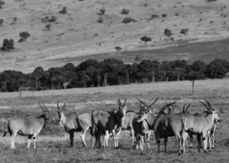
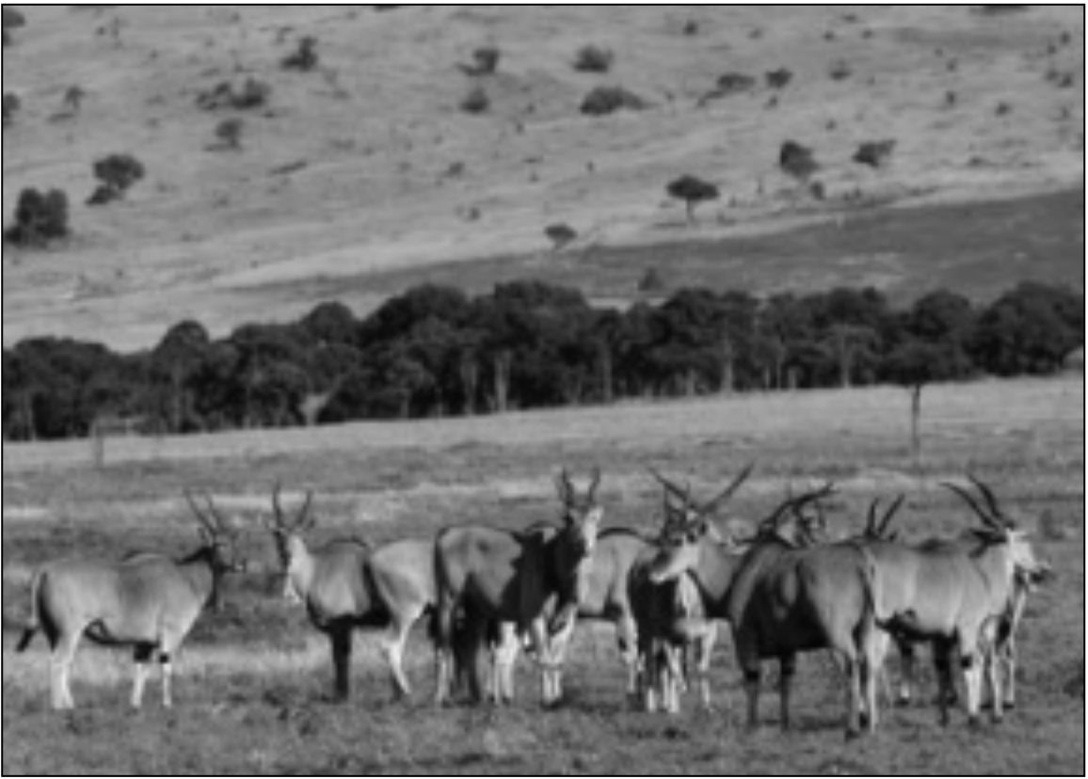
CASE STUDIES—WILDLIFE TRADE MANAGEMENT IN PRACTICE
CASE STUDY 1: THE TRADE IN WILD MEAT IN EAST AND SOUTHERN AFRICA
The nature and scale of the wild meat trade
Human beings across the world have relied on wild animals as a source of food and other products throughout human history and many continue to do so today. This is particularly true in East and Southern Africa, where animals are hunted for meat for subsistence purposes and, increasingly, for trade. This use and trade touches on both conservation and development policy agendas. Many of the species whose meat is traded are of high conservation concern and their roles in local and regional ecologies not necessarily well known. What is certain is that wild meat use is currently having far-reaching impacts on wildlife populations in the region, including those within protected areas. At the same time, the consumption and trade of wild meat is a central feature of the livelihoods of many people in East and Southern Africa. Addressing the declines of wild species on which people depend is therefore particularly linked to delivering on the MDGs related to poverty and hunger (1) and environmental sustainability (7).
The importance of wild meat to the livelihoods of the poor in the countries of East and Southern African hinges on its place as an important source of food, particularly protein. Access to nutritional food is especially important for pregnant women and young children, making wild meat an important feature of maternal and child health (MDGs 4 and 5).
The wide variety of species hunted for meat reflects the variety of Africa’s ecosystems and includes most of the large herbivores and primates and some carnivores, birds, reptiles and rodents. In East and Southern Africa, the larger
species of herbivore, such as
Cape Buffalo Syncerus caffer,
Impala Aepyceros melampus,
Eland Taurotragus oryx and
Lesser | Kudu | Tragelaphus
imberbis, account for large
Credit: Martin Harvey/WWF-Canon | Eland Taurotragus oryx, Kenya | proportions of wild meat
Credit: Martin Harvey/WWF-Canon | Eland Taurotragus oryx, Kenya | supplied but hunting is thought
Credit: Martin Harvey/WWF-Canon | Eland Taurotragus oryx, Kenya | to be unsustainable at current
Credit: Martin Harvey/WWF-Canon | Eland Taurotragus oryx, Kenya | levels, given poor adaptation of
Credit: Martin Harvey/WWF-Canon | Eland Taurotragus oryx, Kenya | these species to modified
Credit: Martin Harvey/WWF-Canon | Eland Taurotragus oryx, Kenya | habitats and their reproductive
Credit: Martin Harvey/WWF-Canon | Eland Taurotragus oryx, Kenya | patterns (late sexual maturity
36 | Eland Taurotragus oryx, Kenya | and long gestation periods).
36 | Eland Taurotragus oryx, Kenya | TRADING NATURE:Wildlife trade and the Millennium Development Goals


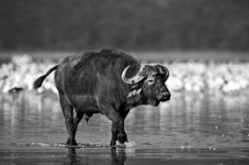
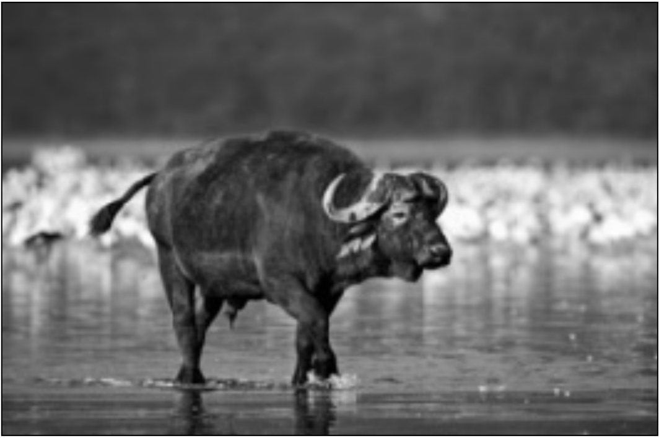
Many smaller species are also used,
such as Common Duiker Sylvicapra
grimmia, Scrub Hare Lepus saxatilis
and several species of Cane Rat
Thryonomys spp., especially in |  |  |  |  | Cape Buffalo Syncerus caffer,a source of wild meat in East | Credit: Martin Harvey/WWF-Canon
countries like Malawi where many of |  |  |  |  | Cape Buffalo Syncerus caffer,a source of wild meat in East | Credit: Martin Harvey/WWF-Canon
the larger species no longer exist |  |  |  |  | Cape Buffalo Syncerus caffer,a source of wild meat in East | Credit: Martin Harvey/WWF-Canon
because | of | habitat | loss | and | Cape Buffalo Syncerus caffer,a source of wild meat in East | Credit: Martin Harvey/WWF-Canon
hunting/poaching (Barnett, 2000). |  |  |  |  | Cape Buffalo Syncerus caffer,a source of wild meat in East | Credit: Martin Harvey/WWF-Canon
The vast majority of trade in wild |  |  |  |  | Cape Buffalo Syncerus caffer,a source of wild meat in East | Credit: Martin Harvey/WWF-Canon
meat is illegal and thus criminalized. |  |  |  |  | Cape Buffalo Syncerus caffer,a source of wild meat in East | Credit: Martin Harvey/WWF-Canon
The trade appeared to be growing |  |  |  |  | Cape Buffalo Syncerus caffer,a source of wild meat in East | Credit: Martin Harvey/WWF-Canon
 |  |  |  |  | and Southern Africa | Credit: Martin Harvey/WWF-Canon
during the 1990s (Barnett, 2000), |  |  |  |  | and Southern Africa | Credit: Martin Harvey/WWF-Canon
and there are no indications that this trend has reversed in recent years. Ensuring that policy and management structures take a more comprehensive and balanced approach to addressing conservation and development issues associated with unsustainable and/or illegal trade in wild meat is therefore critical, and would help deliver on MDG targets related to good governance (MDG 8).
As indicated above, wild species form an important source of food and income in East and Southern Africa. A study of wild meat consumption in seven East and Southern African countries (Barnett, 2000) documented the importance of wild meat in all 13 field sites surveyed. In the Kitui District of Kenya, for example, approximately 80% of the households consumed an average of 14 kg of wild meat per month, with this meat representing the majority of all meat protein consumed. Wild meat use is widespread throughout the African continent and is of highest importance to those living in forests and savannah forests (see Case study 1: Table 1).
Case study 1:Table 1
Relative importance of wild meat in Africa (1994)
Wild meat production |  | Total | Average/person | All meat production
Ecological region | Population | Total | Average/person | Total | Average/person
(millions) |  | (million t) | (kg/person/year) | (million t) | (kg/person/year)
Savannah | 344 | 405 421 | 1.2 | 4 857 133 | 15.2
Savannah forest | 163 | 533 763 | 3.3 | 1 571 732 | 9.7
Forest | 54 | 287 225 | 5.3 | 418 527 | 7.8
Islands | 16 | 3846 | 0.2 | 378 029 | 22.7
Total | 577 | 3846 | 2.1 | 7 225 422 | 12.5
Source: Chardonnet et al. (2002).
TRADING NATURE:Wildlife trade and the Millennium Development Goals 37

Beyond its importance in the day-to-day economies of rural people, wild meat also acts as a safety net during times of famine or other forms of disruption, to which the rural poor are particularly vulnerable. In Tanzania, refugees fleeing Rwanda relied on wild meat as a source of protein prior to the arrival of humanitarian agencies. Wild meat subsequently supplemented diets when refugees’ food rations were reduced to below recommended calorie intake levels. A policy that discouraged self-reliance amongst refugees in order to encourage voluntary repatriation also meant that many sought out the income-generating possibilities offered by participation in the wild meat trade, either as hunters or middlemen (Jambiya et al., 2007).
In Zimbabwe, the impacts of recent land reforms, political and economic instability have meant that many people are resorting to wild foods, which were found in 2002 to provide the most common substitutes for cereals when these were in short supply. Hunting and fishing were specifically mentioned as supplying foods in some areas, e.g. the Zambezi Valley (Zimbabwe National Vulnerability Assessment Committee, 2002). “Operation Nyama” allows police and defence forces to hunt wild species to alleviate hunger and park staff are allowed to kill a set number of animals per week as rations. The illegal hunting of wild species for meat in response to food shortages also appears to have increased significantly in recent years, and is believed to be greatly reducing wildlife populations in Zimbabwe (Eagle, 2006). Poaching for meat was expected to escalate further following the government closure of private abattoirs in 2007 (Anon., 2007a).
Wild meat is increasing in importance as a traded commodity in Africa, this trade tending to be regionally focused, influenced by existing internal trade networks and markets. An FAO study estimated that the foreign trade in wild meat from selected West African countries amounted to USD150–160 million annually above and beyond income derived from wild animal trophy exports (Molade, 1999).
The wild meat trade has been studied in depth for some countries and regions of the world, but there are few data on the extent of the trade in global terms. Although largely taking place within national boundaries, international (or trans-regional) trade does occur—particularly to and from countries with large immigrant communities. A recent survey indicated, for instance, that it was possible to get smoked wild meat of African species in large urban centres with significant African communities such as New York, Montreal, London, Brussels and Paris (Marris, 2006). In some countries, local scarcity of wild meat has also given rise to inter-regional trade (Barnett, 2000). Despite the lack of research, several points can be made with a good deal of certainty:
• The trade of wild meat is a global phenomenon;
• The trade is an important source of income for rural people;
• The dynamics of the trade vary tremendously by region, reflecting varying cultural characteristics and human migration patterns, the character of regional economies, and the different ecosystems supplying wild meat.
38 TRADING NATURE:Wildlife trade and the Millennium Development Goals


The drivers behind the trade in wild meat are numerous and vary between different African regions. In many places, wild meat is an essential good for both subsistence and income purposes. Widespread rural poverty combined with the lack of protein alternatives often makes meat from the wild the only option. Where meat from domesticated animals is available, it is typically more expensive than wild meat. Some reports indicate use is shifting from personal consumption to trade, as local extinctions give rise to regional markets (Barnett, 2000). Urbanization has also created distance between supply and consumers, creating markets for traded wild meat. In some countries with rising incomes, wild meat has become preferred to domestic meat for reasons of taste and status and trade has emerged to meet this demand. Cultural preferences also influence demand, especially where there are reputed health or medicinal values from the consumption of certain species, as with the demand for animal parts for traditional medicines.
Case study 1: Box 1
Livelihood dimensions of the wild meat trade in East and Southern Africa
• A TRAFFIC report based on analysis of primary data collected from 13 different sites across seven
different countries in the region suggested a number of livelihood dimensions to the trade in the
region. Rising populations and localized declines in wildlife populations mean trade has emerged to
meet a need for meat that cannot be met from local sources of expensive, domestic meat.
• Economic values of quantities consumed equate to a considerable proportion of household average
monthly incomes, from between 15% and 40% depending on the area surveyed
• Income from wild meat sales is substantial and significant enough to those involved in the trade to
compete with alternative livelihoods strategies
• Hunters capture a significant portion of the final sale price
• Products from legal wild meat sources are often exported or are by-products of other activities, e.g.
trophy hunting or problem animal culls, i.e. not providing a consistent or reliable supply
Source: Barnett, 2000.
In areas with few livelihood alternatives, sales of wild meat can be an important way to generate income. Barnett (2000) estimated that the value of wild meat use in East and Southern Africa was up to 34% of household income. In Mozambique, an average hunter in Gile game reserve earns approxi-mately USD29 over four months from sales of wild meat compared to an average annual income from crop sales of USD49 (Fusari and Carpaneto, 2006). Similar findings have been noted from Central Africa (de Merode et al., 2004). However, reliance on trade in wild meat as a source income is not universal, a recent study showing, for example, that this trade accounted for only a minor part of household income in the Udzungwa Mountains of Tanzania (Nielsen, 2006).
TRADING NATURE:Wildlife trade and the Millennium Development Goals 39


Case study 1: Box 2
Characteristics of the wild meat trade in East and Southern Africa
Bowen-Jones, Brown and Robinson (2002) provide a succinct characterization of the wild meat trade in West and Central Africa. Their typology is used here to simplify comparison with that region. The Barnett (2000) study reveals many similarities between the two regions but many differences as well.
General:
• Significant, but often invisible, contributor to local economies in East and Southern Africa; it may rival the formal wildlife sector’s contribution to the national economy.
• The distribution of its benefits tends to be more equitable for rural people living close to the resource, who capture a greater percentage of the value of the resource than they receive from alternative uses of wild species.
• Highly complex and displays significant geographic variation.
• Depending on the species, already unsustainable at various local levels and appears to be increasing.
Livelihood and trade:
• Use has recently become more commercialized.
• Wild meat has significant impacts on the livelihoods of the rural poor, providing both an affordable source of animal protein and a livelihood opportunity for men as hunters and women as traders.• Wild meat is a favoured food item and is part of a complex commodity chain, linking rural hunters to urban and rural consumers.
• Smoking or sun-drying wild meat is often the only method of maintaining a store of protein for rural communities.
• Use of wild animals for meat is economically contested, as it is competes with the wildlife tourism sector.
Ecological:
• Savannah lands,the source of much of the region’s wild meat,have intrinsically high rates of production of wild animals in comparison to other ecosystems.
• Some species thrive in the farm-bush mosaic and may be able to sustain relatively high levels of hunting, others may be pest species, and some species are genuinely threatened by over-hunting.
• The current trade is having a negative impact on populations of species of conservation concern.
Institutions, laws and policy:
• Legislation and policy have typically given few tenurial or riparian rights to savannah-dwelling and dependent human populations.
• Problem areas may be immigration zones for the national population.
• Non-traditional protected area management schemes have recently been pioneered in the region with mixed success.
40 TRADING NATURE:Wildlife trade and the Millennium Development Goals

There are important social and gender divisions to the trade of wild meat. There is frequently a gender division of labour, with men as hunters and middlemen and women as traders/sellers. Brown and Williams (2003) note that “in West and Central Africa, hunting is traditionally undertaken by young men at an early stage of the family cycle, to accumulate capital which is later invested in setting up enterprises with a longer time horizon, such as export crop production and petty trade. It thus provides a stepping stone to greater prosperity for a social category that might otherwise be problematic for society”. Anecdotal evidence indicates that such strategies are pursued in East and Southern Africa as well (S. Milledge, TRAFFIC, pers. comm., 2007).
Management of the wild meat trade
The hunting of wild animals for meat, and therefore by extension the trade in the meat of wild species, has long been subject to traditional management systems, including prohibitions on the hunting and eating of totem and taboo animals, prohibitions on the taking of gravid females, and hunting during specific seasons (Barnett, 2000). Traditional management systems have been overlaid with, and in some places replaced by, a variety of regulatory measures stemming from outright hunting bans to community co-management.
In general, across Africa the primary government management approach adopted has been to ban the harvest of wild species for direct consumption and trade of their meat (with certain exceptions such as those described below). As a result, the majority of the wild meat trade in Africa is illegal and thus criminalized, and no active management exists. The largely unrecognized importance of wildlife as a source of food and in some cases income for poor people on the one hand, contrasted with its recognized importance as a source of revenue in the formal economies of range States (e.g. through wildlife tourism) has made wildlife a contested resource across the region, engendering competition for what is also becoming an increasingly scarce resource.
Recently, many national governments in the region have begun to recognize that wildlife populations cannot be properly conserved without the commitment and support of communities living adjacent to them. Many governments have, through changes to law and policy, stated their commitment to the principles of sustainable wildlife use and equitable benefit-sharing. Many have implemented—or are planning to implement—participatory wildlife management models in certain geographic areas. However, recognition of local access rights to wildlife use in these schemes tends to be narrowly understood, with ownership of wildlife remaining vested in the State. Complicating the matter further, land tenure and land use law and policy typically provide few incentives—and may in fact provide disincentives—to wildlife management as a land use (Norton-Griffiths, 2003). There are also instances of policy incoherence, where management responsibilities for some resources are being devolved to local governments or communities more quickly than for others. For instance, in Tanzania, the devolution of management for certain forests on village land (as defined in the Land Act and Village Land Act 1999) does not cover the wildlife found within those same village forests.
TRADING NATURE:Wildlife trade and the Millennium Development Goals 41


At present, national wildlife governance regimes typically prohibit wildlife harvesting within protected areas and/or on state land that is not under a community management scheme. Where harvesting is permitted, it is either allowed for subsistence use only or for a very limited, highly regulated local trade. Case study 1: Table 2 provides a summary of the regulation-based management regimes in selected countries in the region.
Case study 1:Table 2
Regulatory measures to manage the wild meat trade in selected countries in East and
Southern Africa
KENYA
Harvesting regulations: All mammal hunting banned in 1977 although new draft wildlife policy under consideration that would allow hunting again.
Trade regulations: Other than from farming/ranching sector, commercial trade prohibited. Comments: Policy emphasizes non-consumptive uses of wildlife, primarily tourism, especially photographic safaris; Community Wildlife Programme introduced in mid-1990s; Kenya Wildlife Service policy of sharing 25% of national park revenues with local people but has not been implemented and considered unlikely to be in near future.
TANZANIA
Harvesting regulations: Wildlife Conservation Act of 1974 and Amendment No. 21 of 1978 specifies hunting seasons, restricts the types and methods of hunting, and outlines licence requirements; two types of licences: Resident and Safari; traditional hunting methods prohibited.
Trade regulations: Game meat from resident hunting intended for subsistence use; commercial trade prohibited; limited distribution of meat from safari hunting; community-based game meat supply cropping schemes exist around some Game Controlled Areas and National Parks but commercial trade prohibited.
Comments: Establishment of Wildlife Management Areas where rural communities take responsi-bility for the wildlife resource and obtain direct benefits through legal and sustainable wildlife utilization schemes. Wildlife policy and legislation currently under review.
MALAWI
Harvesting regulations: Hunting in forest reserves prohibited without a permit; outside protected areas, permits issued include Wild Bird Licence, National Game Licence, District Game Licence, Hunting Licence, Special Licence (scientific) and Visitor’s Licence (safari).
Trade regulations: National Parks and Wildlife Act, 1992 regulates harvest, possession, sale and trade in wildlife; meat harvested under licence may be consumed or traded at the discretion of the licence holder.
Comments: Small number of licences issued on annual basis. This is likely to be owing to declines in availability of wildlife and distrust of bureaucracy; most wild meat is therefore hunted and traded illegally.
42 TRADING NATURE:Wildlife trade and the Millennium Development Goals


ZAMBIA
Harvesting regulations: Zambia Wildlife Act No. 12 of 1998 allows limited hunting of animals in Game Management Areas through District, National, Safari and Special (for protected species) Game Licences.
Trade regulations: Sale of game meat derived under licence allowed (Zambia Wildlife Act No. 12 of 1998 and National Parks and Wildlife (Licences and Fees) Regulations of 1994); provision made for regulation of trade in game meat through statutory instrument to control, limit or prohibit movement of game meat, including export.
Comments: District licences intended for rural communities within Game Management Areas (GMAs); National Licences for Zambians and resident non-Zambians to hunt in GMAs and open/free areas; as wildlife has declined, some GMAs have been closed to National Licence holders (i.e. outside hunters); declining number of animals allocated under District and National Licences because of wildlife declines and allocation to more lucrative safari hunting sector; while the sale of game meat is allowed, few hunters obtain permits; commercial licensed hunting for trade is a growing phenomenon, owing to high urban demand.
ZIMBABWE
Harvesting regulations: Subsistence hunting within communal areas allowed; safari hunting allowed; harvesting on private game farms and ranches permitted.
Trade regulations: Parks and Wildlife Act 1975 (Amended 1990) and Parks and Wildlife (General) Regulations, 1990 regulate the harvest, possession, sale and trade in wildlife products; Forest Act 1949 (amended 1981) regulates trade in forest produce and wild meat; trade within communal areas is allowed but commercial trade with non-resident outsiders is prohibited.
Comments: Game meat production is often a by-product of other more lucrative uses; owing to movement and marketing restrictions, most game meat is marketed locally (in 1996, 86% of game meat produced on commercial farms was sold; remaining meat was consumed on farm); some farmed meat is exported, e.g. exports (mostly to Europe) of Ostrich Struthio camelus meat represented 82% of sales.
MOZAMBIQUE
Harvesting regulations: Subsistence hunting for residents only; safari sport hunting by non-residents is under licence.
Trade regulations: Commercial trade of wildlife products is largely prohibited; commercial trade in wild meat prohibited.
Comments: Government company EMOFAUNA given right to trade in Cape Buffalo meat and hides in Marromeu Game Reserve; “Tchuma Tchato” community-based natural resource management project is laying groundwork for greater community participation and management of natural resources.
Source: Original information from Barnett (2000), updated by the author.
TRADING NATURE:Wildlife trade and the Millennium Development Goals 43


With the exception of Zimbabwe, South Africa, Namibia and, to a lesser extent Kenya, where game ranching industries exist, the legal meat supply tends to be a by-product of trophy hunting, wildlife culls/cropping and problem animal control. Estimates of legal wild meat production during the late 1990s are provided in Case study 1: Table 3. Even in the late 1990s, these legal sources represented a minority contribution to meeting wild meat demand in the region (Barnett, 2000).
Case study 1:Table 3
Regional overview of estimated annual legal game meat production (1998)
Country | Production (million t) | Value (USD) | 7 Population | 8 Approximate kg/person/year
1  Kenya | 686 | 570 396 | 28 606 607 | 0.024
2 Tanzania | 1282 | 1 141 218 | 34 443 603 | 0.037
3 Malawi | 154 | 124 352 | 9 933 868 | 0.015
4 Zambia | 975 | 288 000 | 9 885 591 | 0.986
5 Zimbabwe | 2925 | 1 889 008 | 13 076 000 | 0.224
6 Mozambique | 300 | 1 949 200 | 19 888 700 | 0.002
Total | 6322 | 5 962 174 | 115 834 369 | 0.002
Notes: 1: Large game ranching sector (94% of legal supply); 2: No ranching sector; 3: Little large megafauna compared with other countries in region; 4: Large contribution from game cropping; 5: Largest game ranching industry in region; 6: Still recovering from civil war at time of survey; 7: Census dates: 1997 (Mozambique), 1998 (Malawi), 1999 (Kenya), 2000 (Zambia) and 2002 (Tanzania, Zimbabwe); 8: Does not account for distributional differences within country.
Source: Barnett (2000); author’s own calculations.
In Zimbabwe, in communal areas with some presence of wildlife, large-scale cropping for the purposes of meat production and distribution at low prices takes place through the CAMPFIRE (Communal Areas Management Program for Indigenous Resource Areas) programme, but only for people resident in these areas. In many cases, wild meat is sold for less than the market price. In the late 1990s, prices for meat sold in CAMPFIRE areas from culls or problem animal control were USD0.17–0.42/kg compared to USD0.92/kg for ranched/farmed meat, USD1.26/kg for illegally hunted meat and USD 1.67–2.92/kg for domestic beef (at approximate USD equivalent for 1997; rate used was USD1 = ZWD12) (Barnett, 2000). The purchase of wild meat by “non-resident outsiders” for resale in urban centres was considered a problem by CAMPFIRE administrators (Barnett, 2000).
Following the government decision to nationalize farm land in Zimbabwe, the number of farms involved in the wildlife industry and registered with the Department of National Parks as game ranches or conservancies is reported to have fallen from 84 to 14 (Eagle, 2006).
44 TRADING NATURE:Wildlife trade and the Millennium Development Goals

While appearing to hold great promise, game farming/ranching is in many countries constrained by the lack of devolved wildlife resource use rights, insecure land tenure, insufficient capital and inappro-priate skills (Barnett, 2000). Further, increased production of meat from some taxa that hold potential for intensive management is constrained by religious or cultural views that prohibit consumption of their meat. For example, the region contains a significant Muslim population for whom the meat of Common Warthogs Phacochoerus africanus and other wild pigs, for which production could be increased, is anathema. Illegally sourced wild meat therefore remains the primary source of supply and provides the greatest income for a wider spectrum of people, especially in rural areas lacking in alternative livelihood options.
Perhaps because of competition from illegally sourced meat, the game meat industry in southern Africa is increasingly turning its attentions towards supplying foreign markets outside the region (Hoffman and Wiklund, 2006)—thus exacerbating the problem of a limited domestic supply of legal meat.
Impacts of trade management
Although the trade in wild species for meat is heavily managed on paper, as is shown above, management on the ground in most countries in East and Southern Africa is limited, and sometimes restricted to anti-poaching measures within protected areas. Notable exceptions include South Africa and Namibia, both of which continue to maintain healthy wildlife populations in national parks, private game ranches and, in Namibia, in community management areas. In the case of South Africa, where legal harvest of wild species for meat is limited to privately managed game reserves, access to meat and/or associated income earning opportunities is similarly limited. However, opportunities for income from other wildlife based industries, e.g. tourism, are maintained owing to the continued presence of healthy wildlife populations.
Where enforcement of prohibitions on the hunting and trade of wild meat is taking place, it tends to affect the rural poor disproportionately. Criminalization thus increases the vulnerability of the rural poor for whom wild meat occupies an important place in livelihood security strategies. Available data indicated that the majority of illegally sourced meat in the region ends up commercially traded (Barnett, 2000; Carpaneto and Fusari, 2006; Brown et al., 2006), i.e. is not used for subsistence purposes.
By criminalizing the commercial trade, restrictive national governance regimes have resulted in the majority of the trade being clandestine, difficult to police and effectively unmanaged. Arguably, therefore, the lack of a well-regulated, sustainable trade entails opportunity costs—or foregone income benefits—for the rural poor. Because they lack incentives for the rural poor to engage in sustainable management of wildlife resources, these regimes have also led to wildlife depletion and conversion of land to other uses with greater incentives and livelihood opportunities, such as agriculture.
TRADING NATURE:Wildlife trade and the Millennium Development Goals 45

The lack of effective management, coupled with the apparent increases in demand, have already increased prices for the meat of larger species and increased reliance on smaller species, both of which are likely to indicate declines in the availability of larger species (Barnett, 2000). These declines have implications for the long-term ecological sustainability of hunting and trade, both at the species and ecosystem level, and hunting has been shown to affect local ecologies (Setsaas et al., 2007). In many cases, the wider ecological importance of particular species may not be well known, making those at greater risk from local extinction of particular concern. Research from forested regions of South America, for example, indicates that hunting can have adverse affects on seed dispersal, and by extension, local flora biodiversity (Stoner et al., 2007).
Conclusions and recommendations—enhancing the contri-bution of the wild meat trade to the MDGs
Wild meat clearly pays an important role in meeting the food needs of many people in East and Southern Africa, particularly in times of instability, when food supplies from domesticated sources may be unavailable or unaffordable. However, unsustainable (and frequently illegal) hunting to supply wild meat has resulted in significant declines in wildlife populations in the region, and shows no signs of abating. At present, therefore, the situation is perhaps more one of ensuring that the wild meat trade does not undermine other efforts to achieve the MDGs, particularly MDG 7, rather than one of considering how this trade can contribute to their achievement. Despite this somewhat pessimistic outlook, however, examples of successful management regimes for wild meat production and trade in the region demonstrate that, if managed effectively, the trade can help deliver on both development and conservation priorities.
A fundamental requirement for moving towards sustainability and achievement of development goals is for debates about management approaches to move beyond the typical differentiation between subsistence and commercial use of wildlife. Such distinctions do not accurately capture the character of the social institutions that are involved in the wild meat trade (Hurst, 2007). Rather, institutional norms mean that individuals often define the legitimacy of resource claims according to a different notion of proximity than do governments or external conservation actors. Legitimacy can depend more on kinship or political ties to an area than on one’s physical presence there. At the same time, local hunters do not define entitlement according to where a resource is consumed, and patrolling the“borders” of areas within which “subsistence” hunting is allowed will be difficult. Many existing norms of entitlement to the resource and notions of legitimacy that follow from them do not take into account whether wild meat has been “commercialized” (i.e. it has been transported out of the local area and exchanged for cash) or not. Legitimizing access to a resource solely on the basis of customary rights can be problematic also. Customary or traditional claims to resources are often contested and local definitions of who is and is not “local” can change depending on the context in which the term is used.
46 TRADING NATURE:Wildlife trade and the Millennium Development Goals



Also fundamental to improving the management of the meat trade—and enhancing its contribution to the MDGs—is improving knowledge of its dynamics. This includes increased understanding of current hunting and trade volumes and patterns (both legal and illegal), existing institutional frameworks governing hunting and trade, the response of wildlife populations and habitats to current offtake levels, and the response of human populations to changes in the availability and price of both wild and domesticated sources of meat. Although arguably a global phenomenon, collection of this information will be required at a far narrower scale, taking into account the trade’s geographic specificity (Bowen-Jones et al,. 2002).

Many smaller species may be able to withstand sustained off-
take | because | of | their
adaptability to newly modified
environments | and | greater
breeding capacity. Preliminary research from West Africa suggests the consumption and trade of such species can be sustainable in post-depletion environments (see Cowlishaw et al., 2005), a finding that might be relevant in countries such as

With access to this information, those with authority over | Malawi.
wildlife hunting and trade management (e.g. government decision-makers, community leaders), will be better equipped to establish appropriate management plans. Decisions that might result could include, for example:
• Focusing conservation, including regulatory enforcement, efforts on particular species, e.g. those whose populations have already declined to worrying levels and/or are particularly susceptible to hunting pressure; and
• Ceding management control to local people for species that can withstand higher levels of hunting pressure, which may increase their willingness to forego access to other species that cannot.
Current regulatory structures banning most if not all wildlife hunting and/or trade may preclude options such as the latter in many cases, however, with the illegal nature of the wild meat trade being a key stumbling block to its sustainable management. As shown above, policies that criminalize the trade have not been effective at bringing it under control, a situation that will surely continue in the face of what appear to be growing markets for wild meat in the region. Greater consideration of alternative management scenarios, including legalizing hunting and trade of certain wild species for meat, is therefore required. Such approaches are being experimented with in several countries in West and Central Africa that could provide useful models and “lessons learned” for East and Southern Africa (Case study 1: Box 3).
Changes to existing regulatory structures would need to consider and ideally to take advantage of the potential market value of legal wild meat supplies. In urban settings, wild meat holds promise as a“luxury item”, i.e. a product that is able to avoid substitution even where alternatives exist at competitive prices. Should market research confirm that such luxury markets exist, wild meat would appear to be less vulnerable to price fluctuation and product substitution and therefore likely to
TRADING NATURE:Wildlife trade and the Millennium Development Goals 47

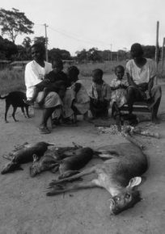
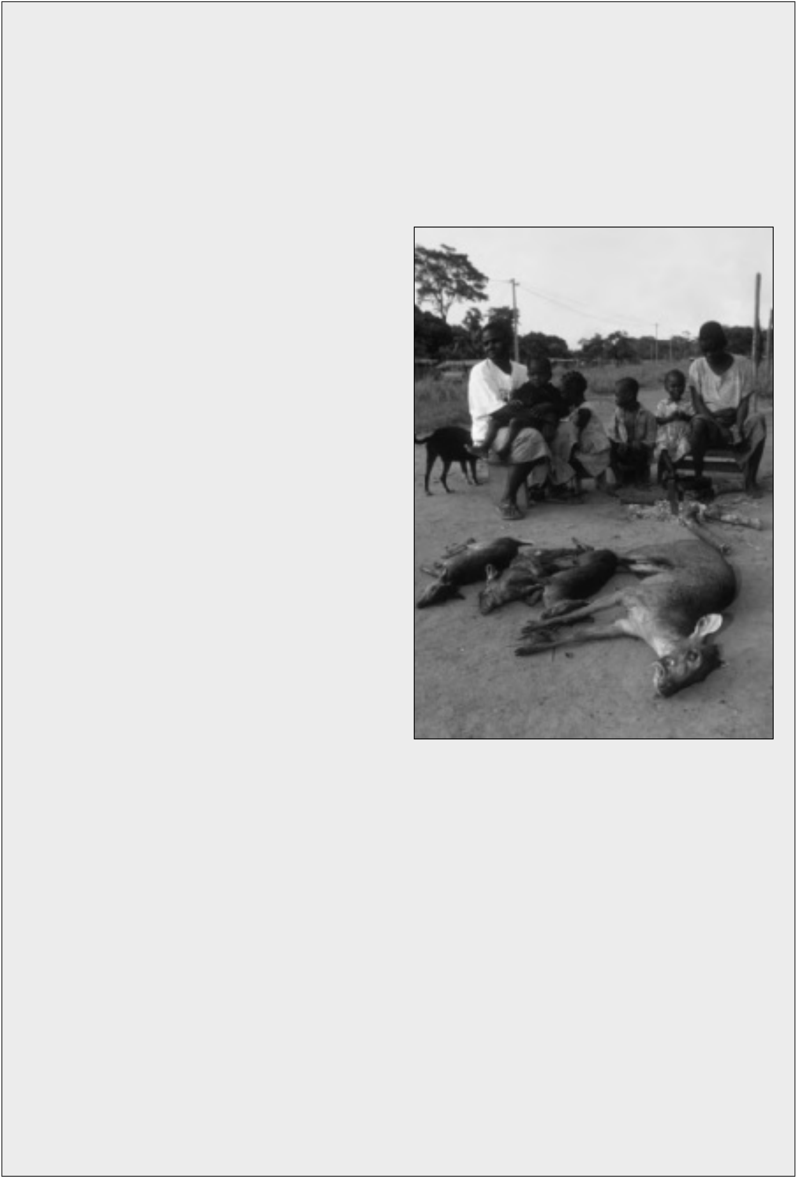
Case study 1: Box 3
Managing the commercial wild meat trade in West and Central Africa
In West and Central Africa,experiments with alternative approaches to managing the wild meat trade that are consumer-driven and provide incentives for sustainable management by community-based associ-ations appear to correct many of the problems with more widespread command and control efforts.
In Cameroon, legal provision was first made for
community hunting zones in the revised National
Forest Policy of 1994. Thirteen such zones have
been mapped and identified as eligible for
establishment of community hunting management;
five such zones are now under active management.
In addition, the government is working with WWF
to create a system that will allow community
hunting groups to sell their meat legally outside the
local areas. The government is considering changes
to the law that would oblige wild meat traders in
cities and towns to purchase wild meat from
"sustainable" sources, which in effect would mean |  | Credit: Martin Harvey/WWF-Canon
the Community Hunting Zones. | According to | Credit: Martin Harvey/WWF-Canon
WWF, restaurants in Yaoundé are already in direct contact with communities managing Community Hunting Zones. In addition to legalizing potentially lucrative income streams for local communities, such changes would make circumvention of the rules more difficult by attempting to control |  | Credit: Martin Harvey/WWF-Canon

secondary wild meat markets in urban areas—markets that should be easier to regulate and control than the highly decentralized primary markets.

Antelope catch displayed back home in the village, Central Africa

In Gabon, where hunting with a permit is legal, the government is considering regulating the wild meat trade through the establishment of village associations. These associations would provide the only legal source of meat for outside traders, and hunting could only be done by hunters registered with the village association who possessed the appropriate permits. This would build on existing accountability mechanisms and may incorporate measures that buttress the ability of local people to avoid exploitation by local elites or outsider traders and negotiate more equitable relationships with marketers and consumers alike. Urban consumers will continue to have access to the resource while local people will be ensured a fair share of the benefits to which they are entitled as joint custodians of species used for wild meat.
Source: Hurst (2007).
48 TRADING NATURE:Wildlife trade and the Millennium Development Goals

generate higher levels of returns to producers compared to other wild foods. In fact, evidence from other African regions suggests that hunters can capture a surprisingly high proportion of the value added in the trade. A recent study of the commodity chain in Ghana, for example, found that hunters captured 74% of the final sale price in chop bars (Mendelson et al., 2003).
Allowing commercial trade should not be viewed as some sort of a panacea, however. The trade does not necessarily operate in a pro-poor fashion (Brown, 2003), nor are there any guarantees that legal supplies will be able to keep up with demand. Urban demand seems certain to increase in the region given rates of urbanization; sub-Saharan Africa is expected to have the highest rate of urban growth in the world over the next decades (UNFPA, 2007). The long-term sustainability of the trade is therefore open for debate, and will depend greatly on the symmetry or divergence between demand for wild meat, ecologically sustainable hunting levels, and the ability to implement agreed management systems.
Regardless of the pitfalls, approaches to the trade of wild meat that consider both poverty reduction and conservation agendas hold the potential of contributing positively to the growth of good governance of the broader natural resource base (Brown and Williams, 2003). Other sectors, e.g. forestry, have made significant progress in giving local people greater control over forest resources, working with rural people as partners, not as beneficiaries, and using people-centered frameworks for planning and implementation. As agreements for more equitable benefit-sharing are made, rural people have been more willing to work with governments to protect and improve or expand the forest, thereby safeguarding an asset base of crucial importance to the poor as well as a national and international public good.
The MDGs recognize the centrality of a healthy environment in poverty reduction efforts, but without a legal stake in the future of this resource, local people will be wary of participating actively in its conservation and this will undermine efforts aimed at reversing the decline in environmental resources—one of the targets of MDG 7. Changes must recognize the legitimacy of local claims but also bind in law the responsibilities that go along with these claims. For those countries that have not already done so, the legitimacy of the access claims of the rural poor on wildlife resources in their vicinity should be recognized. Devolution and/or decentralization is no guarantee that the twin goals of poverty alleviation and biodiversity conservation can be met. But in the case of other natural resource sectors—notably water management and forestry—there is a great deal of relevant experience that should be mined to good effect (Shyamsundar et al., 2005).
TRADING NATURE:Wildlife trade and the Millennium Development Goals 49


CASE STUDY 2:THE LATIN AMERICAN TRADE IN WILDLIFE SKINS AND WOOL
The nature and scale of the Latin American skin trade
The collapse of the Amazon rubber boom in the early 1900s led many rural communities in South America to look for other sources of income, of which the skin and fur trade was one. Hunting for this purpose increased rapidly, peaking in the 1950s and 1960s. Pelts were sold through a system of profes-sional hunters and traders until the 1970s. Numerous species have been involved, the trade tending to follow the common pattern of species with a high value on the international market being over-exploited in resource-poor areas, leading to a decline in

availability and in some cases near extinction (e.g. some spotted cats, otters, caimans, Vicuña, chinchilla Chinchilla spp.), and replacement by other species. Protective legislation was introduced in many countries in the 1970s and 1980s and, along with changes in fashion, resulted in a decline in the trade for many of these species. In tropical parts of South America, for

The joint exploitation of Spectacled Caiman Caiman crocodilus and tegu Tupinambus spp. hides represented more than 20% of the world trade of the legal exports of reptile skins in 1990 (Chardonnet et al., 2002). From 1975 to 1986, over 16 million skins of

example, skins have little or no trade value. Tupinambis spp. were exported
legally from Argentina. This trade

Elsewhere in the region, however, certain (more common) species are still targeted specifically for their skins including tegu lizards Tupinamibis spp.; Coypu

earned the national economy millions of dollars and had a considerable impact on rural populations from

Myocastor coypus; Capybara Hydrochaeris hydrochaeris | northern Argentina, | where | this

and Guanaco Lama guanicoe.

activity became an important source of income (Chardonnet et al 2002).

This case study focuses on three taxa (Case Study 2: Box 1) | The | Tupinambus |  | skin | trade
that have the potential to bring sustainable economic | subsequently |  | declined, |  | though

benefit to local communities, but for which many obstacles constrain this potential:

continues in smaller quantities.

• Peccaries. The White-lipped Peccary Tayassu pecari and the Collared Peccary Pecari tajacu are capable of withstanding exploitation and are listed as Lower Risk/Least Concern in the IUCN Red List (IUCN, 2007b), although the Chacoan Peccary Catagonus wagneri has a narrow range and is listed as Endangered.
• Caimans Caiman spp. and Black Caiman Melanosuchus niger. Several species were over- exploited before the trade was regulated and trade shifted between species and countries as regulations were developed and enforced; all caiman species are listed as Lower Risk on the IUCN Red List and all but Black Caiman are further categorized as Least Concern.
• The Vicuña was brought to near-extinction through overhunting but is now recovering (categorized as Lower Risk/Conservation Dependent in the IUCN Red List) and subject to intensive management.
50 TRADING NATURE:Wildlife trade and the Millennium Development Goals

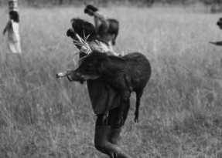
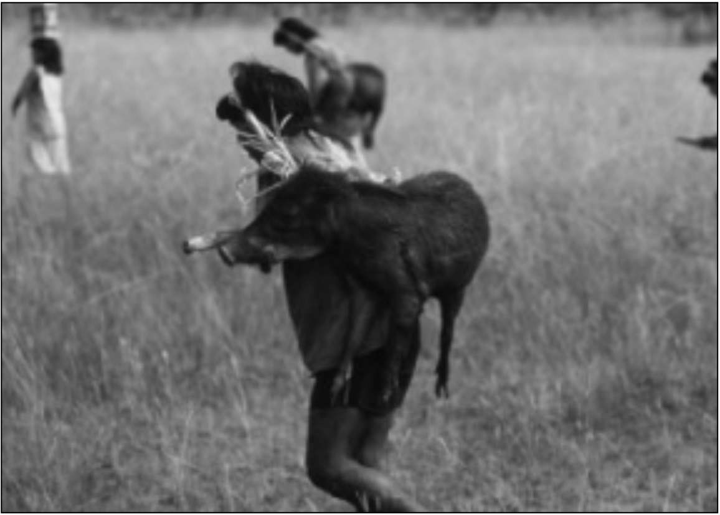
Management of the skin trade
The trade in all three taxa is subject to management at both the national and international levels. From the mid-20th century, even prior to the coming into effect of CITES, many South American governments banned exports of native wildlife because of real or perceived wildlife population declines.
Peccaries
Peccary skins—particularly from Collared Peccaries—were in high demand and had been exported in large quantities from many Latin American countries during the first half of the 20th century (Ojasti, 1996), prior to the entry into force of national export bans on trade in these and other species. For example, between 1946 and 1973, nearly 1.3 million White-lipped Peccary and three million Collared Peccary skins were exported from Peru (WCMC/IUCN-SSC/TRAFFIC, 1999).
In 1987, Collared and White-
lipped Peccaries were listed in
Appendix | II | of | CITES
(excluding the US and Mexican
populations of White-lipped
Peccaries), allowing interna-
Credit: Juan Pratginestos/WWF-Canon | White-lipped Peccary Tayassu pecari, Brazil | tional trade under a system of
Credit: Juan Pratginestos/WWF-Canon | White-lipped Peccary Tayassu pecari, Brazil | permits designed to ensure that
Credit: Juan Pratginestos/WWF-Canon | White-lipped Peccary Tayassu pecari, Brazil | peccary products in interna-
Credit: Juan Pratginestos/WWF-Canon | White-lipped Peccary Tayassu pecari, Brazil | tional trade were sourced in a
Credit: Juan Pratginestos/WWF-Canon | White-lipped Peccary Tayassu pecari, Brazil | legal and sustainable manner.
Credit: Juan Pratginestos/WWF-Canon | White-lipped Peccary Tayassu pecari, Brazil | National export bans remain in
Credit: Juan Pratginestos/WWF-Canon | White-lipped Peccary Tayassu pecari, Brazil | place in range States (Altrichter
Credit: Juan Pratginestos/WWF-Canon | White-lipped Peccary Tayassu pecari, Brazil | and Boaglio, 2004), except for
Credit: Juan Pratginestos/WWF-Canon | White-lipped Peccary Tayassu pecari, Brazil | in Peru. Here, the skins may
only be obtained from subsistence hunters living in the Amazonian region—hunting by commercial professional hunters is prohibited. A quota system has been established by the National Institute of Natural Resources (INRENA) to ensure the trade is sustainable—about 50 000 Collared Peccary skins and 20 000 White-lipped Peccary skins were exported in the mid-1990s (Bodmer et al., 1997). According to CITES annual report data, an annual average of approximately 15 000 White-lipped Peccary skins and 48 000 Collared Peccary skins were exported from Peru 2000–2006.
Demand is met by illegal commercial hunting in other countries, particularly Brazil (Nogueira-Filho and Nogueira, 2004). Changes are under way, however, which may increase the legal supply of skins and help ease the demand for illegally sourced products:
TRADING NATURE:Wildlife trade and the Millennium Development Goals 51


Case Study 2: Box 1
The local significance of trade in peccaries, caimans and Vicuña in Latin America
Peccaries have played an important role in the economic and cultural development of many indigenous people—such as the Mayan Lacandones in Mexico, Mundurucu tribe in Brazil and Guayaki in Paraguay—and have provided an important resource for many tribal and rural groups for protein and income (March, 1993). Both Collared and White-lipped Peccaries are widely hunted for meat for both subsistence use and sale in local markets. In the Peruvian Amazon peccaries are worth up to USD23 (Collared) and USD30 (White-lipped) per animal for their meat (Bodmer et al., 2004a).
Skins are a by-product of the meat trade and often discarded because of the lack of profitability of skin sales. In the Loreto region of the Peruvian Amazon, for example, hunters from both indigenous and non-indigenous rural communities receive USD2–5 for a skin and collectively generate about USD74 500 over the year.This might appear considerable, but in fact is only about 11% of the value of the peccary meat trade (USD633 265) in the same region (Bodmer et al., 2004b). The skins do, however, have potentially significant value, providing a high grade leather for quality gloves (e.g. golf gloves), shoes, belts and watch straps for which there is interna-tional demand (Bodmer et al., 2004b; Nogueira-Filho and Nogueira, 2004). Gloves retail for EUR120–180 (USD95–143) a pair in Europe (Anon., 2006).
Caimans are crocodilians—a taxonomic group of which Latin America has the highest diversity in the world, with 12 taxa occurring from Mexico to Argentina. Caiman skin is considered inferior to that of classic leather from true crocodiles Crocodilus spp. and alligators because of the bony deposits in the skin that complicate tanning and alter the appearance of the leather. However, caiman skins have become a mainstay of the trade because of over-exploitation of more highly valued species elsewhere in the world (Thorbjarnarson,1999). The trade is largely based on intensive production—or ranching—which can be a source of rare jobs that may be highly valued by unskilled or semi-skilled workers. In Bolivia, for example, some 1750 people were employed in the Yacare Caiman leather trade in 2005 (Burgener, 2007) and it is estimated that over 60% of the income from the trade benefited indigenous populations compared to just under 40% for private ranch owners (Aparicio and Rios, 2006).
The Vicuña is a member of the camel family found only at elevations above 3500 m in the central Andes of Argentina, Bolivia, Chile, and Peru (although there is also a small, introduced population in Ecuador) (Lichtenstein and Vila, 2003; CITES 2007a). The Vicuña fleece produces one of the finest wools in the world, which is used to make highly valued cloth. Each Vicuña can yield 200–220 g of wool every two to three years from live-shearing, most of this fibre being exported to Italy, the main manufacturing centre (Lichenstein and Renaudeau d’Arc, undated). Market prices in 2004 were about USD566/kg (Sahley et al., 2007)—over 10 times the value of cashmere.Vicuña scarves and jackets may retail for as much as USD1000 and USD5000 each, respectively (Lichtenstein and Vila, 2003).
Jobs associated with the trade in Vicuña wool are also highly valued in Peru. In the district of San Cristobal, community members involved in Vicuña work can collectively earn about USD50 000 a year (Roe et al., 2002). This kind of money is highly significant when it is considered that the range of the Vicuña coincides with the home of some of the poorest people in South America, who inhabit a region with harsh climatic conditions that reduce options for agriculture and limit economic activities. Household economies are based on subsistence agriculture and livestock herding and there is much out-migration of people to seek better opportunities in cities and rural areas at lower altitudes (Bonacic and Gimpel, 2003; Lichtenstein and Vila, 2003; CITES 2007a).
52 TRADING NATURE:Wildlife trade and the Millennium Development Goals


• In Brazil, the national agency for wildlife management (Instituto Brasileiro do Meio Ambiente e dos Recursos Naturais Renováveis, IBAMA) is experimenting with semi-intensive production of peccaries and other species including Common Rhea Rhea americana and capybara as an alternative to extensive ranching or wild capture. The production models indicate that meat yields can be significant under this system, but in order to make production commercially viable the skins must also be used to provide income from the leather (Noguiera-Filho and Nogueira, 2004).
Bolivia, previously an important exporter, is in the process of re-opening peccary skin exports from•
a select number of indigenous communities (Anon., 2006) in association with the Bolivian Biotrade Programme (FFI, 2006).
• Altrichter (2005) has suggested that there might also be potential for re-opening the skin trade in Argentina, also previously an important exporter.
A certification programme is also being developed that may provide the incentives necessary to ensure that skins come from sustainably managed populations and that they are of the quality required by the industry (Case Study 2: Box 2).
Case Study 2: Box 2
Exploring certification of the peccary skin trade
The Peccary Pelt Certification Project, an initiative of the Durrell Institute for Conservation and Ecology (DICE) and the Wildlife Conservation Society (WCS), is aimed at increasing benefits to communities by“certifying” or labelling pelts that come from sustainably managed populations, thus increasing their market value. Communities already involved in community wildlife management schemes have been approached to participate in the project and are enthusiastic as they see the certification programme as a means of securing long-term support. The hunters see the associated capacity-building programme as a means to help improve the preparation—and thus quality and price—of pelts. Currently skins are of poor quality owing to the presence of ticks and other marks, but the low pelt prices have meant that hunters do not consider it worth investing in good preparation techniques, although these were well known by early professional hunters (Bodmer et al., 2004a). Middlemen, tanneries and exporters are supportive as they believe this will help guarantee sustainability of peccary populations and thus their business interests.
Unless subsidised by donor funding, the initial costs of certification to the communities will be high, since the peccary leather industry is not currently in a position to cover costs. Direct costs will vary depending on the number of communities applying for certification and the distance that certifiers have to travel. Indirect costs will include the investment needed to ensure that local communities set up sustainable wildlife management schemes that meet certification standards (training in sustainable hunting practices, development of community-based management plans and no-hunting zones, establishment of hunting registers) and the transport of certified pelts (Bodmer et al., 2004a).
TRADING NATURE:Wildlife trade and the Millennium Development Goals 53

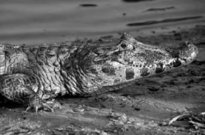
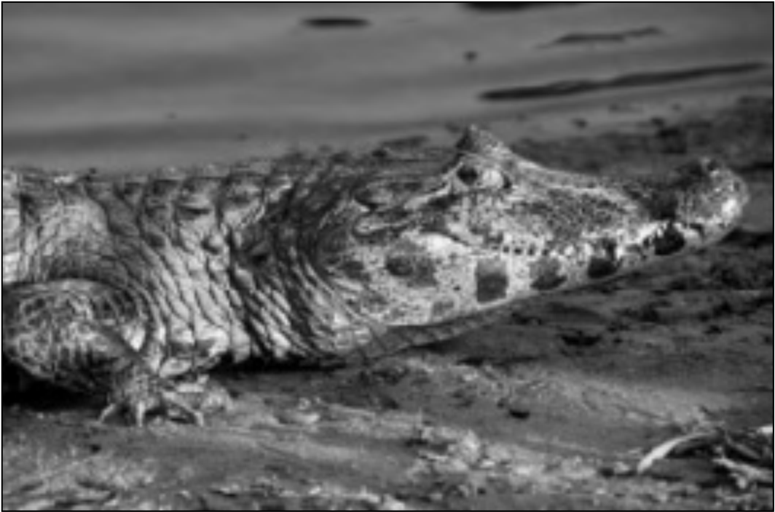
Caimans
By the early 1970s, an estimated
90% of the two million or so
crocodilian skins in trade were from
the | Latin |  | American |  | Common |  | Yacare Caiman Caiman yacare, exploited for the leather | Credit: Michel Gunther/WWF-Canon
Caiman Caiman crocodilus (Hutton |  |  |  |  |  |  | Yacare Caiman Caiman yacare, exploited for the leather | Credit: Michel Gunther/WWF-Canon
and Webb, 2003). Exploitation was |  |  |  |  |  |  | Yacare Caiman Caiman yacare, exploited for the leather | Credit: Michel Gunther/WWF-Canon
occurring at such a rate, however, |  |  |  |  |  |  | Yacare Caiman Caiman yacare, exploited for the leather | Credit: Michel Gunther/WWF-Canon
that many populations declined |  |  |  |  |  |  | Yacare Caiman Caiman yacare, exploited for the leather | Credit: Michel Gunther/WWF-Canon
rapidly, |  | some |  | reaching |  | near | Yacare Caiman Caiman yacare, exploited for the leather | Credit: Michel Gunther/WWF-Canon
extinction. As with some other |  |  |  |  |  |  | Yacare Caiman Caiman yacare, exploited for the leather | Credit: Michel Gunther/WWF-Canon
crocodilian species, some caimans |  |  |  |  |  |  | Yacare Caiman Caiman yacare, exploited for the leather | Credit: Michel Gunther/WWF-Canon
were therefore listed in CITES |  |  |  |  |  |  | Yacare Caiman Caiman yacare, exploited for the leather | Credit: Michel Gunther/WWF-Canon
Appendix I with the coming into |  |  |  |  |  |  | Yacare Caiman Caiman yacare, exploited for the leather | Credit: Michel Gunther/WWF-Canon
 |  |  |  |  |  |  | trade in Bolivia | Credit: Michel Gunther/WWF-Canon
force of the Convention in 1975: |  |  |  |  |  |  | trade in Bolivia | Credit: Michel Gunther/WWF-Canon
Broad-nosed |  |  | Caiman |  | Caiman |  | trade in Bolivia | Credit: Michel Gunther/WWF-Canon
latirostris, Black Caiman and the Common Caiman subspecies C. crocodilus apaporiensis.
Some trade in skins of the Appendix I-listed species/subspecies continued—either legally, as trade in captive-bred specimens and/or only countries not Party to CITES, or illegally, in response to the high demand. In order to tackle the illegal trade, CITES Parties permitted transfer of certain crocodilian species and/or populations from Appendix I to II as long as measures to ensure sustainability were taken—including strict quotas for wild harvested specimens and/or ranching programmes (Hutton and Webb, 2003). This included, for example, Ecuador’s population of Black Caiman (initially subject to a zero export quota) in 1995, and Brazil’s population of this species in 2007.
In response to concerns regarding population declines and associated CITES processes, during the 1980s countries around the world developed crocodilian management programmes. These included harvesting from the wild and ranching programmes in, for example, Venezuela, Guyana, Brazil, Argentina and Bolivia (Case Study 2: Box 3), as well as captive-breeding initiatives. Trade therefore moved from being dominated by skins harvested from the wild prior to the 1980s to being dominated by ranched or captive-bred specimens after the 1980s (MacGregor, 2002). Management programmes are based on evaluations of the impact of the harvest on wild populations and, in the case of ranching and captive breeding, include restocking wild populations with juveniles reared in captivity (A. Velasco in litt., Regional Chairman, Latin America and the Caribbean, Crocodile Specialist Group of IUCN, 6 November 2007). In order to pre-empt any re-emergence of the illegal trade, CITES Parties also introduced a universal tagging system in 1992, whereby skins are required to be certified at points of origin and re-export as having been legally sourced.
54 TRADING NATURE:Wildlife trade and the Millennium Development Goals


Case Study 2: Box 3
Examples of caiman management programmes in Latin America
Venezuela: A management programme was started for the Common Caiman in 1983 by the Ministry of Environment and Natural Resources (MARNR), aimed at commercial production of skins, with meat as a commercial by-product. Under this programme, harvesting of wild populations on authorized private cattle ranches is allowed under permits issued by MARNR, provided certain conditions are met. There are seasonal and minimum size limits, a quota, and skins must be marked with a unique number plastic tag to comply with CITES tagging requirements. The large quantity exported (about 40 000–50 000 a year 1997–2003 (Velasco and de Sola, 2005) is thought to be sustainable. Some 10 million hectares of land within the Llanos area are now within the programme, although not all caiman populations are harvested (Thorbjarnarson and Velasco, 1999).
Bolivia: A total ban on wildlife export introduced in 1990 was lifted in 1999 and programmes for harvesting Common Caiman and Yacare Caiman were initiated based on the Venezuelan model, with licences given to indigenous communities or cattle farmers by the Ministry of Environment, Natural Resources and Forest Development (VMARNDF), to harvest wild populations. An annual quota is set based on censuses. In 1999, the quota for Common Caiman was 36 500 skins and 30 000 skins were harvested in Beni Province by the Indigenous Communities of Beni (CPIB) for commercial use (i.e. to be sent to tanneries). The quota has increased in recent years but is within that set by CITES (FFI, 2006; Burgener, 2007). Export quotas were set at 50 000 skins for each of the years 2006–2008. A ranching programme using wild-collected eggs was initiated in 2006 (Velasco in litt.., 6 November 2007).
Brazil: A ranching programme for Yacare Caiman has been under way for many years involving collection of eggs from the wild and rearing in captivity (CITES, 2007b). Black Caiman are taken from the wild for meat and the skins are not used, but a wild-harvesting programme for skins has been proposed, following an experimental programme that looked at its economic potential. Harvesting would be allowed only in Sustainable Use Conservation Units and would focus on juvenile males, with the take limited to less than 10% of the estimated non-hatchling population size (FFI, 2006; CITES, 2007b).
Vicuña
The Inca considered the Vicuña to be sacred and collected the wool by rounding animals up into a corral and shearing them—an annual activity called a chaku. Following the arrival of Europeans, Vicuñas were hunted rather than shorn—in order to speed up the wool production—and this, combined with livestock competition and possibly disease brought by domestic European livestock, led to a drastic decline in populations, from an estimated two million at the time of the Spanish Conquest to about 10 000 in the 1960s. The Vicuña was therefore listed in CITES Appendix I as soon as it came into force, reflecting its perilous conservation status (Engler and Parry-Jones, 2007; Lichtenstein and Renaudeau d’Arc, undated). Even prior to CITES, however, a regional Convention for the Conservation and Management of Vicuña (Vicuña Convention) had been developed (in 1967) and
TRADING NATURE:Wildlife trade and the Millennium Development Goals 55

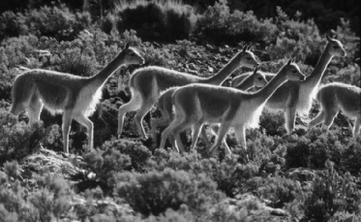
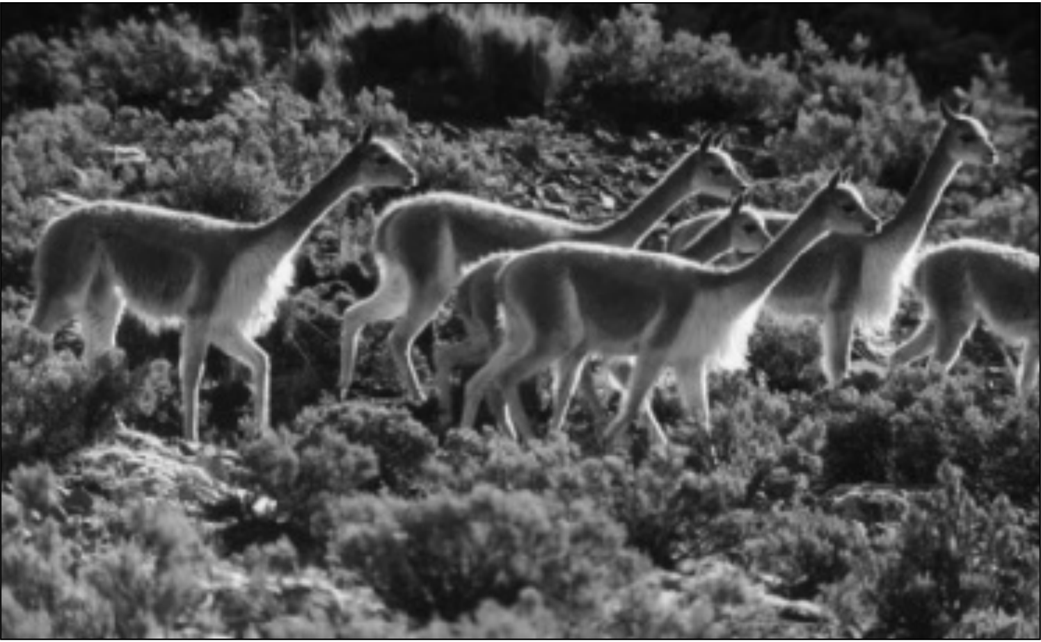
signed by Bolivia and Peru in 1969, Chile and Argentina in 1974 (Bonacic and Gimpel, 2003), and Ecuador in 1979. A primary objective of the Convention is to protect wild Vicuñas for the benefit of Andean communities and to allow trade in wool shorn from live animals (Lichtenstein and Vila, 2003).
Credit: Hartmut Jungius/WWF-Canon
Vicuña Vicugna vicugna
Vicuña populations made a rapid comeback—the total population size is now in the order of over a quarter of a million (Bonacic et al., 2006). As a result, by 1987, some populations were transferred to CITES Appendix II to allow trade in wool from live-shorn animals and, by 2003, all populations of Peru and Bolivia and some populations in Argentina and Chile had been so transferred. As for caimans, all products traded must be labelled, identifying the country of origin of the wool. Also as for caimans, different countries have developed different approaches to Vicuña management. Two broad management models have emerged—communal and private.
Communal management schemes, whereby whole communities are collectively responsible for the animals on their land, first started in Peru and are now being extended to Bolivia and Chile. Bolivia and Peru have specific legislation that supports this approach and seeks to ensure that the benefits of Vicuña use accrue to local people (Lichtenstein and Vila, 2003; Engler and Parry-Jones, 2007). In contrast, Argentina, where land is mainly owned by private ranchers, has a system based on private ownership (Case Study 2: Box 4). New legislation in Peru allowing individuals, as well as communities, to own Vicuñas on their land has opened the way to privatization in this country and resulted in much concern in some quarters as benefits to communities could potentially be reduced (Sahley et al., 2004).
Vicuña management plans were originally designed for whole communities to catch small groups of Vicuñas annually, shear them, and then release them, thus having minimal impacts on the wild
56 TRADING NATURE:Wildlife trade and the Millennium Development Goals


population (called wild management). However, there is now a growing trend in both the communal and private systems for captive management, which means that animals are kept permanently in a system of fully fenced enclosures or corrals on land from which domestic stock has been removed. A third system, used in Peru, is “repopulation” (see below).
Case Study 2: Box 4
Peru and Argentina: Different approaches to managing Vicuña
Peru: The campesino communities on whose land the Vicuña live were granted ownership of the animals and the right to use their products in 1995. Communities must set up Vicuña Management Committees and register with the government (Wheeler and Hoces, 1997; Sahley et al., 2004). The wool is sold through the National Vicuña Society (NVS), a federation of producer communities set up in 1993, which prevents competition between producers and with intermediaries and ensures the “exclusivity” of the product. NVS organizes the sale of the wool to an international consortium based in Italy (de Roy, 2002; Roe et al., 2002).
All three types of management are being implemented. Most Vicuña in Peru are under “wild” management where the communities employ guards to protect the animals on their land from illegal hunting and, once a year, organize the chakus. Captive management was initiated in 1996 by the National Council (or Corporation) for South American Camelids (CONACS) and is being promoted by the government. CONACS provides the fencing to build corrals on communal land but communities have to repay the cost through the sale of wool. An estimated 26 000 Vicuña are now kept in this manner. The third type of management is repopulation and involves transferring animals from dense populations to communities that have few Vicuñas; these translocated animals are maintained in corrals (Sahley et al., 2004).
Argentina: There is no wild management of Vicuña in Argentina but around 1500 animals are kept in corrals owned by individual ranchers. Fencing materials and shearing equipment are provided by the main local wool buyers but the cost of these has to be repaid in wool, which may take four to 10 years. The Vicuña are provided by the State-run National Institute of Agriculture and Cattle Technology (INTA) from its own captive herd; INTA also runs the wool auction and provides technical assistance (Lichtenstein and Vila, 2003). The producers have to repay INTA with Vicuña produced by their captive herds, which may also take several years.
Impacts of trade management
Trade and associated harvest management has certainly resulted in increases in populations of the wild species described above. Vicuña populations have recovered sufficiently well for community-based management and trade programmes to begin. Caiman populations have also recovered—although trade is still centred on ex situ production. Trade management has, not surprisingly, had some impact on local incomes, however. Revenue from the Latin American skin trade was greatest in the period of
TRADING NATURE:Wildlife trade and the Millennium Development Goals 57

the 1950s to 1970s, before controls on trade were introduced—although this was to the detriment of the wildlife involved, as was particularly evident with caimans and Vicuñas. As a result, income benefits on the scale seen during the middle of the last century would have been relatively short-lived, regardless of whether trade controls were introduced. If trade had pushed to the point where wild populations were further reduced, and/or species became extinct, then the income potential would have been lost permanently.
Achieving similar levels of economic benefits through sustainable management is proving more difficult because of the generally lower rates of exploitation, the higher management costs involved, and slower rates of return. Despite the high value of the products and the particular characteristics that make these species suitable for exploitation (high reproductive rates in caimans and peccaries; live-shearing of wool from Vicuñas) incomes are currently only marginal, particularly for hunters (Bodmer et al., 2004b). The total annual value of the Peruvian peccary skin trade, for example, is estimated at USD4 868 500, of which only 1.5% goes to the hunters, 11.1% to the national pelt industry and 87.3% to the international leather industry (Chardonnet et al., 2002; Bodmer et al., 2004a). The three Peruvian tanneries that work with peccary skins do, however, have a respectable return. Two work exclusively with these species and one tans other types of leather as well (Bodmer et al., 2004a).
Economic returns from caiman harvesting may be similarly small. In Venezuela, for example, 1983–1995, an average of 80 000 caimans were harvested annually with a total export value of over USD115 million for that period. However the mean annual income from the sale of caiman skins from an average sized ranch (9435 ha) was only USD2114, which is very small compared with the income from cattle (USD66 800–223 000) from a similar sized ranch (Thorbjarnarson and Velasco, 1999). Income earned through, for example, the collection of eggs or neonates can, however, be significant for the poor and landless with few other income-generating opportunities (Thorbjarnarson, 1999). Most caiman harvesting programmes are implemented by local people, including ranch owners, and indigenous people. Hunters and egg collectors receive a salary or are paid according to how many skins they obtain or eggs they collect, nevertheless respecting the annual regulations based on biological, ecological, reproductive studies for all species in all countries (A. Velasco in litt., 6 November 2007).
Burgener (2007) concludes that local people are benefiting from the caiman skin trade in Bolivia, but there are concerns that the programme may be closed down as a result of problems in the value chain, conflicts among stakeholders, lack of proper monitoring and control systems and an inadequate legal framework (FFI, 2006). The United Nations Conference on Environment and Development’s (UNCTAD) BioTrade Initiative is trying to address this problem by exploring the potential of a certifi-cation scheme for caiman leather in order to help promote the quality and sustainability of the trade, thus generating better and more secure returns for local participants.
The Vicuña trade is better documented, but even here it is not entirely clear to what extent communities are benefiting. Lichtenstein and Vila (2003) considered that over the 10 years after trade in Vicuña
58 TRADING NATURE:Wildlife trade and the Millennium Development Goals

wool was allowed to resume, “the economic benefits intended to change local community attitudes towards Vicuñas” had “yet to deliver either conservation or poverty alleviation”. The hope was that opening trade in wool from live-shorn Vicuñas would encourage local participation and create a positive attitude towards this species that would lead to greater tolerance on community lands where Vicuñas tend to compete with domestic livestock, reduced poaching (or a decrease in logistic support to poachers), gradual replacement of sheep and cows by Vicuñas, and support for conservation measures. However, commentators have mixed opinions on whether this has indeed been the case.
In Peru, over 780 Andean communities (over 250 000 families) are registered to participate in managing Vicuñas (although not all are involved yet) (Sahley et al., 2004). There is considerable variation in the extent to which different communities benefit from the wool trade, however (Bonacic and Gimpel, 2003) and the greatest benefits captured are where Vicuña abundance is high, effective property rights agreements have been agreed, and the wild management system is used (Roe et al., 2002; Engler and Parry-Jones, 2007). In the districts of Lucanas and San Cristobal, for example, which have 11 000 and 7000 animals, respectively, each animal is worth USD17–28 a year (based on 1998 wool prices) (Roe et al., 2002).
However, where captive management is used, the communities have to cover the costs of materials for the corrals (approximately USD20 000 each), provide their labour for free, and remove their domestic animals from the land. As a result, some small communities have fallen into debt (Lichtenstein and Vila, 2003). It has been calculated that a minimum of 250 Vicuñas are needed for the economic viability of a captive management scheme (Sahley et al., 2004). In Argentina, over 30% of captive management enterprises have reportedly given up or had to close down (Lichtenstein and Vila, 2003).
The level of economic benefit also depends very much on the market price for wool. In 1994, NVS managed to get a good deal at the first auction for wool—2000 kg brought in USD1.3 million; the proceeds were divided among the 35 communities involved, 30% being earmarked for Vicuña conser-vation and management activities, and 70% for community development activities (Wheeler and Hoces, 1997). Since then, prices have been lower, stagnating at USD140/lb (about USD300/kg) as a result of the monopoly held by the International Vicuña Consortium (de Roy, 2002).
Conclusions—the contribution of the skin trade to achieving the MDGs
It is clear that the Latin American skins and wool trade is contributing to MDG 1 in terms of income and employment. Management of the trade also contributes to MDG 7 on environmental sustain-ability—there appears to be little concern about any ecological impacts. Wild management of Vicuñas, for example, is generally considered to have a positive impact on the environment (although monitoring data are lacking), while there is no evidence that caiman and peccary harvesting is having any detrimental effect and the proposed harvesting and certification programmes require that healthy habitat is maintained. In this case, therefore, the trade is not undermining the natural resource base on which poor communities are so dependent for their livelihoods.
TRADING NATURE:Wildlife trade and the Millennium Development Goals 59

However, a much greater understanding of the social and economic status of the communities involved at the production end is needed in order to understand the significance of the trade to household and local community economies better. Given that the Latin American skin trade is aimed primarily at international, high-value markets, it faces many of the same challenges for local livelihoods as many other NTFP commercialization programmes—as discussed earlier in this report—including (Thorbjarnarson, 1999):
• the relatively limited market for luxury goods, which is influenced by the global fashion industry;• competition from other cheaper but equivalent products (e.g. cashmere from China and improved wool from sheep and Alpacas Vicugna pacos, in the case of Vicuña wool (Bonacic and Gimpel, 2003); Ostrich in the case of caiman leather);
• the fact that trade in luxury goods is likely to decline first if the global economic situation worsens; and
• problems associated with ensuring a steady production of skins where many sustainable use programmes are not working effectively enough to deliver steady supplies.
Nevertheless, the experiences from the various efforts at sustainable management suggest interesting approaches and models for the future that could enhance the livelihood contributions made by this trade.
60 TRADING NATURE:Wildlife trade and the Millennium Development Goals



CASE STUDY 3: TRADE IN ASIAN COASTAL FISHERIES PRODUCTS
Introduction
Marine fish and invertebrates are the
last great source of wild-caught food
on the planet. Over one third of the
global fish catch is traded interna-
tionally and a large proportion of the
remainder enters local trade. The
fish trade is steadily increasing and
worldwide is worth over USD71
billion a year (Macfadyen et al.,
2005). The main direction of trade is
from | developing | countries | to
developed countries, on top of a
huge | domestic | trade | within
developing countries. Growth in
international trade is symptomatic of
a rapidly globalizing market, fuelled by growing demand for fish in developed countries and facilitated by new storage and transport |  |  | Credit:Cat Holloway/WWF-Canon
technologies | (Kurien, | 2005; | Credit:Cat Holloway/WWF-Canon
Macfadyen et al., 2005). |  |  | Credit:Cat Holloway/WWF-Canon

In Asia, millions of people are involved in a wide range of fishery-

Clown Anemonefish Amphiprion ocellaris, Papua New Guinea

related activities (Case study 3: Box 3), from full-time, small-scale operators to those involved in seasonal and migratory positions in the processing and marketing industries (Gonzales et al., 2006). Much of the fisheries trade in this region is based on products from reefs, a key resource for poor communities (Whittingham et al., 2003). Coastal fishery stocks in Asia are considered to have declined by as much as 40% since the end of the 1990s (Gonzales et al., 2006).
This case study focuses on three groups or taxa—ornamental fish and invertebrates, seahorses and Humphead Wrasse. These are small components of the global fish trade but are of interest because of their relatively high value on the export market, which means that they could potentially bring increased economic benefits to the coastal communities involved in their collection without necessarily impacting local food security.
TRADING NATURE:Wildlife trade and the Millennium Development Goals 61


Case study 3: Box 1
The diversity of the Asian fisheries trade
A vast range of species and types of product, live or dead, are involved in the Asian fisheries trade. They can be broadly categorized as follows:
Seafood:
• Fresh fish; especially reef fish—harvested at market size or as juveniles for grow-out (Sadovy et al., 2003).
• Fresh invertebrates for local sale and export including octopus, squid, shrimp, crabs, lobsters, abalone, giant clams and many other molluscs.
Dried fish and invertebrates; a vast number of species and products involved; traded between coastal•
communities and with inland communities where it is an important source of protein.
• Live fish for Asian restaurants (Sadovy et al., 2003).
• Sea cucumbers; about 300 species involved; usually dried for sale and exported to countries in Asia; their easy collection in shallow areas has led to widespread decline, as well as dependence by local communities on collecting as a source of income (Clarke, 2002; Bruckner et al., 2003).
• Shark fins: dried and used for shark-fin soup and other “celebratory” dishes in East Asia, prices reaching as high as USD400/kg; some 30–40 species are exploited from over 120 countries; harvesting is a major contributor to the decline of many shark species worldwide (Clarke, 2002).
Ornamental products:
• Corals and shells for the curio trade; 70–90% of corals in international trade originate from Indonesia (Wabnitz et al., 2003).
• Pearl oysters; for pearls and nacre.
• Fish and invertebrates for the aquarium trade.
Other products:
• Seaweeds: cultivated in large quantities in South-east Asia for the agar industry.
• Seahorses and invertebrates for traditional medicines and pharmaceuticals; includes pipefish (Martin- Smith and Vincent, 2006) and seamoths (Pajaro et al. 2004).
• “Trash” fish and invertebrates; inedible small species sold for feeding to edible fish and invertebrates, e.g. lobsters and live reef fish, for “grow-out”.
Ornamental fish and invertebrates for the marine aquarium trade
Nature and scale of the trade
An estimated 1.5–2 million people worldwide have marine aquaria, mainly in USA and Europe, and increasingly in Asia itself (Wabnitz et al., 2003; Macfadyen et al., 2005). Over 20 million fish, of some 1470 species, 9–10 million marine ornamental invertebrates (excluding coral) of some 500 species,
62 TRADING NATURE:Wildlife trade and the Millennium Development Goals



including molluscs, shrimps and anemones, 140 stony coral and 61 soft coral species are involved in the aquarium trade each year. Estimates of the value of the trade vary, but it may be as high as USD330 million a year (Wabnitz et al., 2003).
Unlike freshwater aquaria species, 90% of which are farmed, the majority of marine ornamental species are taken from the wild, largely from coral reefs. South-east Asia is the main source, with Indonesia and the Philippines the two largest exporters, accounting for 80% of the trade (Wabnitz et al., 2003). With the rapidly expanding hobby trade in both the Philippines and Indonesia, there is also now a substantial domestic trade in these countries (MAMTI, 2006).
The | marine | ornamental | trade
provides income for poor people in
coastal communities where few
other livelihood options exist and
where there is dwindling production
from capture fisheries. The industry
involves a range of different groups,
including the collectors who use
boats or swim, women and children
who glean on shallow reefs, packers,
cleaners and others who work in the
processing and exporting companies,
many of whom get most of their
yearly income from the business.
Some work part time and have other
jobs; others are solely dependent on
the trade, while some are children. Compared to many other forms of fishing, the equipment and skills needed are simple, especially for shallow-water species (e.g. Banggai Cardinal Fish Pterapogon kauderni and clownfishes and anemonefishes | Credit:Cat Holloway/WWF-Canon

Amphiprioninae) and the low prices paid per fish mean that generally other fishers do not try to compete.

Tomato Anemonefish Amphiprion frenatus, Fiji

The supply chain is complex and involves large numbers of people with collectors spread over wide areas, hundreds of middlemen and numerous exporting companies. The Philippines, for example, has an estimated 5000–7000 aquarium fish collectors with a further 3000–4000 people involved as traders, working in holding facilities and so on. Indonesia has an estimated 10 000 collectors, with numerous other people involved in the trade (MAC and ReefCheck, 2006; MAMTI, 2006). Collectors use basic
TRADING NATURE:Wildlife trade and the Millennium Development Goals 63

equipment such as “tickler sticks”, hand nets and barrier nets, although more sophisticated scuba equipment is increasingly being used. Many use cyanide to stun the organisms before collection. Collecting trips may be self-financed or funded by wholesalers and exporters, with advanced expenses deducted from the income from their catch after each diving operation. Once ashore, species are placed in holding tanks, or immediately packaged for transport and/or export. From large numbers of producers, exports tend to be channelled through a relatively small number of exporters (Macfadyen et al., 2005). There are about 30 export companies in the Philippines, while in Indonesia there are over 100 registered exporters mainly located in Jakarta and Bali (Lilley, 2001).
Aquarium fish collectors are usually paid according to the number of fish they collect (Macfadyen et al., 2005), receiving highest prices for rare species with attractive or unusual colours and appearances—most specimens collected are juveniles as these are easier and cheaper to transport and most are more attractive visually than the adults (MAMTI, 2006). As with many trade chains, however, the collectors tend to secure a very small proportion of the sale price. In the late 1990s in the Philippines, for example, 85% of the price paid for fish by exporters went to middlemen whereas only 15% went to collectors (Rubec et al., 2000). In addition, a cycle of debt often develops with middlemen providing food, boats, fuel and sometimes cyanide to fishers in return for inexpensive fish. Poverty and lack of alternative livelihood options means that people borrow money at high rates and often illiterate subsistence fishers make financial decisions that bind them to selling at low prices to middlemen (Shuman et al., 2004).
Despite this, earnings can be substantial—Gonzales and Savaris (2005) found that collectors in the Philippines might earn between USD9 and USD233 a month, compared with other fishers (USD36–144 a month), shell gleaners (USD2.7–4.5) and seafood vendors (USD43–50 a month). And although there is such disparity in the amounts earned at different stages of the supply chain, each level seems to operate on relatively fixed margins from their respective suppliers one step back down the chain. Middlemen and women provide important services, such as credit and some limited market information. Shipping costs and the equipment and infrastructure needed to maintain healthy live fish are substantial and so the price structure may not be as intrinsically “anti-poor” as it appears. It does mean, however, that if the sale price could be increased (e.g. through certification and improved quality) and costs and/or mortalities reduced, additional benefits could be generated throughout the supply chain (Macfadyen et al. 2005).
Management of the trade
In most countries, collection of specimens for the aquarium trade is unregulated. International trade is also unregulated except for those few taxa covered by CITES (mainly corals, seahorses and giant clams). Few fish or invertebrate species are listed, partly because of the difficulty in obtaining the necessary data to determine if populations meet the required criteria for the various Appendices, and partly because of perspectives on the “endless” fish supply of the sea. In Indonesia, there is some regulation through a trade association: only members of the national coral exporters association AKKII may legally export live corals (Macfadyen et al., 2005).
64 TRADING NATURE:Wildlife trade and the Millennium Development Goals


In the Philippines and Indonesia, however, a major programme—The Marine Aquarium Management Transformation Initiative (MAMTI: funded by USAID, a joint initiative between MAC, ReefCheck, and the Community Conservation Investment Forum (CCFI))—was initiated to promote sustainable management of the trade and minimize its ecological impact, using a certification scheme (Case study 3: Box 2).
Case study 3: Box 2
MAC (Marine Aquarium Council) certification standards
There are four different standards in the MAC certification programme addressing (1) management of the collection area, (2) collection and handling prior to export, (3) handling and transport during export, and (4) aquaculture. All aspects of the supply chain are covered. Of most relevance here are the Ecosystem and Fishery Management (EFM) and Collection, Fishing and Handling (CFH) standards. The EFM standard requires that the collection area be defined, a Collection Area Management Plan (CAMP) be drafted by a multi-stakeholder committee and adopted, a Total Allowable Catch (TAC) agreed and the No-take areas are harvest monitored, and that reef health and fish stocks be monitored regularly.
identified adjacent to the collection areas and, in some cases, rehabilitation and restoration of reefs is undertaken (MAMTI and MAC 2007). This standard has proved difficult to implement because of the lack of scientific knowledge about the reproductive biology and life history characteristics of most target species (Shuman et al., 2004).
The standards require that collectors be trained, that they use non-destructive techniques, comply with local laws and maintain catch records, and that best practices be used during post-harvest handling. A total of 483 collectors and traders have been trained for EFM and CFH standards and 167 in the Philippines and 145 in Indonesia have been certified to these standards (MAMTI and MAC, 2007).
A serious problem associated with the aquarium fish trade is the use of sodium cyanide—a practice that is now banned throughout Asia. Cyanide temporarily stuns the fish but also causes broad-spectrum damage to other organisms on the reef and is considered to be a major threat to reefs across the Indo-Pacific and especially South-east Asia. Enforcement of the ban has proved difficult because cyanide is easy to obtain, inexpensive and makes fish catching easier (Wood, 2001). The MAC certification process is helping to reduce its use which is not only benefiting local fishers, as noted above, but also having a positive ecological effect.
In addition, in the Philippines, the certification process is bringing the “best practices” developed for the aquarium trade into broader Fisheries Management Plans and has led to strengthening of seven no-take Marine Protected Areas (MPAs). By closely linking no-take areas with aquarium fish collection, there is improved willingness in local communities to support and manage the MPAs (Shuman et al., 2004; MAMTI and MAC, 2007). The certification process also generates an immense amount of information that can be used to improve management in general (Macfadyen et al., 2005).
TRADING NATURE:Wildlife trade and the Millennium Development Goals 65

Impacts of trade management
At present, there is little evidence of a real increase in prices of fish as a result of MAC certification. There are anecdotal reports that in the Philippines the introduction of better management practices has seen benefits at Batasan Island in the form of better pricing and better income for collectors, owing to reduced mortality rates (Macfadyen et al., 2005). However MAC personnel state that, so far, MAC-certified species have not resulted in higher prices for collectors in the Philippines (Ronet Santos, MAC, in litt., 16 October 2007). In Indonesia, collectors and local traders in Pulau Seribu (Jakarta Bay) have reported that they are paid more for MAC-certified fish and that their income has increased by USD3–5 a day. They also say that some species that had previously declined or disappeared are now more abundant; although it is not clear if this is linked to MAC activities, it is a positive development (G. Lilley, MAC, in litt., 15 October 2007). There is a risk that, if certification does result in higher prices, it will become more attractive and more fishers will be enticed into the business. Regulating collecting effort by restricting the number of collectors is one way to avoid this problem (Wood 2001).
There are a number of other benefits from the MAC certification procedure that are already being realized. Many collectors suffer from poor health caused by the long hours spent under water at depth and the poor quality of compressed air. The MAC certification process is promoting free diving and helping to eliminate or reduce the use of compressors and, at a minimum, improving the way they are used to reduce injury (Macfadyen et al., 2005).
Through the MAMTI project, collectors and communities are also receiving financial and business training and have improved their community organization skills, household and business financial management and ability to manage savings and loans. The project has developed links with micro-finance institutions and other businesses that can support collectors and traders. As a result, over USD13 000 has been accessed as loans by those in the lower levels of the supply chain, to buy equipment and materials (e.g. collecting nets, jars, holding tanks). The loans have seen 100% repayment in the Philippines and 86% in Indonesia (MAMTI and MAC, 2007). The MAMTI project is also specifically addressing women and ensuring that they can participate in the industry and benefit from it. Collectors are also increasingly involved in broader coastal resource management efforts in their communities, which will help to sustain the fishery. Exporters are now reporting that the quality of MAC-certified fish has improved (MAMTI and MAC, 2007).
One major problem, however, is that in both Indonesia and the Philippines the majority (an estimated 50–80%) of collectors are “roving”, i.e. they harvest in areas where they are not legal residents. Many are ethnic groups such as the Bajao or “sea gypsies”, who traditionally live at sea and depend on marine resources for their survival. The extent of this has only been discovered recently (MAMTI, 2006). Although these collectors may be harvesting legally, their roving lifestyle makes it difficult to develop Collection Area Management Plans, and thus at present they cannot be certified under the EFM standard. Many use cyanide and diving equipment such as compressors and the quality of their specimens is poor: they receive low prices for them and have a rejection rate of 20–30%, compared
66 TRADING NATURE:Wildlife trade and the Millennium Development Goals

with 6–19% for MAC-certified collectors. If trained, roving collectors could be certified under the CFH standard. There is also potential for using the EFM standard for collecting “corridors” or a series of collection areas (MAMTI, 2006). It is clearly important that this group of collectors is incorporated into sustainable management programmes and MAC will start to address this issue.
Seahorses
Nature and scale of the trade
Seahorses Hippocampus spp. inhabit a circum-global band of tropical and temperate seas in sea grass, mangroves and coral reefs, with a few species ranging into deeper waters (Foster and Vincent, 2005). There are at least 33 species but the taxonomy is highly problematic and more will probably be described in the future (Lourie et al., 2004). At least 77 countries are involved in international trade. The main exporting nations are in Asia (India, the Philippines, Thailand and Viet Nam), as are the main importers (China and Taiwan) (Foster, 2005). Case Study 3: Box 3 summarizes the main products and purposes of the seahorse trade.
The vast majority of the seahorse trade is international, but there is a small domestic trade in some countries e.g. Viet Nam (Giles et al., 2005) and Indonesia (Vincent, 1996) for traditional medicine. In Australia, there is a low-volume domestic trade in live and dried seahorses estimated to be worth about USD163 000 a year. According to Hong Kong’s import statistics, Australia exported around USD27 000 worth of dried seahorses each year 1998–2002, most of which were derived from aquaculture rather than targeted fisheries or by-catch (Martin-Smith and Vincent, 2006). Annual seahorse exports from Viet Nam may be worth VND2–10 million (USD170 000–962 000) (Giles et al., 2005).
In some countries, catch rates from individual fishers and vessels are relatively low (e.g. around 1–2 seahorses per trawling vessel per night in Viet Nam, (Meeuwig et al., 2006)), but the sale of seahorses is considered as a welcome bonus making a limited contribution to the annual incomes. In the Philippines, most people who target seahorses are subsistence fishers who derive their main cash income from these species, allowing them to buy rice and other food (Vincent, 1997). In Palawan and the central Philippines, seahorse fishers and traders reported that seahorses contributed approximately 30–40% of their annual income—although sometimes this proportion reached 80%—and up to 90–100% in the main seahorse fishing season. Similar figures of reliance on seahorse fishing and trading were found in southern India and Indonesia (Vincent, 1996). Equally, fishers and traders in trawl fisheries benefit from the sale of seahorses taken as by-catch e.g. in Viet Nam (Giles et al., 2005).
Reports from fishers and traders suggest that severe declines in seahorse populations have occurred in the past few decades (Vincent, 1996) and in some areas, such as Latin America, declines are as high as 90% (Baum and Vincent, 2005). There are also reports of a decline in the size of seahorses being caught (Vincent, 1996). Habitat degradation of coral reefs, seagrass meadows and mangroves, as well as fishing pressure, are likely to be contributing to these declines. The damage caused by trawlers to shallow coastal habitat is a further concern for seahorse conservation (Lourie et al., 2004). Seven
TRADING NATURE:Wildlife trade and the Millennium Development Goals 67


seahorse species are currently listed as Vulnerable, one as Endangered and the remaining as Data Deficient in IUCN’s Red List (IUCN 2007).
Case study 3: Box 3
Different uses of seahorses in international trade
USE: Traditional Chinese medicine (TCM)
PRODUCT: Dried seahorses
SCALE OF TRADE: TCM accounts for an estimated 90% of the overall trade in seahorses (Foster, 2005). In the mid 1990s, at least 20 million seahorses were traded each year mainly for this purpose, with demand increasing by around 10% per year (Vincent, 1996). Demand continues to outstrip supply by far, driven partly by economic growth in China.
SOURCE: Wild-caught. Some are taken in directed fisheries, usually involving hand-collection by divers, e.g. in the Philippines (Martin-Smith et al., 2004), Indonesia (Vincent, 1996) and Latin America (Baum and Vincent, 2005). Others are caught as by-catch in trawl fisheries (often shrimp fisheries) in the tropics, e.g. in the Gulf of Mexico (Baum et al., 2003), India (Salin and Yohannan, 2005) and Viet Nam (Meeuwig et al., 2006).
USE: Curios
PRODUCT: Dead specimens
SCALE OF TRADE: Dead seahorses are sold as souvenirs in beach resorts and shell shops around the world.
SOURCE: As for TCM.
USE: Ornamentals
PRODUCT: Live specimens
SCALE OF TRADE: North America and Europe are the main markets for live seahorses for public and private aquaria; an estimated 50 000 live, captive-bred seahorses and approximately one million live, wild-caught seahorses are traded each year (Dennis, 2006), most exports coming from Indonesia and the Philippines as part of the wider marine aquarium trade.
SOURCE: Wild-caught and captive-bred. In Sri Lanka and Viet Nam pregnant males are captured and the young are then reared in captivity to marketable sizes (Vincent, 1996; Dennis, 2006). Public aquaria also increasingly obtain seahorses from captive-breeding, often exchanging specimens between aquaria—e.g. a recent survey of 21 North American public aquaria indicated that over 80% of seahorses were derived from captive-bred sources (Koldewey, 2005).
The biology of seahorses renders them inherently vulnerable to heavy fishing pressure and habitat degradation. Males incubate relatively small clutches of eggs for prolonged periods, preventing seahorses from rapidly recovering from over-exploitation (Foster and Vincent, 2005). Furthermore, seahorses live at naturally low densities and have small home ranges and low mobility, which limits their capacity to recolonise heavily fished areas (Vincent, 1996).
68 TRADING NATURE:Wildlife trade and the Millennium Development Goals

Management of the trade
Recognizing that, although seahorses are vulnerable, populations could probably support a carefully managed harvest, all seahorse species were listed in CITES Appendix II in 2004 (Koldewey, 2005). In order for export permits to be issued, exporting nations that are Parties to CITES are required to make non-detriment findings (NDFs), which demonstrate that export levels do not threaten the future of the species in the wild.
At the local level, potential models for sustainable management of a seahorse fishery are the community-based MPAs work of which the first, initiated in the mid-nineties, was Handumon village, off the northern coast of Bohol, central Philippines (Pajaro et al., 1997). Trading in dried seahorses from this area began in the 1960s and in live seahorses for the aquarium trade in the 1970s and a certain degree of informal management had already evolved by the 1990s. This included the rotation of harvesting areas and avoidance of smaller seahorses (although the minimum size of seahorses allowed to be caught had decreased over the years). In 1995, at the suggestion of the village council, this arrangement was formalized with the establishment of a 33-ha protected area, patrolled and maintained by villagers (Vincent, 1997). Small seahorses are donated by fishers to be released into the sanctuary to help populations recover (Pajaro et al., 1997). There are now 28 MPAs in place, which are contributing to protection of seahorses and sustainable livelihoods for local communities (Meeuwig et al., 2003; Martin-Smith et al., 2004; Samoilys et al., 2007). Wider benefits have also been demonstrated with a higher abundance of other reef fish, both inside and outside the reserves (Samoilys et al., 2007).
An increasing number of specimens are being obtained through captive breeding and the benefits of this management approach are being assessed by Project Seahorse (Koldewey, in litt., 9 November 2007). For example, a research programme is underway at the National Institute of Oceanography in Viet Nam to rear captive and semi-captive seahorses for sale to the aquarium trade. The aim is to involve local farmers and fishermen, eventually, in establishing small-scale seahorse culturing in net fish cages placed in ponds and estuaries (Vincent, 1996; H. Scales, case study co-author, pers. comm. 2007).
Impacts of trade management
It is extremely challenging to make non-detriment findings for seahorses given the lack of knowledge about the biology and population status of most species (Koldewey, 2005). Consequently, as an interim measure, CITES is allowing exports of specimens, both dead and alive, with a minimum size limit of 10 cm, since this is the size at which most species involved in the trade have reached sexual maturity (Foster and Vincent, 2005). In the Philippines, however, CITES-listing has had the unintended impact of making seahorse fishing illegal as a result of existing domestic legislation; Section 97 of the Philippines 1998 Fisheries Code prohibits the harvesting and export of any species listed under CITES. Project Seahorse is working with seahorse fishing communities to study the implications of this ban, and also with the government to try and reverse it.
TRADING NATURE:Wildlife trade and the Millennium Development Goals 69

At present there is no information on the actual or potential livelihood benefits from a well-managed seahorse trade, given that management activities are relatively new. Given the extent of the seahorse trade and the growing demand for, and rising prices of, dried seahorses, it is highly likely that many thousands of people will continue to be dependent on the trade for some part of their income. Without effective trade management, the reported declines described above are a potential threat to local fishermen’s livelihoods and one which sustainable management could help to address.
Humphead Wrasse
Nature and scale of the trade
Humphead Wrasse, also known as the Maori Wrasse, Napoleon Wrasse or Napoleonfish, is one of the largest bony reef fish in the Indo-Pacific region. Large males can reach over two metres in length, developing a prominent bump on their heads, and can live for at least 30 years. Humphead Wrasse is a threatened species—listed as Endangered in the IUCN Red List (IUCN, 2007b)—and inherently vulnerable to overfishing, since the fish grow slowly, are late to mature and are naturally uncommon (Sadovy et al., 2004). They also spawn in small aggregations that may offer attractive targets for fishermen and can be easily depleted (Sadovy and Domeier, 2004).
Humphead Wrasse has become one of the most valuable species in the lucrative international trade in live reef food fish (LRFF), alongside other species of large-bodied coral reef fish, including groupers Serranidae spp., snappers Lutjanidae spp. and wrasses Labridae spp. (Sadovy et al., 2004). The flavour and texture of the fish are believed to be superior if they are kept alive until moments before cooking (Lee and Sadovy, 1998). Dining on freshly killed, colourful coral reef fish—a trend that began in the 1960s amongst wealthy Hong Kong businessmen—has become a prestigious and prodigious activity in ethnic Chinese communities around the world, driving a trade thought to be worth in excess of USD800 million per year (Johannes and Riepen, 1995; Sadovy et al., 2004). The most valuable Humphead Wrasse are the smaller “plate-sized” juveniles and sub-adults, while larger fish may be of interest for display. In particular, large, adult Humphead Wrasse are valued for banquets and special occasions such as Chinese New Year. The retail value of Humphead Wrasse in up-market seafood restaurants can be as high as USD180 per kg and a plate of the lips of adult males sold for USD150 in the late 1990s (Lau and Parry-Jones, 1999).
All large Humphead Wrasse in trade are wild-caught. Initially, these and other species involved in the LRFF trade were caught from reefs close to Hong Kong—which remains the main hub of the trade today. As those stocks became over-exploited and the demand for live fish increased, the trade began to open up in countries further from Hong Kong and today it stretches thousands of kilometres across the Indo-Pacific region, with live fish being exported, often by air, from as far away as Fiji, the Maldives, the Solomon Islands and the US Marshall Islands (Smith, 1997; Bentley, 1999; Hughes et al., 2003).
70 TRADING NATURE:Wildlife trade and the Millennium Development Goals


Figures on the number of fishers involved in the LRFF trade are not available. Prior to the 1980s, LRFF were mainly collected by large, foreign-owned, purpose-built transport vessels (mostly from Hong Kong and China) employing foreign divers and fishers (Bentley, 1999). Since the late 1980s and early 1990s, however, a range of locally owned, middle-level LRFF operations have emerged throughout the South-east Asian region, which either buy live fish from independent local fishers or employ local fishers on larger, locally operated vessels. In some areas, local fishers also sell catches directly to visiting foreign LRFF vessels, so that people who fished previously for subsistence purposes or to sell to local markets now participate. It is likely, therefore, that significant numbers of people are dependent to some extent on income from the trade.
At present, because of the increasing rarity of Humphead Wrasse in most parts of the Indo-Pacific, it is likely that very little income is derived overall from this species by fishers and traders. While many were still being caught perhaps 10 years ago, catches are now extremely rare and restricted to the most skilled fishers within a particular fishing community (H. Scales, unpublished thesis, 2005).
Case study 3: Box 4
Livelihood risks from involvement in the live reef food fish trade
Involvement in the LRFF trade is not without its risks to livelihoods. Investment costs are generally high (e.g. for motorized boats and specialized equipment) and can trigger a burden of debt if the income flow is not continuous or long lasting—as is often the case. The equipment itself can represent a risk to human health (for example, in the use of surface-fed “hookah” diving equipment) without necessary safety and training (Johannes and Riepen, 1995). The introduction of a cash-based LRFF trade also sometimes competes with, and has an impact on, traditional social processes such as contributions to food security, maintenance of networking and social coherence among community members (Kronen et al., 2006). There are few places where the LRFF trade has not sparked social disputes and disruption,such as conflict between fishers and traders over prices and the distribution of income within a community and between fishers and villages over ownership and access rights to fish in certain areas (Sadovy et al., 2003). Furthermore, the LRFF trade is highly susceptible to external political and economic pressures. The outbreak of Severe Acute Respiratory Syndrome (SARS) in 2003, for example, triggered a reduction in demand for live fish in restaurants in Hong Kong and, consequently, prices paid to fishers in several countries dropped by as much as 40% (Muldoon et al., 2005).
Management of the trade
Prior to 2004 there was no co-ordinated management of the trade in Humphead Wrasse. A few countries had set national size restrictions and export bans but these were weakly implemented (Lau and Parry-Jones, 1999). In the Pacific, a Regional Live Reef Fish Trade Initiative was established in 1998 by the Secretariat of the Pacific Community and is addressing conservation and sustainable management of both live food fish and marine ornamental fish (Sadovy et al., 2003). Overall, however, the main emphasis on management has been towards curbing the use of destructive fishing practices
TRADING NATURE:Wildlife trade and the Millennium Development Goals 71


such as cyanide fishing, which are strongly associated with the trade, rather than over-fishing which is the major problem (Sadovy et al., 2003).
Humphead Wrasse was listed in Appendix II of CITES in 2004, requiring source nations that are Party to CITES to introduce or enforce existing management measures to ensure the sustainability of the trade. As a result, several regional workshops have been held across South-east Asia in order to help co-ordinate national efforts, raise awareness of the Appendix II listing, facilitate data collection and develop methods to set quotas at a sustainable level (Chu et al., 2006). Some of the proposed management measures are still at the stage of discussion and recommendation and Indonesia is the only exporting nation to have set a CITES quota partly based on an analysis of stock status (FAO, 2007).
Case study 3: Box 5
Managing the Humphead Wrasse trade in Indonesia and Malaysia
The high value of Humphead Wrasse provides a strong incentive for illegal and unsustainable fishing, undermining the resource base for future fisheries, and therefore the economic base for present and future fishers. Efforts have been made to increase the availability of information about fisheries and trade patterns, with a focus on Indonesia and Malaysia, two of the largest producers, and to catalyse more effective management of fishing and trade, including through increased co-operation among fishers, traders and government agencies. This work, which was led by the IUCN/SSC Grouper and Wrasse Specialist Group (GWSG), in collaboration with FAO and the CITES Secretariat, provided a foundation for development of management tools for Humphead Wrasse in Indonesia, including a revised policy between fisheries, government and industry participants at local and national levels. Parameters developed by the GWSG and TRAFFIC for monitoring trade and wild populations will be used at government level to work with industry stakeholders to increase awareness of the need to regulate annual offtake from local populations, as well as annual limits on export volumes, and thereby secure the resource base for future harvest.
In Malaysia, management of the international trade in Humphead Wrasse was shifted away from the terrestrial-focused Sabah Wildlife Department, to the Sabah Fisheries Department in Malaysian Borneo. Development of a new, reduced export quota and standardized trade monitoring protocol have been initiated, working in Sabah where new policies are being developed from the ground up. This should simplify the initial steps of the formulation process, which can then be adapted to the more complex nature of Indonesia and Philippines and Papua New Guinea (other important range States).
As well as setting the stage for improved management of this species, the outcomes of the work on Humphead Wrasse will serve as an important model for other efforts to address unsustainable and/or illegal trade in coral reef species.
As both large and plate-size specimens have declined in abundance, Humphead Wrasse are now harvested at a very young age and “grown-out” in floating sea cages until they reach a marketable
72 TRADING NATURE:Wildlife trade and the Millennium Development Goals


“plate-size” of around 0.5 to 1kg (Sadovy and Domeier, 2004). While rearing small fish to a larger, more profitable size potentially offers an important source of income to local communities that can no longer access larger wild-caught fish, its ecological impacts need to be carefully assessed because it involves the removal of juveniles, i.e. the breeders of the future, from the population and excessive removals will compromise the reproductive potential of the stock (FAO, 2007; Sadovy et al., 2007).
Impacts of trade management
It is likely to be a long time before conservation efforts lead to recovery of populations to sizes from which fishers could begin to benefit in terms of income earned directly from fishing this species. Sustainable levels of Humphead Wrasse harvest are also likely to be extremely low because of the biological characteristics that minimize the species’s resilience to exploitation.
Undoubtedly, therefore, CITES trade controls will have some negative impact on local livelihoods (albeit in the cause of sustaining the trade over the longer term). This seems to mirror the general trends for other species in the LRFF trade. So far, there are few examples where fishing has been sustainable and rarely have fishers secured a long-lasting source of income from participating in the trade. “Boom and bust” patterns of fishery development are commonplace, the wave of exploitation radiates further and further from Hong Kong and reef resources are being rapidly liquidated in a particular region before the trade moves on to the next area (Scales et al., 2006).
Conclusions—can the Asian coastal fisheries trade contribute to the MDGs?
Nearly two per cent of the world’s population depends on fishing and fishing-related activities, in both inland and marine environments, the vast majority (80%) in Asia. The majority of fishers are small-scale, artisanal, coastal operators, often among the poorest in society—and certainly included amongst those targeted by the MDGs. These people are attracted to the coast by its open-access resources, which are not available inland—an opportunity of “last resort”. Coastal, and in particular reef, fisheries are of great importance to poor communities as they can be exploited by people of all ages and abilities—the elderly, children and women are able to access a range of food and revenue-generating products—gleaning is particularly important. Little, and
often no, capital investment is required as many fisheries "Stock depletion has implications for can be accessed on foot and products collected by hand food security and economic

or with very simple gear using cheap and locally available materials—particularly important for female-

development, reduces social welfare in countries around the world and

headed households (Whittingham et al., 2003; Gonzales | undermines | the | well-being | of

et al., 2006).
The fish trade, even unmanaged, provides a vitally important source of income for these people—as well as

underwater ecosystems." Ichiro Nomura, FAO Assistant Director General for Fisheries, cited in an FAO press release, 2005.

TRADING NATURE:Wildlife trade and the Millennium Development Goals 73

increased food security for those involved in the trade as consumers. Given the dependence of so many people on fish as a primary source of protein, however, it is vital that the trade is well managed in order to ensure the food security of those who are not involved in the trade but simply dependent on fish for their day-to-day existence. Trade management is thus essential to maximize the contribution to the achievement of the two targets within MDG 1 on hunger and poverty. However, most capture fisheries are considered unsustainable and their ability to provide long-term benefits is in doubt (Millennium Ecosystem Assessment, 2005b). Improved management is thus a high priority if trade in fish is to contribute to more than MDG 1. In some cases, this may lead to a short-term reduction in benefit to those involved at the production end, but in the longer term it is the only way to ensure the continued availability of this essential resource.
Potentially, sustainable management of both domestic and international trade in many fishery products could make a significant positive contribution to poverty alleviation—both directly though increased food security and enhanced income-earning opportunities, and indirectly through the maintenance of a secure natural resource base. Seahorses, Humphead Wrasse and certain ornamental fish can be considered as flagship species, promoting not only their own conservation but also wider habitat protection, as within MPAs in the Philippines, or fostering discussions on sustainable fishery management, as in Indonesia. The challenge is to find the mechanisms and trade structures that will benefit those at the production end of the supply chain, without causing damage to the ecosystems on which the industries depend.
74 TRADING NATURE:Wildlife trade and the Millennium Development Goals

REFERENCES
Altrichter, M. and Boaglio, G. I. (2004). Distribution and relative abundance of peccaries in the Argentine Chaco: associations with human factors. Biological Conservation 116: 217–225.
Altrichter, M. (2005). The sustainability of subsistence hunting of peccaries in the Argentine Chaco. Biological Conservation 126: 351–362.
Andel, van T., MacKinven, A and Banki, O. (2003). Commercial Non-Timber Forest Products of the
Guiiana Shield. An inventory of commercial NTFP extraction and possibilities for sustainable harvesting. Netherlands Committee for IUCN, Amsterdam, Netherlands.
Angelsen, A. and Wunder, S. (2003). Exploring the forest—poverty link: key concepts, issues and research implications. Bogor, Indonesia: CIFOR.
Anon (2001). Namibia bans exports of live animals. Ultimate Africa Safaris. http://www.ultimateafrica.com/mar01.htm, viewed 18 January 2002.
Anon | (2006). | Peccaries. | Peccary | Pelt | Certification | Project.
http://www.kent.ac.uk/anthropology/dice/research/peccary/peccaries.htm, viewed 31 October 2007. Anon. (2007a). ZIMBABWE Food Security Outlook October 2007 to March 2008. Famine Early Warning Systems Network, USAID, Washington, D. C.
Anon. (2007b). Zimbabwe poaching seen rising on meat shortages. Reuters News Service http://uk.reuters.com/article/worldNews/idUKL274168120070727), viewed 15 December 2007. Aparicio, J. and Rios, J. (2006). Experiencias de manejo en el proceso de aprovechamiento sostenible del lagarto (Caiman yacare) en Bolivia (1995–2004). Rev. Electrónica Manejo de Fauna Silvestre en Latinoamérica 1: 1–11.
Arnold, J. E. M. (1995). Socio-economic benefits and issues in non-wood forest products use. In: FAO (Ed.) Report of the International Expert Consultation on Non-Wood Forest Products, Yogyakarta, Indonesia, 17–27 January 1995. Food and Agriculture Organization, Rome, Italy.
Barden, A., Awang Anak, N., Mulliken, T. and Song, M. (2000). The Heart of the Matter: Agarwood Use and Trade and CITES Implementation for Aquilaria malaccensis. TRAFFIC International, Cambridge, UK.
Barnett, R. (2000). Food for Thought: The Utilization of Wild Meat in Eastern and Southern Africa. TRAFFIC East/Southern Africa, Nairobi, Kenya.
Bass, S., Thornber, K., Markopoulos, M., Roberts, S. and Grieg-Gran, M. (2001). Certification’s Impacts on Forests, Stakeholders and Supply Chains. International Institute for Environment and Development, London, UK.
Baum, J. K., Meeuwig, J. J. and Vincent, A. C. J. (2003). Bycatch of lined seahorses (Hippocampus erectus) in a Gulf of Mexico shrimp trawl fishery. Fishery Bulletin 101:721–731.
Baum, J. K. and Vincent, A. C. J. (2005). Magnitude and inferred impacts of the seahorse trade in Latin America. Environmental Conservation 32:305–319.
de Beer, J. H and McDermott, M. L. (1996). The Economic Value of Non-Timber Forest Products in South East Asia. Netherlands Committee for IUCN, Amsterdam, Netherlands.
Belcher, B. (2003). What isn’t an NTFP? International Forestry Review 5(2): 161–168.
TRADING NATURE:Wildlife trade and the Millennium Development Goals 75

Belcher, B., Ruiz-Perez, M., and Achdiawan, R. (2007). Global Patterns and Trends in the Use and Management of Commercial NTFPs: Implications for Livelihoods and Conservation. World Development 33(9): 1435–1452.
Belcher, B. and Schrekenberg, K. (2007). Commercialisation of Non-timber Forest Products: A Reality Check. Development Policy Review 25(3): 355–377.
Bennett, E. L. and Robinson, J. G. (2000). Hunting of Wildlife in Tropical Forests. Implications for Biodiversity and Forest Peoples. Biodiversity Series—Impact Studies. World Bank, Washington DC, USA.
Bentley, N. (1999). Fishing for Solutions: Can the Live Trade in Wild Groupers and Wrasses from Southeast Asia be Managed? TRAFFIC Southeast Asia, Kuala Lumpur, Malaysia.
BirdLife | International | (2004). | State | of | the | World’s | Birds.
http://www.birdlife.org/action/science/sowb/pressure/42.html, viewed 29 April 2008.
Blay, D. (2004). Dental hygiene and livelihoods: a case of chewing sticks in Ghana. In: Sunderland, T. and Ndoye, O. (Eds). Forest Products, Livelihoods and Conservation. Case Studies of Non-Timber Forest Product Systems. Volume 2 Africa. CIFOR, Bogor, Indonesia.
Bodmer, R. E., Fang, T. G., Villanes, R. A. and Puertas, P. E. (2004a). Certification of the peccary pelt trade: a strategy for managing bush meat hunting in the Peruvian Amazon. Suiform Soundings 4 (1): 5–11
Bodmer, R. E., Penn, J. W., Puertas, P., Moya, L. M. and Fang, T. G. (1997). Linking conservation and people through sustainable use of natural resources. In: Freese, C. H. (Ed). Harvesting Wild Species: Implications for Biodiversity Conservation. Baltimore University Press, Baltimore, USA. Bodmer, R. E., Pezo Lozano, E. and Fang, T. G. (2004b). Economic analysis of wildlife use in the Peruvian Amazon. In: Silvius, K., Bodmer, R. and Fragoso, J. (Eds.). People in Nature: Wildlife Conservation in South and Central America. Columbia University Press, New York, USA.
Bonacic, C. and Gimpel, J. (2003). Sustainable Use of the Vicuna: a Critical Analysis of the MACS Project. In: Lemons, J., Victor, R. and D. Schaffer (Eds). Conserving Biodiversity in Arid Regions. Kluwer Academic Publishers, Boston, USA.
Bowen-Jones, E. and Brown, D. and Robinson, E. (2002). Assessment of the Solution-orientated
Research Needed to Promote a More Sustainable Bushmeat Trade in Central and West Africa. Wildlife and Countryside Directorate, DEFRA, London, UK.
Broad, S., Mulliken, T. and Roe, D. (2003). The nature and extent of legal and illegal trade in wildlife.
In: Oldfield, S. (Ed.). The Trade in Wildlife, Regulation for Conservation. Earthscan, London, UK. Brown, D. (2003). Bushmeat and poverty alleviation: the case for development policy. Wildlife policy briefing. Overseas Development Institute, London, UK.
Brown, D., Fa, J. and Gordon, L. (2006). Assessment of Recent Bushmeat Research and Recommendations to Her Majesty’s Government. Overseas Development Institute, London and Durrell Wildlife Conservation Trust, Jersey, UK.
Brown, D. and Williams, A (2003). The case for bushmeat as a component of development policy: issues and challenges. International Forestry Review 5(2): 148–155.
Bruckner, A. W., Johnson, K. A. and Field, J. D. (2003). Conservation strategies for sea cucumbers: can a CITES Appendix II listing promote sustainable international trade? SPC Bêche-de-mer Information Bulletin 18:24–34.
76 TRADING NATURE:Wildlife trade and the Millennium Development Goals

Burgener, M. (2007). Trade Measures—Tools to Promote the Sustainable use of NWFP? Non-Wood Forest Products Working Document No 6. Food and Agriculture Organization, Rome, Italy.
Burgess, J. C. (1992). The Impact of Wildlife Trade on Endangered Species. LEEC Discussion Paper. 9202, International Institute for Environment and Development, London, UK.
Castro, J., Magbanua, F. and D’Agnes, L. (undated). Integrated Approach Contributes to MDG in the
Philippines. | PATH | Foundation | Philippines | Inc. | Available | at
http://www.ehproject.org/PDF/phe/ipopcorm-mdg.pdf, viewed 22 November 2007.
Chardonnet, P., des Clers, B., Fischer, J., Gerhold, R., Jori, F. and Lamarque, F. (2002). The value of wildlife. Revue Scientifique et Technique de L Office International des Epizooties 21 (1): 15–51. Chernela, J. (2003). Innovative Local Protected Area Governance in Jaireth, H. and Smyth D. (Eds).
Innovative Governance: Indigenous Peoples, Local Communities and Protected Areas. Ane Books, New Delhi, India.
Chivian, E. (2003). Beyond wildlife—health and conservation. In: Roe, D. (Ed.). The Millennium Development Goals and Conservation: Managing Nature’s Wealth for Society’s Health. IIED, London, UK.
Choge, S. K. (2004). The woodcarving industry in Kenya. In: Sunderland, T. and Ndoye, O. (Eds).
Forest Products, Livelihoods and Conservation. Case Studies of Non-Timber Forest Product Systems. Volume 2 Africa. CIFOR, Bogor, Indonesia.
Chu C., Kirkpatrick C., Kwan B. and Sadovy, Y. (2006). Final report: Western Pacific Workshop on
Policy, Enforcement and Sustainable Trade for the CITES Appendix II-listed Humphead/Napoleon Wrasse Cheilinus undulatus, 5–7 June 2006. WWF Hong Kong, Agriculture, Fisheries and Conservation Department, Hong Kong S.A.R., IUCN and TRAFFIC.
CITES (2007a). Document CoP 14. Prop. 8. Fourteenth meeting of the Conference of the Parties to CITES, The Hague, Netherlands, 3–15 June 2007.
CITES (2007b). Document CoP 14. Prop. 13 (Rev. 1). Fourteenth meeting of the Conference of the Parties to CITES, The Hague, Netherlands, 3–15 June 2007.
Clarke, S. (2002). Trade in dried Asian seafood: characteristics, estimation and implications for conservation. WCS Working Paper 22. Wildlife Conservation Society, New York, USA.
Clay, J. W. and Clement, C. R. (1993). Selected species and strategies to enhance income generation from Amazonian forests. Forestry Working Paper. Food and Agriculture Organization, Rome, Italy. Cowlishaw, G., S. Mendelson, S. and Rowcliffe, J. M. (2005). Evidence for post-depletion sustain-ability in a mature bushmeat market. Journal of Applied Ecology 42(3): 460–468.
Dennis, K. (2006). Ocean Rider set to launch two new species. Regional Notes, Center for Tropical and Subtropical Aquaculture 17(3): 1–6.
DFID (1999). Sustainable Livelihoods Guidance Sheets. Department for International Development, London, UK.
DFID (2002). Wildlife and Poverty Study. Department for International Development, London, UK. Eagle, W. (2006). Hunger and economic chaos threaten Zimbabwe’s wildlife. Article on Voice of America website. www.voanews.com, viewed 30 April 2008.
Edwards, D.M. (1993). The Marketing of Non-Timber Forest Products from the Himalayas: The Trade Between East Nepal and India. Rural Development Forestry Network Paper 15b Overseas Development Institute, London, UK.
TRADING NATURE:Wildlife trade and the Millennium Development Goals 77

Engler, M. (in prep.). The estimated value of global wildlife trade. TRAFFIC Bulletin 22(1). Engler, M. and Parry-Jones, R. (2007). Opportunity or Threat? The Roles of the European Union in Global Wildlife Trade. TRAFFIC Europe, Brussels, Belgium.
Falconer, J. (1990). The Major Significance of Minor Forest Products. Community Forestry Note, No. 6. Food and Agriculture Organization, Rome, Italy.
FAO (1999). Collection and marketing of matsutake mushrooms in Yunnan Province, China. Non- Wood News 6, 33.
Food and Agriculture Organization, Rome, Italy. FAO (2001). What are NWFPs?
http://www.fao.org/forestry/FOP/FOPW/NWFP/what-e.stm, 18 January 2002, viewed 29 April 2008.
FAO (2005). International trade in fishery commodities by principal importers and exporters. ftp://ftp.fao.org/fi/stat/summary/a3ybc.pdf, viewed 31 October 2007.
FAO (2007). Stock Assessment for Napoleon Fish in Indonesia. FAO Fisheries Circular No. 1023. http://www.humpheadwrasse.info/C1023_Full_Pub.pdf, viewed 23rd November 2007.
FFI (2006). Workshop Report. CITES and Livelihoods Workshop. Centre for Biodiversity
Conservation, Kirstenbosch Botanical Garden, Cape Town, South Africa. 5–7 September 2006.
Document CoP 14 Inf. 20. Fourteenth meeting of the Conference of the Parties to CITES, The Hague, Netherlands, 3–15 June 2007. Fauna and Flora International, Cambridge.
Fitzgerald, S. (1989). International Wildlife Trade: Whose Business Is It? World Wildlife Fund, Washington DC, USA.
Foster, S. (2005). Seahorses and CITES. In: Koldewey H. (Ed.). Syngnathid husbandry in public aquariums. Project Seahorse and the Zoological Society of London, London, UK.
Foster, S. J. and Vincent, A. C. J. (2004). Life history and ecology of seahorses: implications for conservation and management. Journal of Fish Biology 65: 1–61.
Foster S. J. and Vincent A.C.J. (2005). Enhancing sustainability of the international trade in seahorses with a single maximum size limit. Conservation Biology 19: 1044–1050.
Freese, C. (1998). Wild Species as Commodities. Island Press, Washington DC, USA.
FSC (2000). FSC Principles and Criteria for Forest Stewardship. Forest Stewardship Council, Bonn, Germany.
Fusari, A. and Carpaneto G. M. (2006). Subsistence hunting and conservation issues in the Game Riserve of Gile, Mozambique. Biodiversity and Conservation 15: 2477–2495.
Giles, B. G., Si Ky, T., Huu Hoan, D. and Vincent, A.C.J. (2005). The catch and trade of seahorses in Vietnam. Biodiversity and Conservation 15(6): 2497–2513.
Global Witness (2001). Cambodia : Colexim and Everbright logging companies. Global Witness, London, UK.
Gonzales E., Maung Soe K., Mukherjee R., Nguyen S. H., Suspita A., Wattoo, J. M. and Bulcock, P.
(2006). Regional Review of Livelihood Opportunities Related to Mariculture Development. Paper presented at: The Future of Mariculture: A Regional Approach for Responsible Development of Mariculture in the Asia-Pacific Region. Conference, China, March 2006. FAO and NACA.
Gonzales, E. and Savaris, J. (2005). Marine Ornamentals Trade in the Philippines and Options for its Poor Stakeholders. Output 2 of International Seafood Trade: Supporting Sustainable Livelihoods among Poor Aquatic Resource Users in Asia. EC-PREP project (EP/R03/014). Poseidon Aquatic Resource Management Ltd, Network of Aquaculture Centres in Asia-Pacific (NACA) and the STREAM Initiative.
78 TRADING NATURE:Wildlife trade and the Millennium Development Goals

Hoffman, L. C. and Wiklund, E. (2006). Game and venison—meat for the modern consumer. Meat Science 74(1): 197–208.
Hughes, T. P., Baird, A.H, Bellwood, D. R., Card, M., Connolly S. R., Folke C., Grosberg R., Hoegh-Guldberg O., Jackson, J. B. C., Kleypas, J., Lough, J. M., Marshall, P., Nystrom, M., Palumbi, S.
R., Pandolfi, J. M., Rosen, B. and Roughgarden, J. (2003). Climate change, human impacts and the resilience of coral reefs. Science 301: 929–933.
Hurst, A. (2007). The Institutional Challenges of Sustainable Bushmeat Management. In: Davies, G.
and Brown, D. (Eds). Bushmeat and Livelihoods: Wildlife Management and Poverty Reduction. Blackwells, Oxford, UK.
Hutton, J. and Webb, G. (2003). Crocodiles: legal trade snaps back. In: Oldfield, S. (Ed.). The Trade in Wildlife, Regulation for Conservation. Earthscan, London, UK.
ICTSD (2004). EU Plans To Tackle Illegal Logging Criticised. Bridges 4(14) 23 July 2004. http://www.ictsd.org/biores/04–07-23/inbrief.htm, viewed 31 October 2007.
Iqbal, M. (1995). Trade restrictions affecting international trade in non-wood forest products. Food and Agriculture Organization, Rome, Italy.
IUCN (2007a). Facts about threatened species. http://www.iucn.org/themes/ssc/redlist2007/ threatened_species_facts_2007.htm, viewed 31 October 2007.
IUCN (2007b). 2007 IUCN Red List of Threatened Species. IUCN, Gland, Switzerland. http://www.iucnredlist.org/, viewed 15 November 2007.
Jaireth, H. and Smyth, D. (Eds) (2003). Innovative Governance: Indigenous Peoples, Local Communities and Protected Areas. Ane Books, New Delhi, India.
Jambiya, G. S., Milledge, S. and Mtango, N. (2007). Night Time Spinach: Conservation and Livelihood
Implications of Wild Meat Use in Refugee Situations in North Western Tanzania. TRAFFIC East/Southern Africa, Dar es Salaam, Tanzania.
Johannes, R. E, Riepen, M. (1995). Environmental, economic and social implications of the live fish trade in Asia and the West Pacific. Report to The Nature Conservancy and the South Pacific Forum Fisheries Agency, Hawaii, USA.
Jones, J., Andrianhajaina, F., Ranambinintsoa, E., Hockley, N. and Ravoahangimalala, O. (2006). The economic importance of freshwater crayfish harvesting in Madagascar and the potential of community-based conservation to improve management. Oryx 2(2): 168–175.
Koldewey, H. (2005). Seahorses take to the world stage. Live Reef Fish Information Bulletin 13: 33–34.
Kronen, M., Sauni, S., Sauni, L. F. and Vunisea, A. (2006). A socioeconomic perspective on the live reef fish food trade for small-scale artisanal fishers based on case studies from the Pacific. Live Reef Fish Information Bulletin 16: 33–36.
Kurien, J. (2005). Responsible fish trade and food security. FAO Fisheries Technical Paper 456, Food and Agriculture Organization, Rome, Italy.
Kurien, J. (2006). International Food Trade and Security: issues and perspectives. In: Anderson, K. L.
and Thiery, C. (Eds). Information for Responsible Fisheries: Libraries as Mediators: proceedings
of the 31st Annual Conference: Rome, Italy, October 10–14, 2005.
Lau, P. P. F., Parry-Jones, R. (1999). The Hong Kong Trade in Live Reef Fish for Food. TRAFFIC East Asia and WWF Hong Kong, Hong Kong, China.
TRADING NATURE:Wildlife trade and the Millennium Development Goals 79

Lee, C. and Sadovy, Y. (1998). A taste for live fish: Hong Kong’s live reef fish market. NAGA 21: 38–42.
Lichtenstein, G. and Renaudeau d’Arc, N. (undated). Vicuña use by Andean communities: a risk or an opportunity? http://www.google.co.uk/search?hl=en&q=+Renaudeau+d%E2%80%99Arc+%2 Bvicuna+%2BLichtenstein&btnG=Search&meta=, viewed 29 April 2008.
Lichtenstein, G. and Vila, B, (2003). Vicuna use by Andean Communities. Mountain Research and Development 23 (2): 198–202.
Lilley, G. (2001). A review of Indonesian corals in trade with reference to their trade population status and distribution in Indonesia. Traffic/EC Project (DG Env.E.3).
Lourie, S. A., Foster, S. J., Cooper, E. W. T. and Vincent, A. C. .J. (2004). A guide to the identification of seahorses. Project Seahorse and TRAFFIC North America. University of British Colombia and World Wildlife Fund, Washington DC, USA.
MAC and Reefcheck (2006). Law enforcement in the marine ornamental fishery in the Philippines. Macfadyen, G., Phillips, M. and Haylor, G. (2005). The International Seafood Trade: Supporting Sustainable Livelihoods among Poor Aquatic Resource Users in Asia. (EP/R03/014). Output 3 Synthesis Report with Pro-Poor Trade Research Findings and Policy recommendations. Poseidon Aquatic Resource Management Ltd, Network of Aquaculture Centres in Asia-Pacific (NACA) and the STREAM Initiative.
MacGregor, J. (2002). International trade in crocodilian skins. IUCN-SSC Crocodile Specialist Group. http://flmnh.ufl.edu/herpetology/CROCS/MacGregorFinalDec2002.doc, viewed 29 April 2008.
MacGregor, J. (2006). The Call of the Wild: Captive Crocodilian Production and the Shaping of Conservation Incentives. TRAFFIC International, Cambridge, UK.
MAMTI (2006). Report on Roving Collectors: Case Studies from Indonesia and the Philippines. Technical Paper, Marine Aquarium Management Transformation Initiative.
MAMTI and MAC, (2007). Narrative Report July–December 2006. Marine Aquarium Market Transformation Initiative and Marine Aquarium Council. Submitted to International Finance Corporation.
March, I. J. (1993). The White-lipped Peccary (Tayassu pecari). In: Oliver, W. L. R. (Ed.). Pigs, Peccaries and Hippos: Status Survey and Action Plan. IUCN, Gland, Switzerland.
Marris, E. (2006). Bushmeat surveyed in Western cities. Nature News.
Marshall, E., Schrekenburg, K. and Newton, A. (2006). Commercialization of Non-timber Forest
Products: Factors Influencing Success: Lessons Learned from Mexico and Bolivia and Policy Implications for Decision-makers. UNEP-WCMC, Cambridge, UK.
Martin, R. B. (2000). When CITES works and when it does not. In Hutton J. M. and Dickson, B.
(Eds). Endangered Species, Threatened Convention—the Past, Present and Future of CITES. Earthscan, London, UK.
Martin-Smith K. M., Samoilys, M. A., Meeuwig, J. J. and Vincent, A. C. J. (2004). Collaborative development of management options for an artisanal fishery for seahorses in the central Philippines. Ocean and Coastal Management 47:165–193.
Martin-Smith, K. M., Vincent, A. C. J. (2006). Exploitation and trade of Australian seahorses, pipehorses, sea dragons and pipefishes (Family Sygnathidae). Oryx 40(2): 141–151.
80 TRADING NATURE:Wildlife trade and the Millennium Development Goals

Meeuwig, J., Samoilys, M. A., Erediano, J. and Hall, H. (2003). Fishers’ Perceptions on the Seahorse Fishery in Central Philippines: Interactive approaches and an evaluation of results. In: Haggan, N., Brignall, C. and Wood, L. (Eds). Putting Fishers’ Knowledge to Work. FCRR 11(1): 228–204. Meeuwig, J. J., Hoang, D. H., Ky, T. S., Job, S. D., VIncent, A. C. J. (2006). Quantifying non-target seahorse fisheries in central Vietnam. Fisheries Research 81:149–157.
Mendelson, S., Cowlishaw, G. and Rowcliffe, J. M. (2003). Anatomy of a Bushmeat commodity chain in Takoradi, Ghana. Journal of Peasant Studies 31(1): 73–100.
de Merode E., Homewood, K. and Cowlishaw, G. (2003). Wild resources and livelihoods of poor households in Democratic Republic of Congo. Overseas Development Institute Wildlife Policy Briefing series, no. 1. ODI, London.
de Merode, E., Homewood, K. and Cowlishaw, G. (2004). The value of bushmeat and other wild foods to rural households living in extreme poverty in Democratic Republic of Congo. Biological Conservation (118): 573–581.
Milledge, S. A. H., Gelvas, I. K. and Ahrends, A. (2007). Forestry, Governance and National
Development: Lessons Learned from a Logging Boom in Southern Tanzania. An Overview.
TRAFFIC East/Southern Africa/Tanzania Development Partners Group/Ministry of Natural Resources of Tourism, Dar es Salaam, Tanzania. 16 pp.
Millennium Ecosystem Assessment (2005a). Ecosystems and Human Well-being: Biodiversity Synthesis. World Resources Institute, Washington DC, USA.
Millennium Ecosystem Assessment (2005b). Ecosystems and Human Well-Being: Current State and Trends: Findings of the Condition and Trends Working Group. Island Press, Washington DC, USA. Molade, F. S. (1999). Contribution of Bush meat to Food Security in selected West African Countries, Report for FAO Regional Office for Africa.
Moreau, M.-A. and Coomes, O. T (2006). Potential threat of the international aquarium trade to silver arawana Osteoglossum bicirrhosum in the Peruvian Amazon. Oryx 40(2): 152–159.
MRAG (2005). Review of Impacts of Illegal, Unreported and Unregulated Fishing on Developing Countries. Synthesis Report. Marine Resources Assessment Group, London, UK.
Muldoon, G., Peterson, L. and Johnston, B. (2005). Economic and market analysis of the live reef food fish trade in the Asia-Pacific region. SPC Live Reef Fish Information Bulletin 13: 35–41.
Mulliken, T. A. and Thomsen, J. B. (1995). International trade. In: Abramson, J., Speer, B. L. and Thomsen, J. B. (Eds). The Large Macaws: their Care, Breeding and Conservation. Raintree Publications, Hong Kong.
Nasi, R. and Cunningham, T. (2001). Sustainable Management of Non-forest Timber Resources: a Review with Recommendations for SBSTTA. Secretariat to the Convention on Biological Diversity, Montreal, Canada.
Neumann, R. P. and Hirsch, E. (2000). Commercialisation of Non-Timber Forest Products: Review and Analysis of Research. CIFOR, Bogor, Indonesia.
Nielsen, M. R. (2006). Importance, cause and effect of bushmeat hunting in the Udzungwa Mountains, Tanzania: Implications for community based wildlife management. Biological Conservation (128): 509–516.
Nogueira-Filho, S. L. G. and Nogueira, S. S. C. (2004). Captive breeding programs as an alternative for wildlife conservation in Brazil. Chap. 11. In: Silvius, K., Bodmer, R. and Fragoso, J. (Eds) People in Nature: Wildlife Conservation in South and Central America. Columbia University Press, New York, USA.
TRADING NATURE:Wildlife trade and the Millennium Development Goals 81

Norton-Griffiths, M. (2003). How many wildebeest do you need? Kenya Past and Present 2003(34). East African Wildlife Society, Nairobi, Kenya.
Ntiamoa-Baidu, Y. (1987). West African wildlife: a resource in jeopardy. Unalsylva: Tropical Rain Forest Management—a Status Report 39, 156.
Ntiamoa-Baidu, Y. (1997). Wildlife and Food Security in Africa. FAO Conservation Guide No 33. Food and Agriculture Organization, Rome, Italy.
Ojasti, J. (1996). Wildlife Utilisation in Latin America–current situation and prospects for sustainable management. FAO Conservation Guide 25. Food and Agriculture Organization, Rome, Italy.
Oldfield, S. (Ed.). The Trade in Wildlife, Regulation for Conservation. Earthscan, London, UK. Olsen, C. S. (1999). CITES Appendix II re-visited: is the listing of Nardostachys grandiflora and Picrorhiza kurrooa appropriate? Medicinal Plant Conservation 5, 8–10.
Pajaro, M. G., Vincent, A. C. J., Buhat, D. Y. and Perante, N. C. (1997). The role of seahorse fishers in conservation and management. First International Conference in Marine Conservation, Hong Kong, 1996.
Pajaro M. G., Meeuwig J. J., Giles, B. G., Vincent, A. C. J. (2004). Biology, fishery and trade of sea moths (Pisces: Pegasidae) in the central Philippines. Oryx 38: 432–438.
Prescott-Allen, R. and Prescott-Allen, C. (1982). What’s Wildlife Worth? Economic Contributions of Wild Plants and Animals to Developing Countries. Earthscan, London, UK.
Reefcheck (2006). Annual Report 2006. http://www.reefcheck.org/PDFs/annualreport2006.pdf, viewed 30 April 2008.
Rijsoort, van J. (2000). Non-Timber Forest Products (NTFPs): Their Role in Sustainable Forest Management in the Tropics. Theme Studies Series., National Reference Centre for Nature Management, Wageningen, Netherlands.
Roe, D., Mulliken, T., Milledge, S., Mremi, J., Mosha, S. and Grieg-Gran, M. (2002). Making a Killing or Making a Living? Wildlife Trade, Trade Controls and Rural Livelihoods. IIED, London and TRAFFIC International, Cambridge, UK.
de Roy, T. (2002). Return of the Golden Fleece: Peru’s elegant Vicuñas thrive again but are they as wild as ever? International Wildlife Jan.–Feb., 2002.
Sadovy, Y. J., Donaldson, T. J., Graham, T. R., McGilvray, F., Muldoon, G. J., Phillips, M. J., Rimmer, M. A., Smith, A. and Yeeting, B. (2003). While stocks last: the live food reef fish trade. Asian Development Bank, Manila, Philippines.
Sadovy, Y., Domeier, M. (2004). Are aggregation-fisheries sustainable? Reef fish fisheries as a case study. Coral Reefs 24: 254–262.
Sadovy, Y., Kulbicki, M., Labrosse, P., Letourneur, Y., Lokani,. P. and Donaldson, T. J. (2004). The humphead wrasse, Cheilinus undulatus: synopsis of a threatened and poorly known giant coral reef fish. Reviews in Fish Biology 13: 327–364.
Sahley, C. T., Vargas, J. T. and Valdivia, J. S. (2004). Community ownership and live-shearing of vicunas in Peru. Chap. 10. In: Silvius, K., Bodmer, R. and Fragoso, J. (Eds). People in Nature: Wildlife Conservation in South and Central America. Columbia University Press, New York, USA. Sahley, C. T., Vargas, J. T. and Valdivia, J. S. (2007). Biological Sustainability of Live Shearing of Vicuna in Peru. Conservation Biology 21(1): 98–105.
Salin, K. R., Yohannan, T. M. (2005). Fisheries and trade of seahorses, Hippocampus spp., in southern India. Fisheries Management and Ecology 12: 269–273.
82 TRADING NATURE:Wildlife trade and the Millennium Development Goals

Samoilys, M. A., Martin-Smith, K. M., Giles, B. G., Carbrera, B., Anticamara, J. A. and Vincent, A. C.
J. (2007). Effectiveness of five small Philippines’ coral reef reserves for fish populations depends on site-specific factors, particularly enforcement history. Biological Conservation 126: 584–601. Sattherthwaite, D. (2003). The Millennium Development Goals and Local Processes. Hitting the target or Missing the Point? International Institute for Environment and Development, London, UK.
Scales, H., Balmford, A., Liu M., Sadovy, Y. and Manica, A. (2006). Keeping bandits at bay? Science 313: 612–613.
Scoones, I., Melnyk, M. and Pretty, J. (1992). The Hidden Harvest: Wild Foods and Agricultural Systems: A Literature Review and Annotated Bibliography. IIED, London, UK.
Schippmann, U., Leaman, D. and Cunningham, A. B. (2006). A comparison of cultivation and wild collection of medicinal and aromatic plants under sustainability aspects. In: Bogers, R., Craker, L.
and Lange, D. (Eds). Proceedings, Frontis Workshop on Medicinal and Aromatic Plants.
Wageningen, The Netherlands, 17–20 April 2005.
Setsaas, T. H., Holmern, T., Mwakalebeb, G., Stokkec, S. and Røskaft, E. (2007). How does human exploitation affect impala populations in protected and partially protected areas?—a case study from the Serengeti Ecosystem, Tanzania. Biological Conservation 136(4): 563–570.
Shuman, C. S., Hodgson, G. and Ambrose, R. F. (2004). Managing the marine aquarium trade: is eco- certification the answer? Environmental Conservation 31: 339–348.
Shyamsundar, P., Araral, E., Weeraratne, S. (2005). Devolution of Resource Rights, Poverty and Natural Resource Management: A Review. Environmental Economics Series. World Bank Environment Department, Washington DC, USA.
Singh, S., Boonratana, R., Bezuijen, M. and Phonvisay, A. (2006a). Trade in Natural Resources in Attapeu Province, Lao PDR: An assessment of the wildlife trade. TRAFFIC, MWBP, Vientiane, Lao PDR.
Singh, S., Boonratana, R., Bezuijen, M. and Ko, S. (2006b). Trade in Natural Resources in Stung Treng Province, Cambodia: An assessment of the wildlife trade. TRAFFIC, MWBP, Vientiane, Lao PDR. Smith, A. J. (1997). Live reef fisheries activies in the Republic of the Marshall Islands. SPC Live Reef Fish Information Bulletin 3: 14–15.
Stoner, K. E., Vulinec, K., Wright, S. J. and Peres, C. A. (2007). Hunting and Plant Community Dynamics in Tropical Forests: A Synthesis and Future Directions. BIOTROPICA 39(3): 385–392. Sunderland, T., Balinga, M. and Dione, M. (2004). The rattan sector of Rio Muni, Equatorial Guinea In: Sunderland, T. and Ndoye, O. (Eds). Forest Products, Livelihoods and Conservation. Case Studies of Non-Timber Forest Product Systems. Volume 2 Africa. CIFOR, Bogor, Indonesia. ten Kate, K. and Laird, S. A. (1999). The Commercial Use of Biodiversity: Access to Genetic Resources and Benefit Sharing. Earthscan, London, UK.
Thorbjarnarson, J. (1999). Crocodile tears and skins: international trade, economic constraints and limits to the sustainable use of crocodilians. Conservation Biology 13(3): 465–470.
Thorbjarnarson, J. and Velasco, A. (1999). Economic incentives for management of Venezuelan caiman. Conservation Biology 13(2): 397–406.
TRAFFIC (2008). Wildlife trade: what is it? http://www.traffic.org/trade/, viewed 2 May 2008.
TRADING NATURE:Wildlife trade and the Millennium Development Goals 83

UNFPA (2007). State of World Population 2007: Unleashing the Potential of Urban Growth. United Nations Population Fund, New York, USA.
United Nations (2006). Report of the Secretary General on the Work of the Organization, United Nations, New York, USA.
Vedeld, P, Angelsen, A., Sjaastad, E. and Kobugabe-Berg, G. (2004). Counting on the Environment: Forest Incomes and the Rural Poor. Environment Department Paper No. 98. World Bank. Washington DC, USA.
Velasco, A. and de Sola, R. (2005). Exportaciones de pieles de cocodrilos desde Latino América y el Caribe. In: Reunión Regional de América Latina y el Caribe del Grupo de Especialistas en Cocodrilos (CSG/SSC/IUCN) 17 al 20 de mayo 2005. Santa Fe, Argentina. Pp: 127–143.
Vincent, A. C. J. (1996). The International Trade in Seahorses. TRAFFIC International, Cambridge, UK.
Vincent, A. C. J. (1997). Sustainability of seahorse fishing. Proceedings of the Eighth International Coral Reef Symposium, Panama, 1996. Pp 2045–2050.
Wabnitz, C., Taylor, M., Green, E. and Razak, T. (2003). From Ocean to Aquarium: The global trade in marine ornamental species. UNEP/WCMC, Cambridge, UK.
WCMC/IUCN-SSC/TRAFFIC (1999). Review of Significant Trade in Animal Species included in
CITES Appendix II. Detailed Reviews of 37 species. Draft Report to the CITES Animals Committee, May 1999. Prepared by the World Conservation Monitoring Centre, IUCN Species Survival Commission and TRAFFIC Network.
Wheeler, J. C. and Hoces, D. R. (1997). Community Participation, Sustainable Use and Vicuña Conservation in Peru. Mountain Research and Development 17(3). The United Nations University, Managing Fragile Ecosystems in the Andes. Pp. 283–287.
Whittingham, E., Campbell, J. and Townsley, P. (2003). Poverty and Reefs. DFID-IMM- IOC/UNESCO.
WHO | (2003). | Traditional | Medicine | Fact | Sheet | No | 134
http://www.who.int/mediacentre/factsheets/fs134/en/, viewed 31 October 2007.
Wollenberg, E. and Belcher, B. (2001). NTFPs—Income for rural populations or not? ETFRN News 32(1): 30–32.
Wood, E. M. (2001). Collection of coral reef fish for aquaria: global trade, conservation issues and management strategies. Marine Conservation Society,
WorldFish Center (2005). Fish and the MDGs: Solutions for Africa WorldFish Center
World Resources Institute (2005). World Resources 2005: the wealth of the poor–managing ecosystems to fight poverty. UNEP/UNDP/WRI/World Bank, Washington DC, USA.
WWF (2006). Species and People: Linked Futures. WWF International, Gland, Switzerland. Wynberg, R. (2004). Achieving a fair and sustainable trade in devil’s claw (Harpagophytum spp.). In: Sunderland T. and Ndoye, O. (Eds). Forest Products, Livelihoods and Conservation. Case Studies of Non-Timber Forest Product Systems. Volume 2 Africa. CIFOR, Bogor, Indonesia.
Zimbabwe National Vulnerability Assessment Committee (2002). Zimbabwe Emergency Food
Security and Vulnerability Assessment Report. Zimbabwe National Vulnerability Assessment Committee, in collaboration with the SADC FANR Vulnerability Assessment Committee. Harare, Zimbabwe.
84 TRADING NATURE:Wildlife trade and the Millennium Development Goals

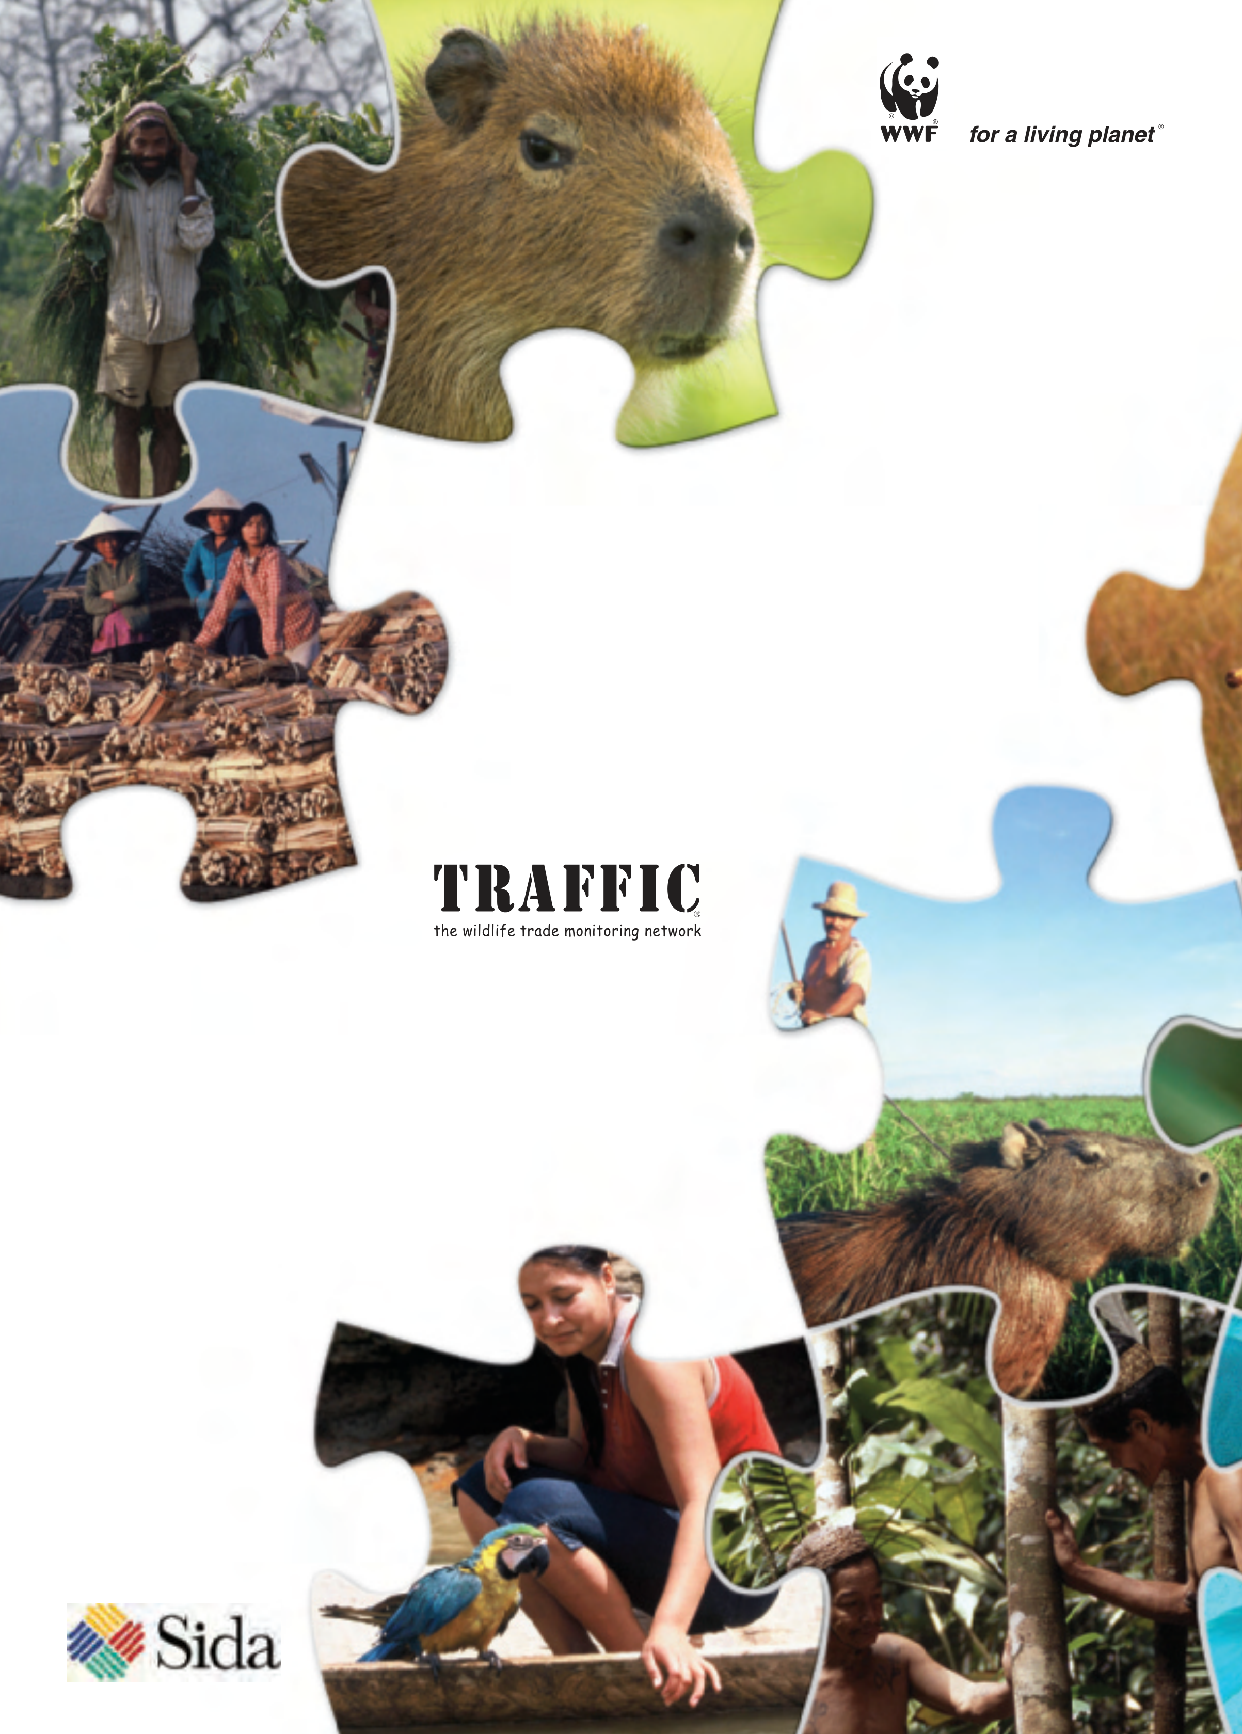
WWF is one of the world’s
largest and most experienced
independent conservation
organizations, with almost
5 million supporters and a
global network active in more
than 100 countries.
WWF’s mission is to stop the degradation
of the planet’s natural environment and
to build a future in which humans live in
harmony with nature, by:
- conserving the world’s biological diversity
- ensuring that the use of renewable natural resources is
sustainable
- promoting the reduction of pollution and
wasteful consumption.
Global Species Programme
WWF International
Avenue du Mont-Blanc
1196 Gland, Switzerland
Tel :  Fax : | +41 22 364 9111 +41 22 364 0640
www.panda.org/species
TRAFFIC, the wildlife trade monitoring network, works to ensure that trade in wild plants and animals is not a threat to the conservation of nature. It has offices covering most parts of the world and is a joint programme of WWF and IUCN – the International Union for Conservation of Nature
TRAFFIC International
219a Huntingdon Road
Cambridge CB3 0DL
UK
tel.  fax. | +44 1223 277427  +44 1223 277237
www.traffic.org
This document has been
financed by the Swedish
International Development
Agency, Sida.
Sida does not necessarily share the
views expressed in this material.
Responsibility for its contents rests
entirely with its author.

